Change scale, qsz or orientation
(lithos Main Menu Option S. Change scale, qsz or orientation )

Description
This option allows you to change the size of a maplet (both GSD and Q size) as well as rotate a maplet while keeping its body-fixed and image space positions unchanged. This second action can be useful if there is a difficult portion at the edge of a maplet that could be avoided.

Suboptions
When you choose Option S. Change scale, qsz or orientation from the Main menu, you will see this set of prompts:

Main Menu: Q 0123O IUCRSG NVAMBX DEPL FZH? s >sSCALE = 0.000100 QSZ = 49 Enter scale (km/px), qsz, cc window rotation (deg) [0 0 0 to quit].00001 49 0
Enter scale (km/px), qsz, cc window rotation (deg) -
- Enter the new GSD
- Enter the new Q size
- Enter the number of degrees you want to rotate the landmark
/!\ Limbfits and overlaps are cleared and the slopes and albedos are re-initialized.
Here is a sample before using this option to change the scale:
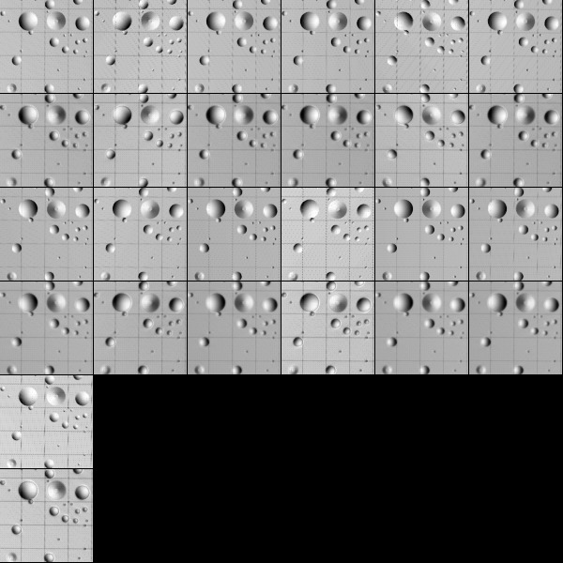
Figure 00: Images Prior to Changing Scale and Orientation
Here is the sample after zooming out the scale.
- (!) Note that the template has now disappeared. It can be reloaded if needed.
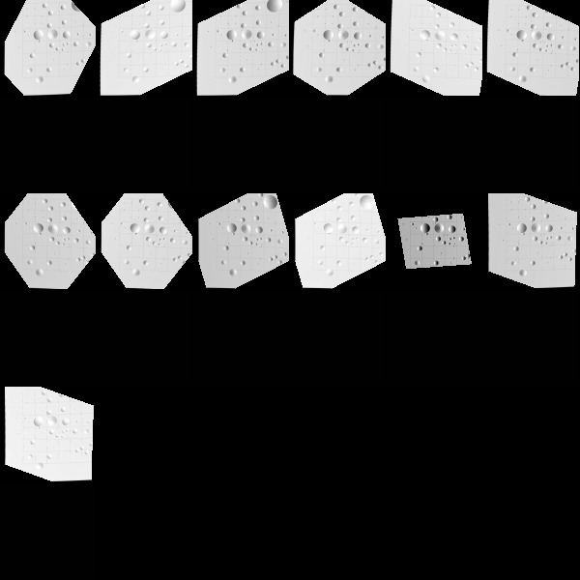
Figure 00: Images After Changing Scale and Orientation (Template needs to be reloaded)

(Compiled by JRW)
CategoryLithosMenu

