LMRK_POS

Basic Description
This code package generates the sun and spacecraft position with respect to a selected landmark during imaging capture of the selected landmark. The position in terms of azimuth, elevation, and zenith angles from a topocentric SEZ (South East Zenith) frame. For visual representation, polar plots are outputed that show the zenith angle and azimuth of the sun and spacecraft when images are taken of the chosen landmark.

Codes and Text Files
This package includes two codes and multiple text files. Some of the textiles are created by the user and others are outputted from a code. Below is a flow chart that details the process of using the codes.
LMRKNAMES.txt - a text file the user makes that consists of of one column list of the landmarks to be analyzed.
POS_SCRIPT.sh - shell script that uses LMRKNAMES.txt to make LAT.txt, LON.txt, NUMBERPIC.txt, RESIDUALS.txt, and PICTIMES.txt.
LAT.txt - a text file that lists the latitudes of the landmarks.
LON.txt - a text file that lists the west longitudes of the landmarks.
NUMBERPIC.txt - a text file that lists number of images taken of landmarks.
REOLUTION.txt - a tex file that lists the resolution of all pictures taken of landmarks.
PICTTIMES.txt - a text file that lists the times of all the images taken of landmarks.
LMRK_SUN_SC_POS.m - MATLAB code that generates the zenith angles, azimuths, and elevation angles of the sun and spacecraft with respect to landmarks.
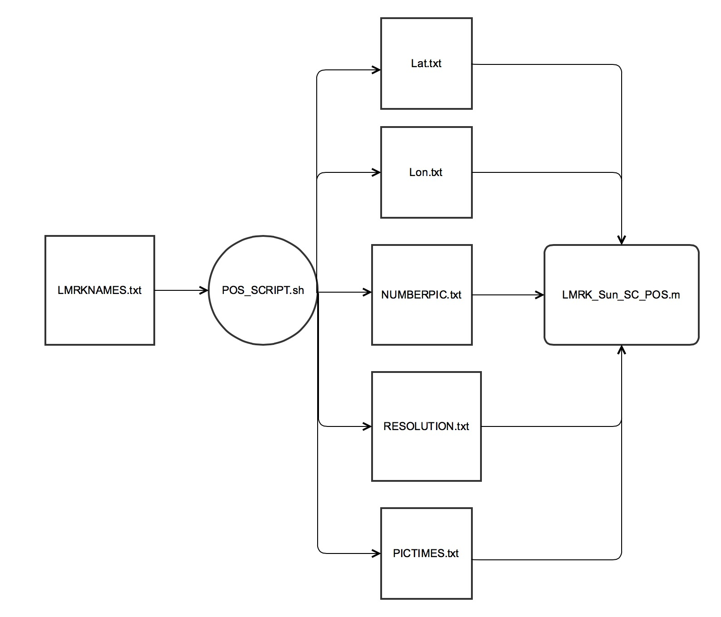

Instructions

