Local Incidence

Description
This is the process to generate local incidence for each LROC NAC image. This process involves only values found in info.txt from ISIS, and a program that reads bigmaps; it ends with an ASCII image.

Procedure

Overview
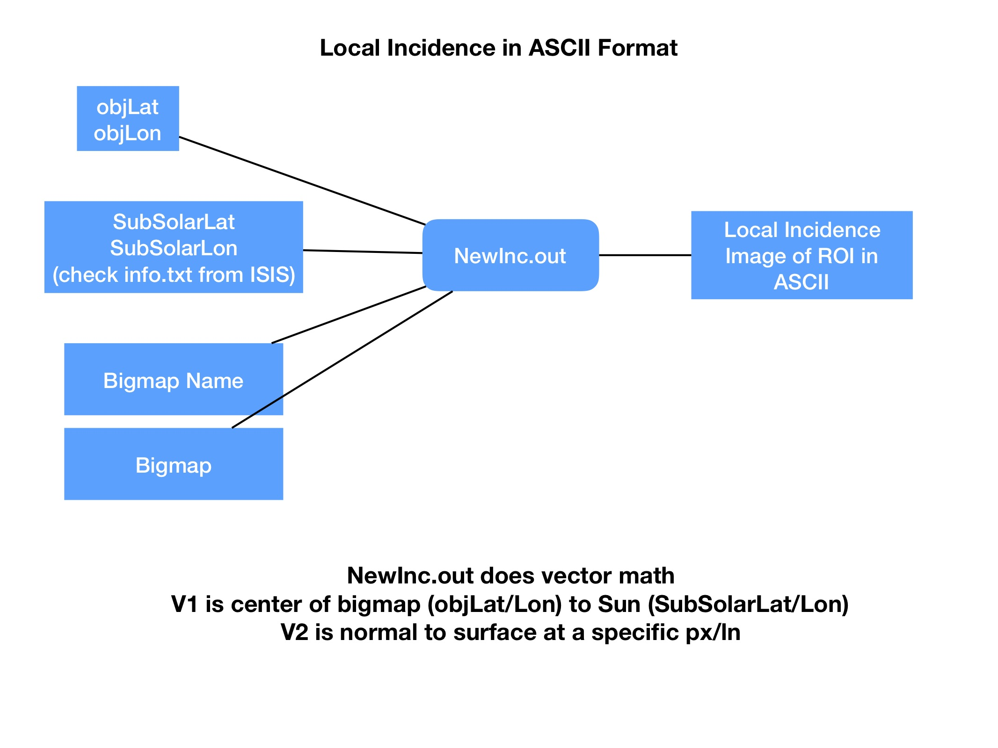

Input Details
- ObjLat/Lon comes from the center pixel of the bigmap
- SubSolarLat/Lon come from caminfo from ISIS (we call the output info.txt).

Code to generate NewInc.out
dumpMapInc.f
- Here is a wrapper to run the compiled version of dumpMapInc.f. It also creates an ISIS cube of the results. ||Incidence Wrapper ||

