Reference Peak

Local Tilt Investigation: Evaluation Statistics: Standard (Forwards) vs Backwards Bigmap Tiling and Iterating

Formal Uncertainty
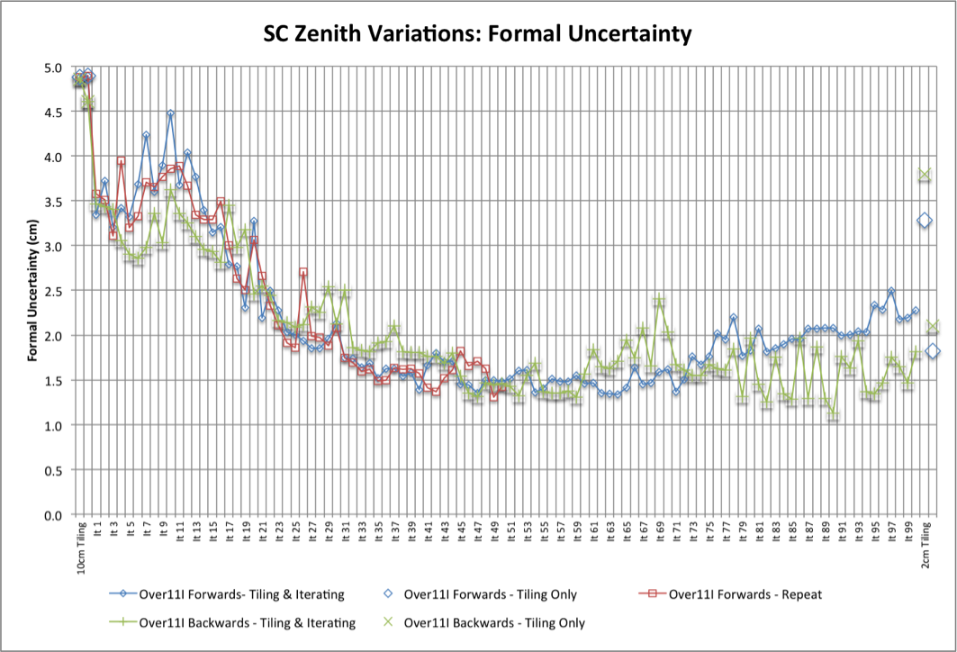

CompMapVec RMS
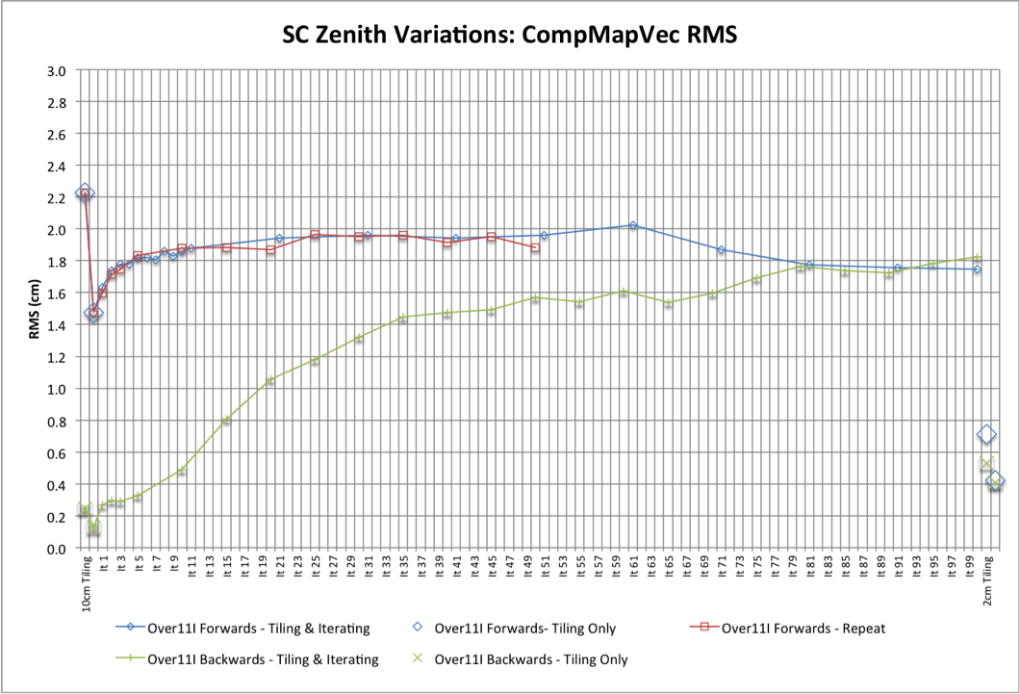

CompareOBJ RMS
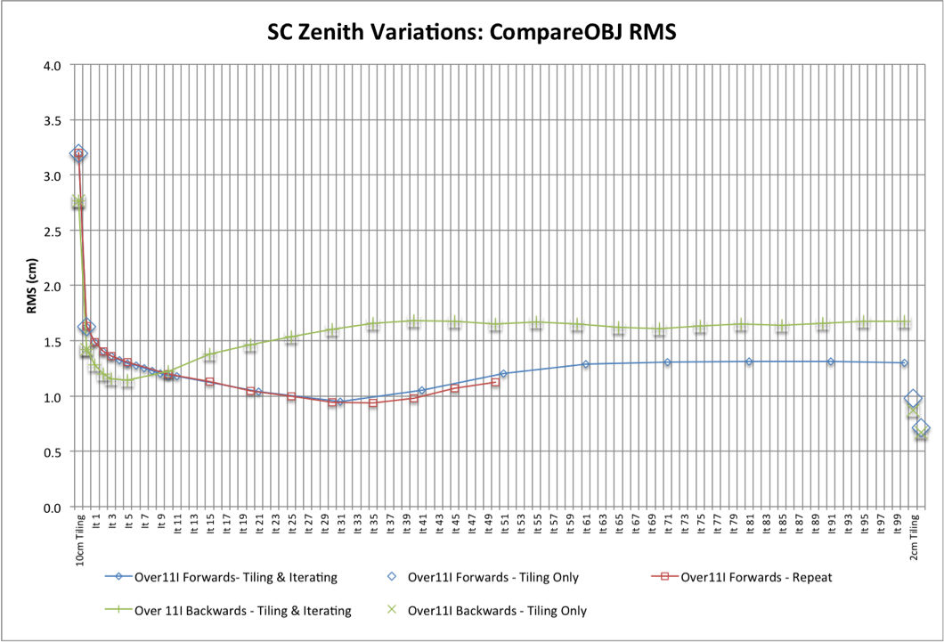

CompareOBJ RMS with Optimal Translation and Rotation


