MMAPL1: F2 Test 10 Ultra-Feature - Lockheed Feature 1 (Crater)

Standard Procedure
Information from lower resolution maplets IS included in the evaluation DTM.

Results
Processing Step | Highest Image Resolution (cm/pixel) | CompareOBJ RMS (cm)
 |  | No Translation/Rotation | With Optimal Translation and Rotation | With Manual Translation
2cm-Tiling | 1.0 | 1.396 | 1.279
1cm-Tiling | 1.0 | 1.167 | 1.189
0.5cm-Tiling | 1.0 | 1.084 | 1.074
0.5cm-Increase Image Res | 0.25 | 1.136 | 1.158
0.5cm-Iteration 1 | 0.25 | 1.152 | 1.177
0.5cm-Iteration 2 | 0.25 | 1.168 | 1.180
0.5cm-Iteration 3 | 0.25 | 1.169 | 1.178
0.5cm-Iteration 3 | 0.25 | 1.171 | 1.175

Residual RMS
Processing Step | Highest Image Resolution (cm/pixel) | Residual RMS (cm)
2cm-Tiling | 1.0
1cm-Tiling | 1.0
0.5cm-Tiling | 1.0
0.5cm-Increase Image Res | 0.25
0.5cm-Iteration 1 | 0.25
0.5cm-Iteration 2 | 0.25
0.5cm-Iteration 3 | 0.25
0.5cm-Iteration 3 | 0.25

Showmap
Images of the evaluation bigmap at various processing steps and images resolutions.
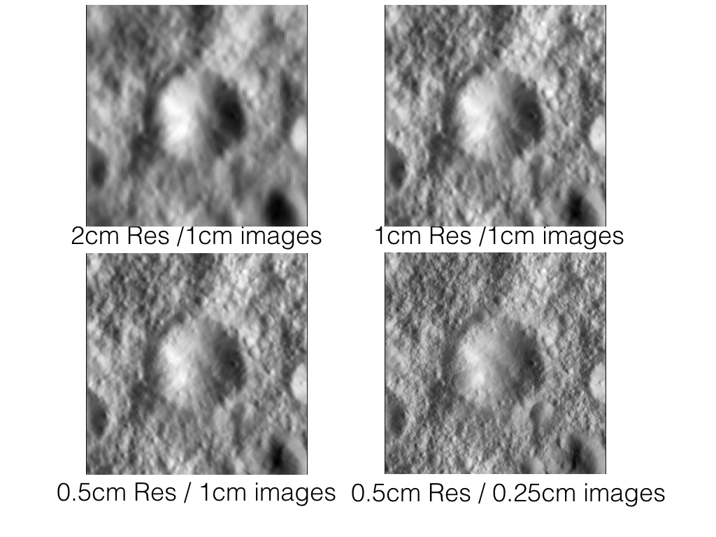

Topographic Transits
North-South transits at various pixel locations in the evaluation bigmap, compared to truth. Transits in clouded for a number of processing steps.
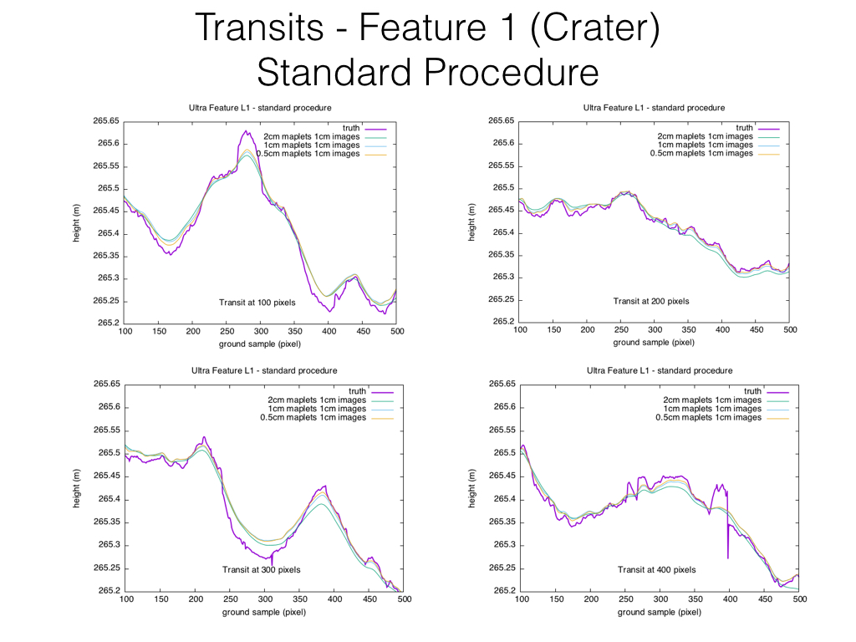

Heatmap
Heatmap depicting difference between evaluation bigmap and truth.


