This is what we are currently doing for Bob for Vesta (Nov 2011). Original powerpoint: tiling.ppt
I am making suggestions to improve and streamline things. First, I have created a directory called "work_general" (about 3GB) that is in the ~/Dropbox/Dawn-shape directory. This directory has all the files needed to do the tiling (landmarks, mapfiles and supporting files). Copy this to your own computer for each processor that you are going to use. Then run the script setup.sh, which will create symbolic links to the ~/Dropbox/Dawn-shape/Vesta directory (specifically the image files). This avoids copying 12GB of data that won't change. Eventually, we can put in an "rsync" command that will keep our working directories up to date with the master dropbox directory.

Look Around
First we need to see where we need new maplets. We run map_coverage.e:

~/bin/map_coverage.e ZS1000 0,.1 ← min,max resolution
And look at the output coverage_m.pgm. Use graphics converter or imagemagik
convert coverage_m.pgm coverage_m.jpg
The bottom part has already been tiled from ZS1200 and ZS1203.
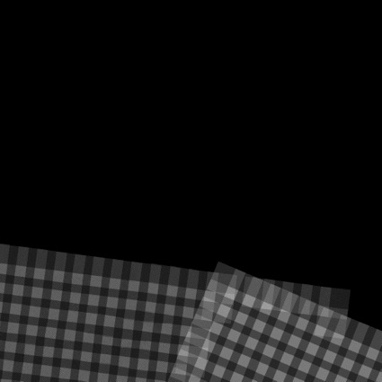

Run
(!) We need to ensure all the old files are removed from previous runs.Before running type:
rm LMRKLIST1.TXT
Then to clean up old stuff, build the scripts and run them, make_scriptT.e
sh rem_script.brm TESTFILES/*rm TESTFILES1/*~/bin/make_scriptT.echmod +x run_script.b ./run_script.b &
It seems to take about 2 minutes per landmark. We are currently generating 361 landmarks, which works out to 10 to 12 hours to finish.
(!) Type this from time to time to see how it is going, find_nofitT.e.
~/bin/find_nofitT.e

Export
We generate a script that will remove unneeded files and take the new landmarks and put them into a tar ball. Makes EXPORT.b and the script EXPORT.TXT, map_coverage.e
~/bin/EXPORT.e

The script EXPORT.TXT is: cp LMRKLIST1.TXT NEW_FILES/LMRKLIST.TXT cd NEW_FILES/LMKFILES rm -f *.LMK cd ../.. cd NEW_FILES/MAPFILES rm -f *.MAP cd ../.. chmod +x EXPORT.b ./EXPORT.b tar -cf NEW_FILES.tar NEW_FILES rm -f LMRKLIST1.TXT
Run this script by
sh EXPORT.TXT
Change name of NEW_FILES.tar to something distinctive like
- NEW_FILES_ZS1000.tar
and e-mail to me or put in dropbox.

Import
Untar to recover NEW_FILES directory, importl.e
~/bin/IMPORTL.e
cp NEWLIST.TXT make_script.in
For make_scriptF.seed use:
nngu1oRECENTn1qEND
Run these commands (copy into window)
sh rem_script.brm TESTFILES/*rm TESTFILES1/*~/bin/make_scriptF.e./run_script.b &
(!) Type this from time to time to see how it is going, importl.e.
~/bin/find_nofitT.e (this didn't seem to work, but find_nofitP.e gave output that made sense)

