Normalized Cross-Correlation Evaluation
This page describes the methodology for using normalized cross-correlation to evaluate a region of the model.
Cross-correlation is performed on the following images:
- Model: Image of bigmap
- Truth: Image of Zmaps
Model (left), Truth (right), S/C Azimuth 0, Zenith 30deg, Sun Azimuth 90deg, Zenith 45deg:
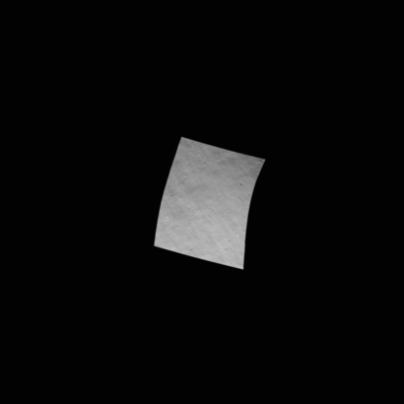 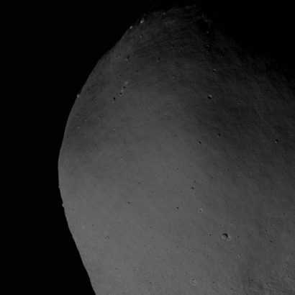
Images are generated using the following set of dirty sumfiles at the required resolution to include:
- low and high phase
- low and moderate incidence
- full set of s/c azimuth angles (observe region from all directions).
Spacecraft |  | Sun
Azimuth (deg) | Zenith (deg) | Azimuth (deg) | Zenith (deg)
0 | 30 | 90 | 45
90 | 30 | 90 | 45
180 | 30 | 90 | 45
270 | 30 | 90 | 45
0 | 30 | 270 | 45
90 | 30 | 270 | 45
180 | 30 | 270 | 45
270 | 30 | 270 | 45
45 | 10 | 270 | 10
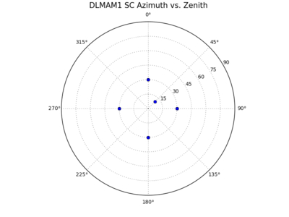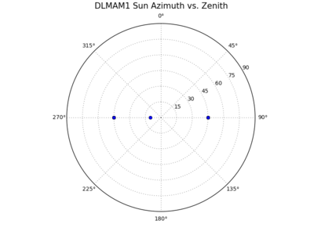
Image resolution is chosen from the following based on the state of the model:
- Resolution: 120cm, 75cm, 35cm, 18cm, 9cm, 5cm.
The following regions have been identified for evaluation:
Region ID | Region Name | Latitude (deg) | West Longitude (deg) | Description
TG | TAG Site 1 | -10 | 350 | Shape 4 TAG site 1
R1 | Region 1 | 45 | 300 | Region of roughness, identified from a visual inspection using Small Body Mapping Tool

Where are the Dirty Sumfiles and Truth Images?
SUMFILES: ormacsrv1:/opt/local/spc/shape4/imageGen/DIRTYSUMFILES/
Truth .pgm files: ormacsrv1:/opt/local/spc/shape4/imageGen/PGMFILES/
Follow this link for details of the image file and bigmap naming conventions: Normalized Cross-Correlation Evaluation - Naming Conventions

Obtain Model Bigmap
Obtain the required bigmap/s from the model working directory (or back-up). A full set of bigmap .in files is stored here:
/opt/local/spc/shape4/support4/MR1051_model_REG1_GSD5cm_width100m.inMR1052_model_REG1_GSD5cm_width20m.inMR1055_model_REG1_GSD5cm_width50m.inMR1101_model_REG1_GSD10cm_width100m.inMR1102_model_REG1_GSD10cm_width20m.inMR1105_model_REG1_GSD10cm_width50m.inMR1351_model_REG1_GSD35cm_width100m.inMR1352_model_REG1_GSD35cm_width20m.inMR1355_model_REG1_GSD35cm_width50m.inMTG051_model_TAG1_GSD5cm_width100m.inMTG052_model_TAG1_GSD5cm_width20m.inMTG055_model_TAG1_GSD5cm_width50m.inMTG101_model_TAG1_GSD10cm_width100m.inMTG102_model_TAG1_GSD10cm_width20m.inMTG105_model_TAG1_GSD10cm_width50m.inMTG351_model_TAG1_GSD35cm_width100m.inMTG352_model_TAG1_GSD35cm_width20m.inMTG355_model_TAG1_GSD35cm_width50m.in

Populate Evaluation Directory
The F6 evaluation directory is here:
/Volumes/Data1/spc-test/F6-evaluation/drwxrwxr-x 227 dlambert OREX\spc 7718 Jul 22 15:09 DIRTYNOMINALSdrwxrwxr-x 227 dlambert OREX\spc 7718 Jul 22 15:09 DIRTYSUMFILESdrwxrwxr-x 226 dlambert OREX\spc 7684 Jul 21 16:01 SUMFILESdrwxrwx--x 13 jweirich OREX\spc 442 Jul 21 14:38 eval_F6_BBD1_TGdrwxrwx--x 15 jweirich OREX\spc 510 Jul 21 14:34 eval_F6_EndApp_TGdrwxrwxr-x 14 dlambert OREX\spc 476 Jul 20 16:36 eval_F6_startdrwxr-xr-x 13 dlambert OREX\spc 442 Jul 22 15:17 eval_F6_template-rw-r--r-- 1 dlambert OREX\spc 117 Jul 22 15:42 listSUM_R1_120cm-rw-r--r-- 1 dlambert OREX\spc 117 Jul 22 15:42 listSUM_R1_18cm-rw-r--r-- 1 dlambert OREX\spc 117 Jul 22 15:42 listSUM_R1_35cm-rw-r--r-- 1 dlambert OREX\spc 117 Jul 22 15:42 listSUM_R1_5cm-rw-r--r-- 1 dlambert OREX\spc 117 Jul 22 15:42 listSUM_R1_75cm-rw-r--r-- 1 dlambert OREX\spc 117 Jul 22 15:42 listSUM_R1_9cm-rw-r--r-- 1 dlambert OREX\spc 117 Jul 20 16:21 listSUM_TG_120cm-rw-r--r-- 1 dlambert OREX\spc 117 Jul 20 16:22 listSUM_TG_18cm-rw-r--r-- 1 dlambert OREX\spc 117 Jul 20 16:21 listSUM_TG_35cm-rw-r--r-- 1 dlambert OREX\spc 117 Jul 20 16:22 listSUM_TG_5cm-rw-r--r-- 1 dlambert OREX\spc 117 Jul 20 16:21 listSUM_TG_75cm-rw-r--r-- 1 dlambert OREX\spc 117 Jul 20 16:22 listSUM_TG_9cmdrwxrwxr-x 4 dlambert OREX\spc 136 Jun 24 16:16 lsupport-rw-r--r-- 1 jweirich OREX\spc 587 Jul 21 14:49 parseXcorr.sh-rw-rw-r-- 1 dlambert OREX\spc 1927 Jun 23 15:12 processing.loglrwxr-xr-x 1 dlambert OREX\spc 30 Jun 24 12:27 support -> /opt/local/spc/shape4/support4lrwxr-xr-x 1 dlambert OREX\spc 39 Jun 24 16:54 truth_PGMFILES -> /opt/local/spc/shape4/imageGen/PGMFILES
Make a subdirectory and populate as follows:
- listSUM -> ../listSUM_35cm - symbolic link to list of dirty sumfiles;
- lsupport -> ../lsupport/ - symbolic link to main directory local support directory;
- MAPFILES/ - directory containing model bigmap/s;
- MAPLIST.TXT - file listing the bigmap to image, appended with 'END';
- PGMFILES/ - directory for storage of generated .pgm files;
- SUMFILES/ - directory for storage and retrieval of SUMFILES which will be generated for the evaluation;
- THUMBNAILS/ - directory for storage of generated .jpg files;
- imageXcorr_results/ - directory for storage of imXcor.py output files;
- truth_PGMFILES -> /opt/local/spc/shape4/imageGen/PGMFILES/ - symbolic link to truth images.

dirID=eval_F6_start # Update this ID!!cd /Volumes/Data1/spc-test/F6-evaluation/mkdir $dirIDcd /Volumes/Data1/spc-test/F6-evaluation/$dirIDmkdir MAPFILES PGMFILES SUMFILES THUMBNAILS imageXcorr_resultsln -s ../lsupport .ln -s /opt/local/spc/shape4/imageGen/PGMFILES truth_PGMFILESln -s ../listSUM_TG_35cm listSUMprintf "%s\n%s\n" "MTG105" "END" > MAPLIST.TXT
Make SUMFILES which will have a unique name for the evaluated model state:
modelStateID=AA # Update this ID!!while read name; do echo $name newNmPart1=`echo $name | cut -c1-8` newNmPart2=$modelStateID newNmPart3=`echo $name | cut -c11-12` newNm=`echo ${newNmPart1}${newNmPart2}${newNmPart3}` sed 's/'$name'/'$newNm'/g' ../SUMFILES/${name}.SUM > SUMFILES/${newNm}.SUM done < listSUM

Generate Model Images
The following script has been written to automate the generation of images of a bigmap using imager_MG. It expects the user to identify an existing list of dirty sumfiles as a common line item, e.g.:

sh lsupport/makeImages_imagerMG.sh listSUM
where

cat listSUMPBF6TG3E0001PBF6TG3E0002PBF6TG3E0003PBF6TG3E0004PBF6TG3E0005PBF6TG3E0006PBF6TG3E0007PBF6TG3E0008PBF6TG3E0009
Generate thumbnails for visual inspection of the bigmap images:
while read name; do echo $name /opt/local/bin/convert PGMFILES/${name}_MTG105.pgm THUMBNAILS/${name}_MTG105.jpgdone < listSUM

Conduct Normalized Cross-Correlation
Conduct cross-correlation using Tanner's script, storing the output in the imageXcorr_results directory:

Mapname=MTG105while read name; do echo $name truthNM=`echo $name | sed 's/PB/P2/g'` python /opt/local/spc/bin/imXcorr.py PGMFILES/${name}_${Mapname}.pgm truth_PGMFILES/${truthNM}.pgm | tee imageXcorr_results/imXcor_${name}_${Mapname}.outdone < listSUM
Algorithm Source: J.P. Lewis
- Fast_normalized_cross-correlation.pdf
- vi95_lewis.pdf

