Test09 OBoptimal

Goal
The point of this test was to evaluate how well SPC could create a bigmap of a tag site (1) using optimal imaging data from Orbit B. Optimal imaging data implies images taken of the tag site occur when the spacecraft and sun are at perfect azimuth and zenith angles so, that all parts of the tag site ( e.g. sides of craters & sides of boulders) could be captured out of shadow. RMS measurements from CompareOBJ that compare the SPC model with the truth model were used to judge the created Bigmap, along with traces and a heat map. Furthermore, the bigmap of the tag site was not the only bigmap evaluated. Five smaller bigmaps fore five Lockheed features respectfully were also evaluated.

Imaging Data
To replicate a terminator orbit trajectory (e.g. Orbit B), sun and spacecraft zenith angles during image capture were selected so that their sum equals 90 degrees. Also, many of the sun azimuth angles chosen are impossible, which was ignored during this test due to the assumption that the imaging data is perfect (We played God) for SPC with the only constraint being that the spacecraft has to be in a terminator orbit. A readme.txt file showing the image angle parameters for each image are shown below, along with the polars.
September 25, 2015Kristofer DrozdThese Sumfiles and and Nominals were created for the first optimal orbit b test.The optimal otbit b test is done to see what SPC can do with the best orbit b images.Image Landmarks:EE0011 (center of tag1 (3)) - -0.3295712733D-01 0.2614730241D+00 -0.3702992051D-01EE0034 (3m north 3m west (1)) - -0.3097255801D-01 0.2617313664D+00 -0.3508827492D-01EE0035 (3m north 3m east (2)) - -0.3798937978D-01 0.2617730236D+00 -0.3504279920D-01EE0040 (3m south 3m west (4)) - -0.3106771623D-01 0.2593010950D+00 -0.4175064864D-01EE0041 (3m douth 3m east (5)) - -0.3807991845D-01 0.2594780195D+00 -0.4172744156D-01Code Inputs:SC az (deg) - 0:45:315SC z (deg) - 45Sun az (deg) - 90:180:270Sun z (deg) - 45distance (km) - .8SC az (deg) - 0:90:270SC z (deg) - 60Sun az (deg) - 90:180:270Sun z (deg) - 30distance (km) - .8SC az (deg) - 0:180:180SC z (deg) - 30Sun az (deg) - 90:180:270Sun z (deg) - 60distance (km) - .8SC az (deg) - 0:180:180SC z (deg) - 20Sun az (deg) - 90:180:270Sun z (deg) - 70distance (km) - .8
Sun Polar (EE0011): Azimuth vs. Zenith
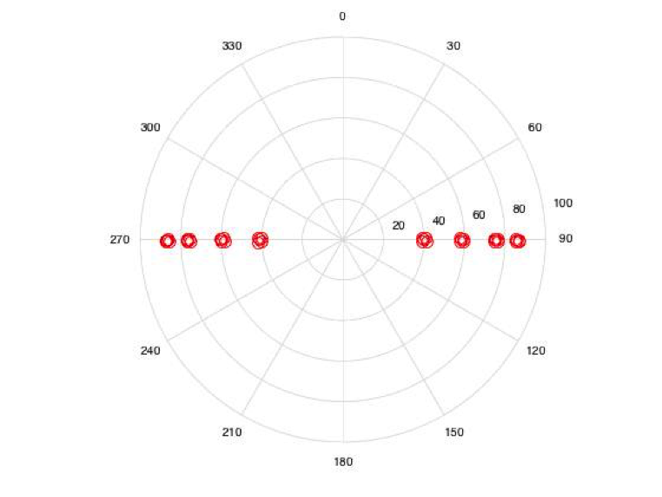
SC Polar (EE0011): Azimuth vs. Zenith
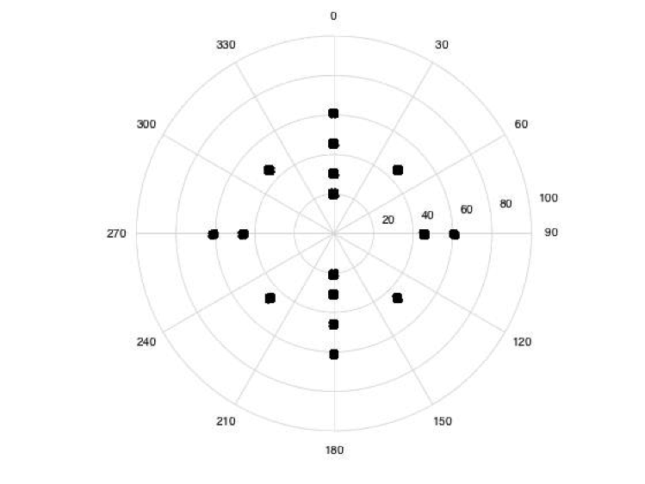

Tagsite 1 Tiling/iterating Procedure
- A 9 cm bigmap of tag site 1 was initialy loaded into the working directory for beginning topography. This was done to replicate a beginning model, similar to what we would achieve in flight from preliminary survey.
- Next a 5 cm ground sampled bigmap was tiled over the tag site and an evaluation bigmap was made. Stats of the newly created model were measured.
- Iterations at the current ground sampled model were then performed until the RMS from CompareOBJ started to increase. Stats at each iteration were then measured.
- Steps 2 and three were then repeated for bigmaps ground sampled to 2.5 cm and 1.25 cm.
Script parameters from a readme.txt file

Scripts for OBoptimal trial 2 testBigmap .in files:TILE03 - for maples of 5 cm resolution -> res = 0.038m; Q = 200TILE04 - for maples of 2.5 cm resolution -> res = 0.02m; Q = 375TILE05 - for maples of 1.25 cm resolution -> res = 0.01m; Q = 750EVALmp - for evaluation bigmap -> res = 0.5cm, Q = 1000.seed files:XXX005.seed - 5 cm tileXX0025.seed - 2.5 cm tileXX0125.seed - 1.25 cm tile
An Example of a seed and bigmap script:
Bigmap script (TILE03.in):

l -8.027 262.768 0.00003800 200 1.23400 1000TILE031.005.02510011111100
Seed Script (XXX005.seed):

0.00005,49giay.5nx.0250abnTAG109n2u1v2ea0,50,.5,.5,0.25,3103n0y101n0y0c.50040103n0y101n0yeo.50au10040282.01141, 2.5, 36yy0.025300u1v1101n0yu10040102n0y101n0yeo.5u10040282.01141, 2.5, 36yy0.025300u1v1101n0yu1oRECENTy1oRECENTn3y1, 3, 5 wiRECENTnnv1u1#v#4oRECENTn1qEND

Results/Conclusions
- Kris' Failed Trials
- Kris' Successful trial
- Tanner's Trial

Eval

echo 1 .001 .001 | residuals &/usr/local/localBin/bigMapRef < RTAG1C-center.in/usr/local/localBin/bigMapRef < RTAGSC-single.in/usr/local/localBin/bigMapRef < maps/MMAPL1.in/usr/local/localBin/bigMapRef < maps/MMAPL2.in/usr/local/localBin/bigMapRef < maps/MMAPL3.in/usr/local/localBin/bigMapRef < maps/MMAPL4.in/usr/local/localBin/bigMapRef < maps/MMAPL5.inecho MMAPL1 | /usr/local/localBin/flatMapVececho MMAPL2 | /usr/local/localBin/flatMapVececho MMAPL3 | /usr/local/localBin/flatMapVececho MMAPL4 | /usr/local/localBin/flatMapVececho MMAPL5 | /usr/local/localBin/flatMapVec# Save filescp MMAPL*.TXT MAPFILES/MTAG[1S]C.MAP MAPFILES/MMAPL*.MAP step##cd MAPFILES# Build and Evaluate main maplets~/eval/bin/Maplet2FITS MTAG1C.MAP f; ~/eval/bin/FITS2OBJ f mtag-1c.obj~/eval/bin/Maplet2FITS MTAGSC.MAP f; ~/eval/bin/FITS2OBJ f mtag-sc.obj~/eval/bin/CompareOBJ mtag-1c.obj ~/eval/bin/TTAG1L-25m2.5cm.obj~/eval/bin/CompareOBJ mtag-sc.obj ~/eval/bin/TTAG1L-25m2.5cm.obj~/eval/bin/CompareOBJ --compute-optimal-translation mtag-1c.obj ~/eval/bin/TTAG1L-25m2.5cm.obj~/eval/bin/CompareOBJ --compute-optimal-translation mtag-sc.obj ~/eval/bin/TTAG1L-25m2.5cm.obj~/eval/bin/CompareOBJ --compute-optimal-translation-and-rotation mtag-sc.obj ~/eval/bin/TTAG1L-25m2.5cm.obj~/eval/bin/CompareOBJ --compute-optimal-translation-and-rotation mtag-1c.obj ~/eval/bin/TTAG1L-25m2.5cm.obj# Convert Lockheed features obj~/eval/bin/Maplet2FITS MMAPL1.MAP f ; ~/eval/bin/FITS2OBJ --local f lockheed1.obj~/eval/bin/Maplet2FITS MMAPL2.MAP f ; ~/eval/bin/FITS2OBJ --local f lockheed2.obj~/eval/bin/Maplet2FITS MMAPL3.MAP f ; ~/eval/bin/FITS2OBJ --local f lockheed3.obj~/eval/bin/Maplet2FITS MMAPL4.MAP f ; ~/eval/bin/FITS2OBJ --local f lockheed4.obj~/eval/bin/Maplet2FITS MMAPL5.MAP f ; ~/eval/bin/FITS2OBJ --local f lockheed5.obj# Evaluate Lockheed features~/eval/bin/CompareOBJ lockheed1.obj ~/eval/bin/TTAG1L-25m2.5cm.obj~/eval/bin/CompareOBJ lockheed2.obj ~/eval/bin/TTAG1L-25m2.5cm.obj~/eval/bin/CompareOBJ lockheed3.obj ~/eval/bin/TTAG1L-25m2.5cm.obj~/eval/bin/CompareOBJ lockheed4.obj ~/eval/bin/TTAG1L-25m2.5cm.obj~/eval/bin/CompareOBJ lockheed5.obj ~/eval/bin/TTAG1L-25m2.5cm.obj

