SUMFILES

Description
This directory stores sumfiles .
A "sumfile" is created by the executable make_sumfiles. It contains the following information about its image:
- camera data
- target-relative position vectors
- pointing vectors
- uncertainty values
- landmark info
There is only one sumfile for each image. SPC uses data from sumfiles throughout various executables such as lithos. As you use SPC to correlate images with lithos, you can update the sumfile vectors and landmark lists using the "v 4" command (see lithos).
Unlike nominals, sumfiles can change throughout SPC usage.
The sumfiles crated by make_sumfiles are named as <image name>.SUM and placed in a directory titled SUMFILES within the user's working directory.
Here is a sample of a sumfile :

W46908480918 # image name2014 NOV 12 17:20:03.128 # utc 2048 2048 500 65535 NPX, NLN, THRSH # pic size, lower and upper dn thresholds 0.1356800000D+03 0.1044000000D+04 0.9380000000D+03 MMFL, CTR # focal length, px/ln center (boresight/optical axis) -0.9665063720D+01 0.1326644487D+02 -0.6673084308D+01 SCOBJ # s/c-object vector (body fixed) -0.6442479111D+00 -0.1829032409D-01 0.7645979944D+00 CX # pixel unit vector (body fixed) 0.5935707119D+00 0.6184779444D+00 0.5149357652D+00 CY # linel unit vector (body fixed) -0.4823053379D+00 0.7855892670D+00 -0.3875965231D+00 CZ # boresight unit vector (body fixed) 0.7254908676D+00 -0.3292717307D+00 0.6043534796D+00 SZ # sun unit vector (body fixed) 74.07410 0.00000 0.00000 0.00000 74.07410 0.00000 K-MATRIX 0.00000D+00 0.00000D+00 0.00000D+00 0.00000D+00 DISTORTION # always zero these days (distortion comes in elsewhere) 0.1007758363D-02 0.1482813397D-02 0.8902614968D-03 SIGMA_VSO # formal scobj uncertainty 0.3071768580D-04 0.3093941486D-04 0.1565302183D-04 SIGMA_PTG # formal pointing uncertaintyLANDMARKS AO0001 2049.39 668.15 AO0002 2020.70 644.81 AO0003 2035.17 708.66 # landmark px/ln centersBD0009 1902.39 884.05 BD0010 1891.13 909.86 ...EK0022 675.73 1371.97 EQ0088 721.76 738.13 FI0002 727.77 220.40 LIMB FITS # landmark-on-limb centers (none here)END FILE
- /!\ Comments (information after the #) were added here for clarification and are not included in an actual sumfile.
Here is another sample sumfile :
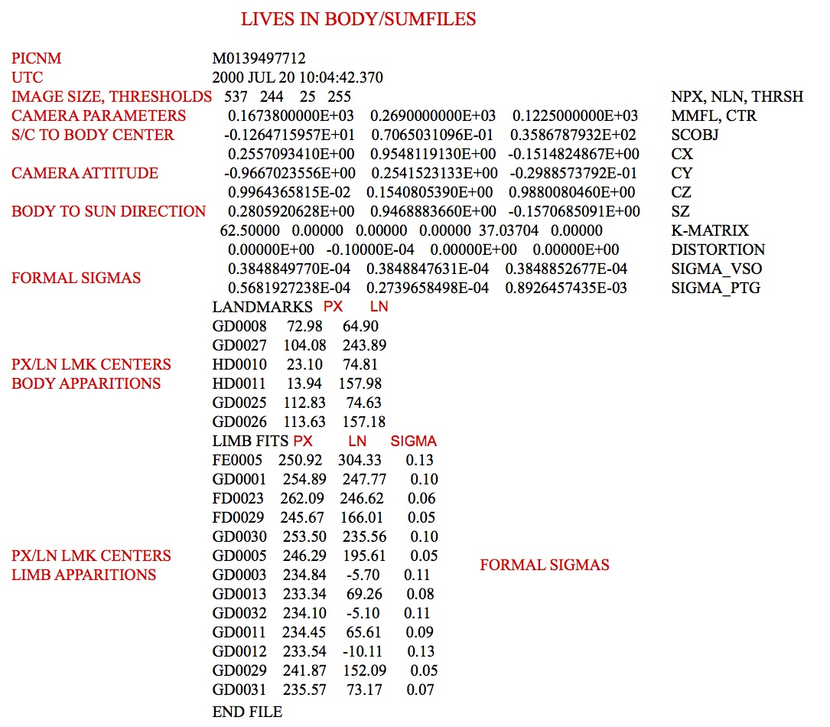
Figure 00: SUMFILES Information Illustration

(Compiled by KD)
CategoryDirectories

