Test 11S - With Overlaps
Truth topography: flat-topped cone with 20deg slope within a landscape of cones and craters.
Evaluation bigmap parameters: GSD = 1cm, Q = 200 (width=4m), centered at REGION.MAP, 966, 1005 (pixel/line location).

Results
Please see results under Tables and Figures, below.
An inspection of the transits and heat plots reveals that, at 50 iterations, the solution has not converged. The North-South and West-East central transits continue to drift with the heights monotonically increasing. This corresponds with a decreasing residual and somewhat diverging RMS values.

Tables and Figures
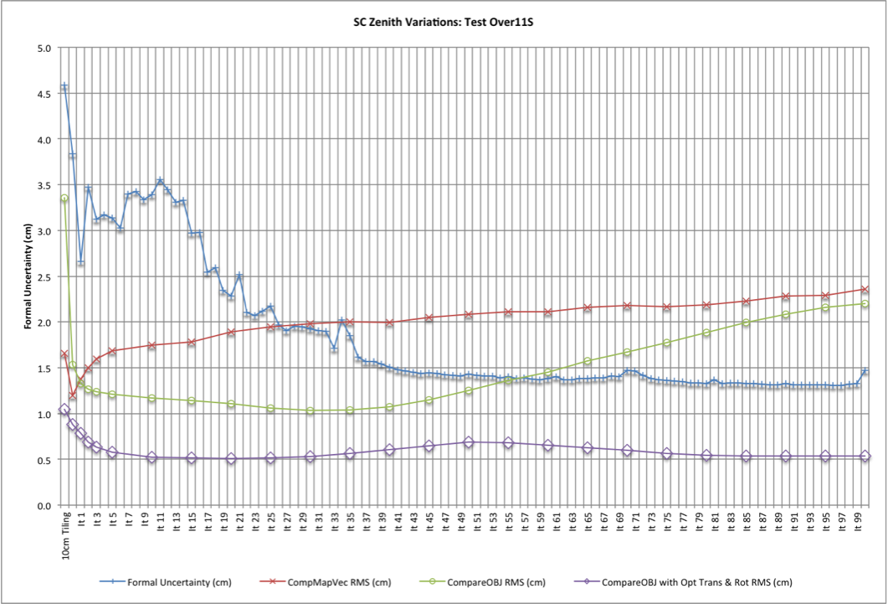
10cm Tiling:
Formal Uncertainty (cm) | CompareOBJ-RMS(cm) | CompareOBJ-RMS with Opt Trans &Rot (cm) | CompMapVec-RMS(cm)
4.589 | 3.357 | 1.043 | 1.660
5cm Tiling:
Formal Uncertainty (cm) | CompareOBJ-RMS(cm) | CompareOBJ-RMS with Opt Trans &Rot (cm) | CompMapVec-RMS(cm)
3.841 | 1.537 | 0.882 | 1.199
5cm Iterations:
Iteration | Formal Uncertainty (cm) | CompareOBJ-RMS(cm) | CompareOBJ-RMS with Opt Trans &Rot (cm) | CompMapVec-RMS(cm)
1 | 2.662 | 1.331 | 0.785 | 1.376
2 | 3.476 | 1.263 | 0.687 | 1.501
3 | 3.122 | 1.239 | 0.632 | 1.593
5 | 3.134 | 1.211 | 0.578 | 1.685
10 | 3.394 | 1.171 | 0.527 | 1.749
15 | 2.968 | 1.146 | 0.518 | 1.779
20 | 2.284 | 1.110 | 0.507 | 1.892
25 | 2.173 | 1.060 | 0.517 | 1.947
30 | 1.923 | 1.035 | 0.527 | 1.984
35 | 1.848 | 1.036 | 0.566 | 2.002
40 | 1.510 | 1.077 | 0.608 | 1.996
45 | 1.444 | 1.152 | 0.650 | 2.048
50 | 1.431 | 1.253 | 0.686 | 2.081
60 | 1.383 | 1.454 | 0.655 | 2.115
70 | 1.469 | 1.670 | 0.601 | 2.182
80 | 1.328 | 1.886 | 0.543 | 2.188
90 | 1.326 | 2.082 | 0.535 | 2.283
100 | 1.473 | 2.199 | 0.534 | 2.362
Center Traces:
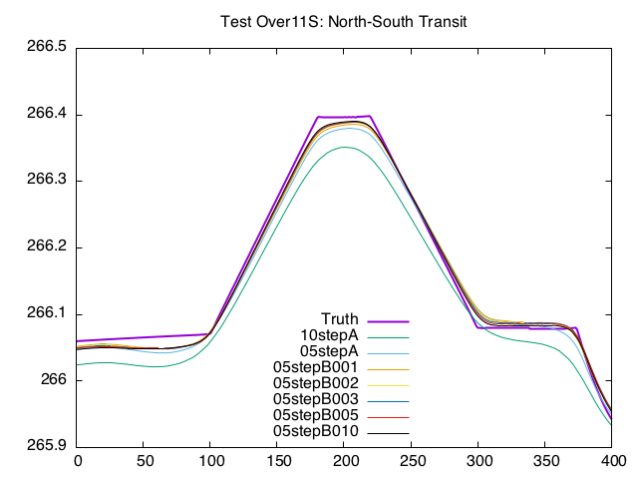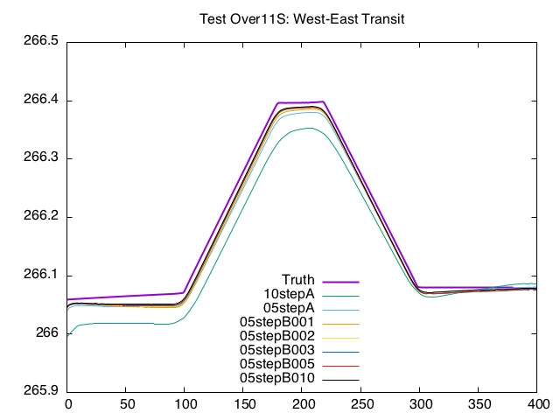
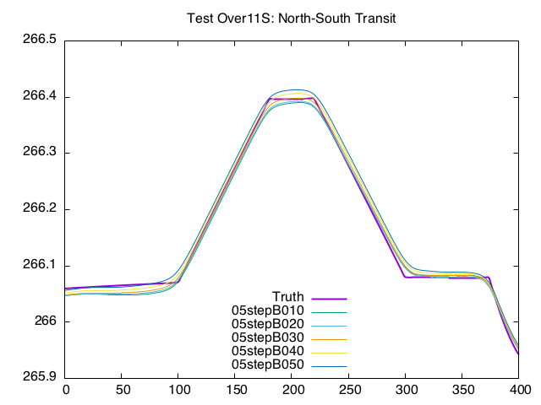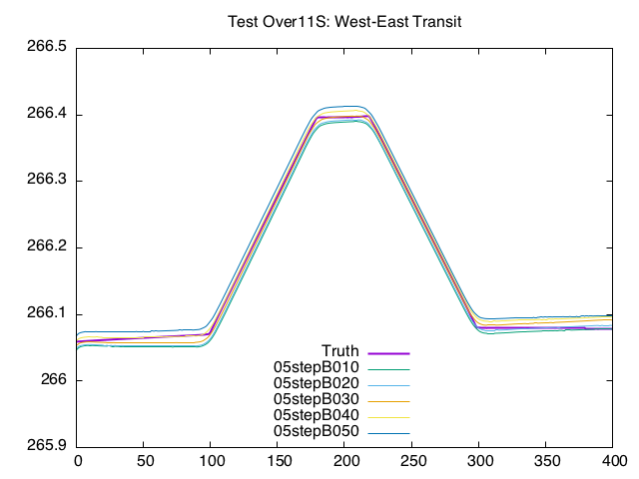
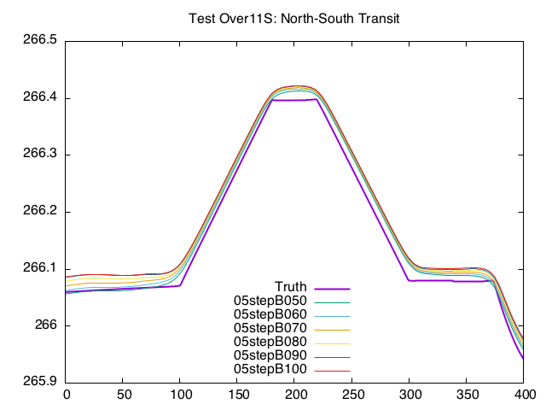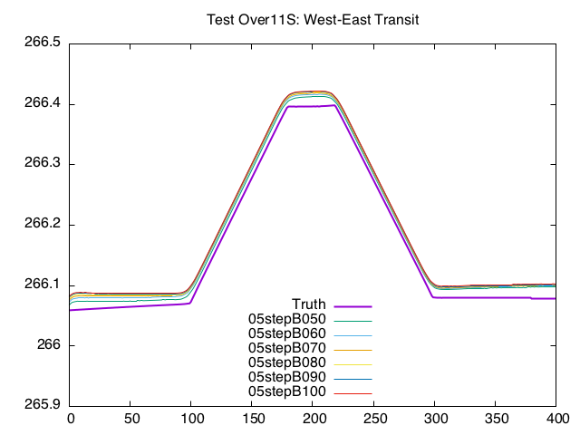
CompMapVecRMS HeatMaps:
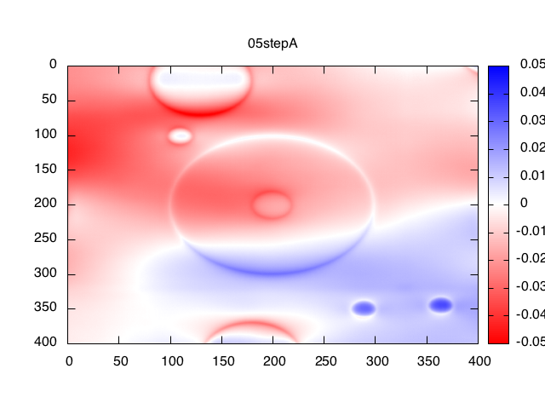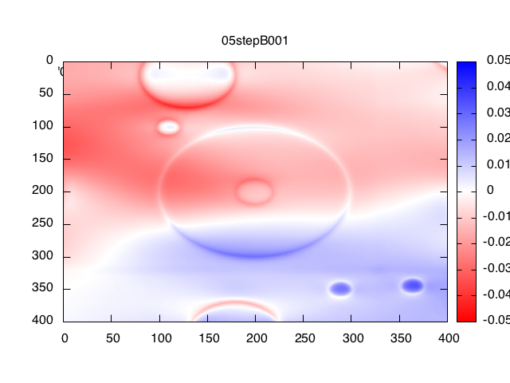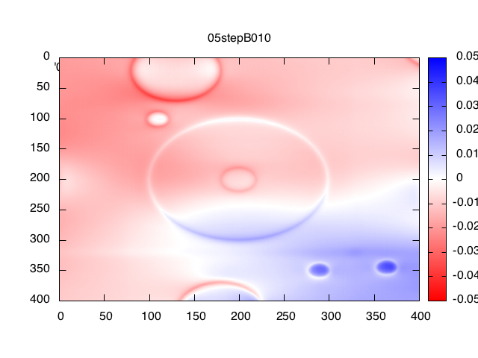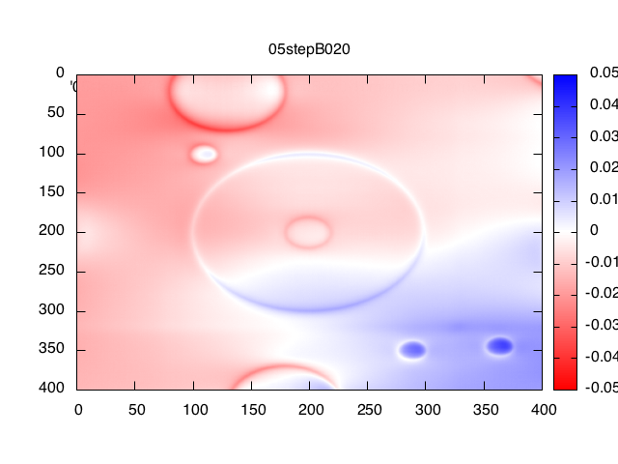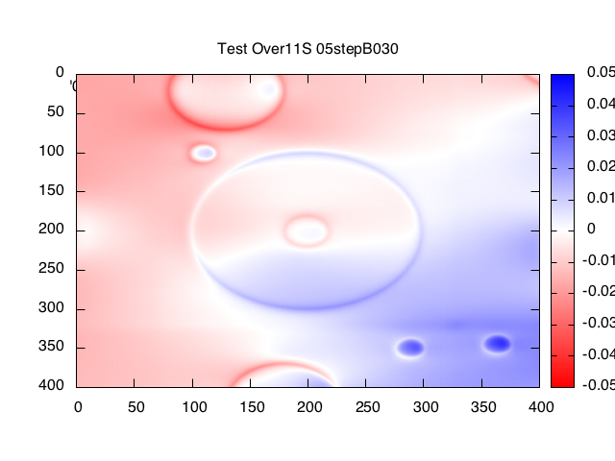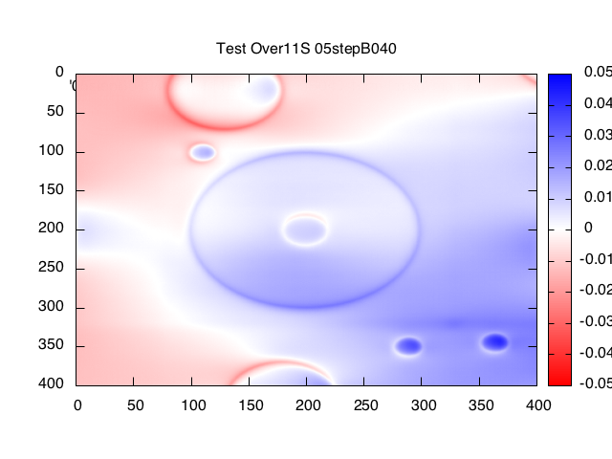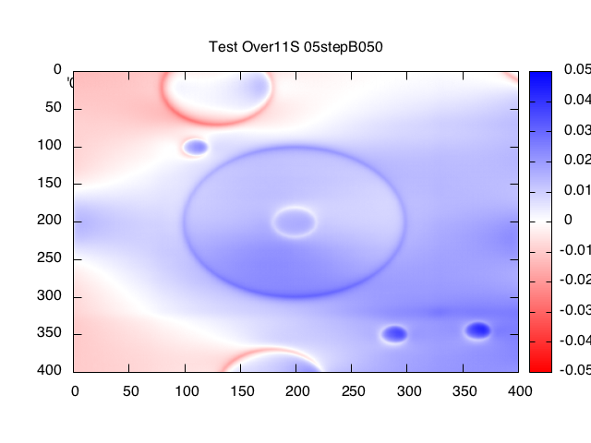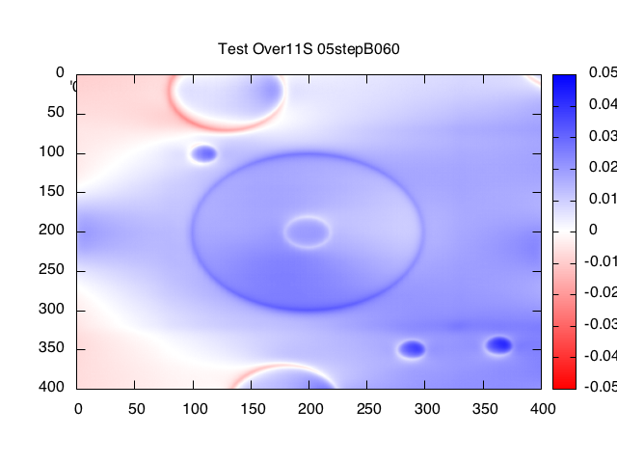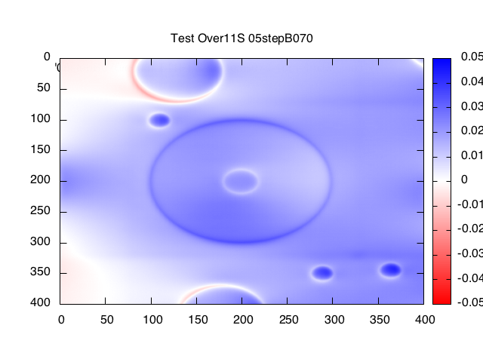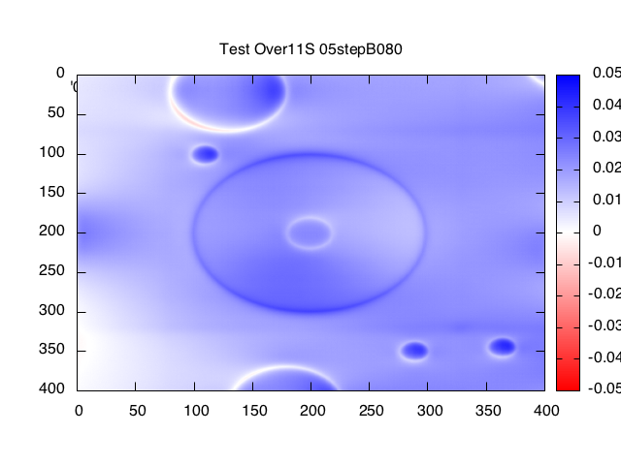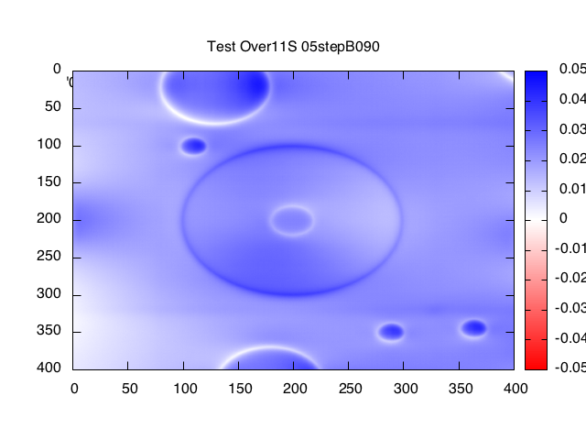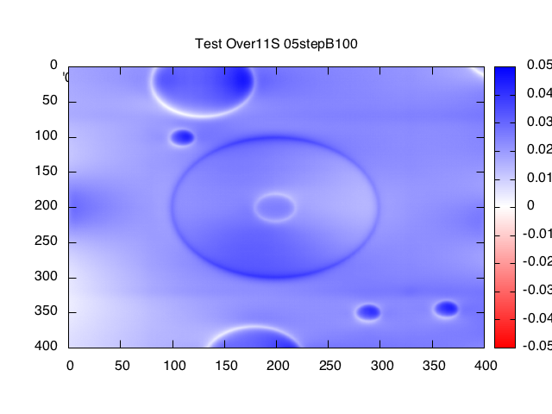
Landmark Display after 1 iteration:
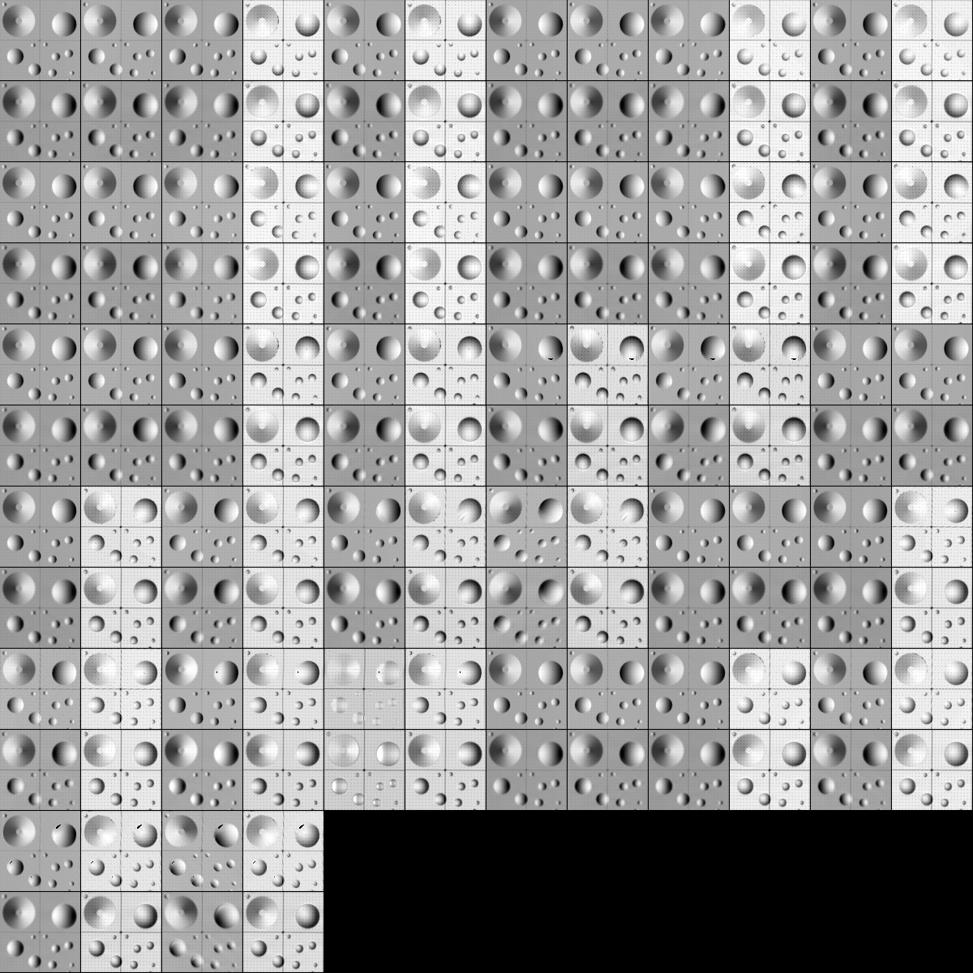
Landmark Display after 10 iterations:
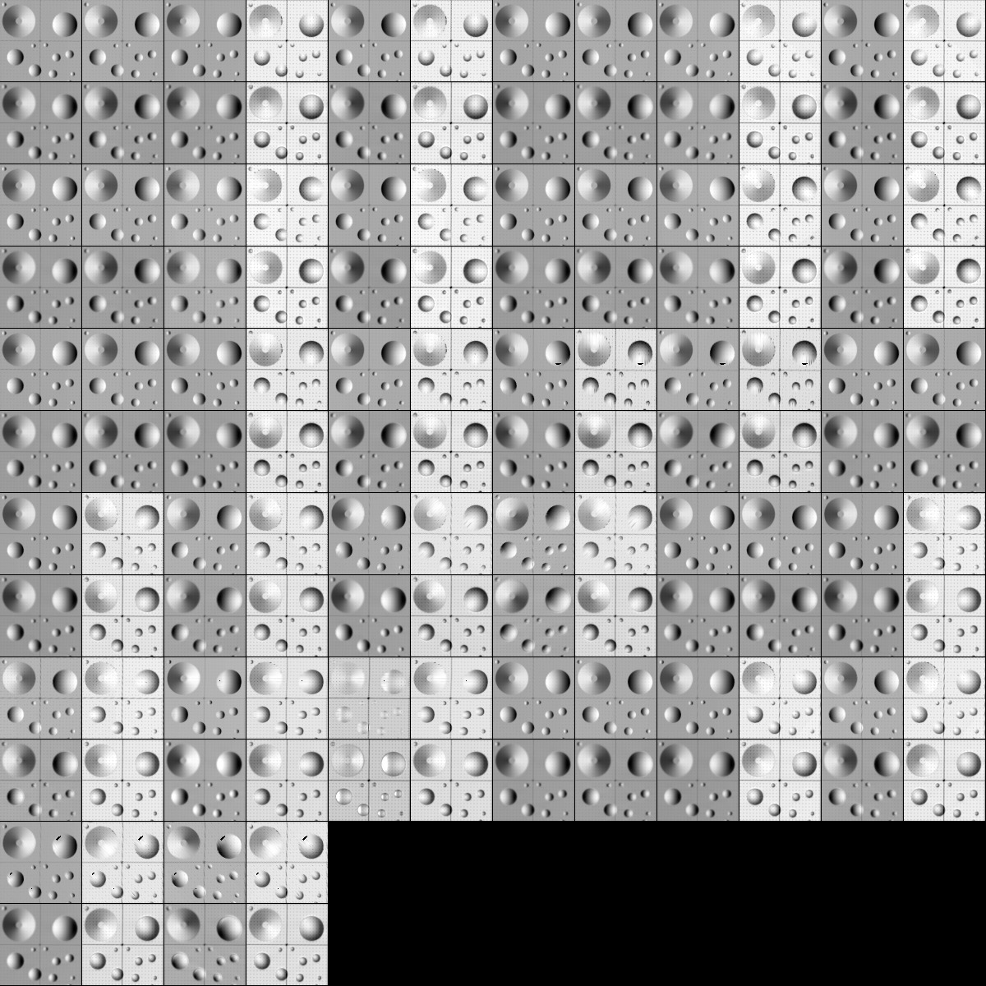
Landmark Display after 20 iterations:


