Test 11T - With Overlaps
Truth topography: flat-topped cone with 20deg slope within a landscape of cones and craters.
Evaluation bigmap parameters: GSD = 1cm, Q = 200 (width=4m), centered at REGION.MAP, 966, 1005 (pixel/line location).

Results

Tables and Figures
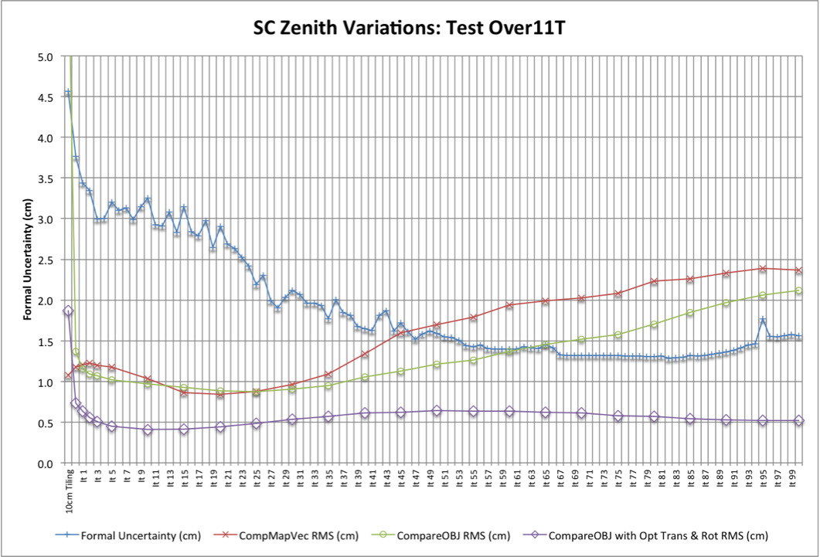
10cm Tiling:
Formal Uncertainty (cm) | CompareOBJ-RMS(cm) | CompareOBJ-RMS with Opt Trans &Rot (cm) | CompMapVec-RMS(cm)
4.566 | 6.305 | 1.868 | 1.074
5cm Tiling:
Formal Uncertainty (cm) | CompareOBJ-RMS(cm) | CompareOBJ-RMS with Opt Trans &Rot (cm) | CompMapVec-RMS(cm)
3.770 | 1.367 | 0.737 | 1.175
5cm Iterations:
Iteration | Formal Uncertainty | CompareOBJ-RMS(cm) | CompareOBJ-RMS with Opt Trans &Rot (cm) | CompMapVec-RMS(cm)
1 | 3.435 | 1.158 | 0.635 | 1.205
2 | 3.345 | 1.089 | 0.557 | 1.227
3 | 2.997 | 1.072 | 0.505 | 1.199
5 | 3.199 | 1.022 | 0.447 | 1.175
10 | 3.254 | 0.973 | 0.410 | 1.035
15 | 3.148 | 0.925 | 0.416 | 0.861
20 | 2.906 | 0.884 | 0.446 | 0.839
25 | 2.191 | 0.874 | 0.485 | 0.876
30 | 2.117 | 0.905 | 0.537 | 0.961
35 | 1.773 | 0.952 | 0.572 | 1.089
40 | 1.647 | 1.054 | 0.613 | 1.343
45 | 1.719 | 1.127 | 0.621 | 1.596
50 | 1.592 | 1.216 | 0.639 | 1.700
60 | 1.396 | 1.370 | 0.637 | 1.941
70 | 1.320 | 1.520 | 0.611 | 2.029
80 | 1.304 | 1.706 | 0.573 | 2.231
90 | 1.366 | 1.968 | 0.528 | 2.335
100 | 1.560 | 2.118 | 0.523 | 2.368
Center Traces:
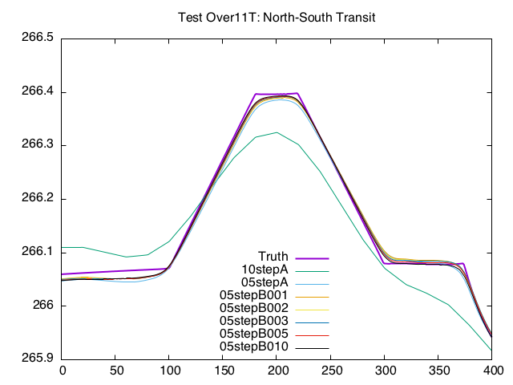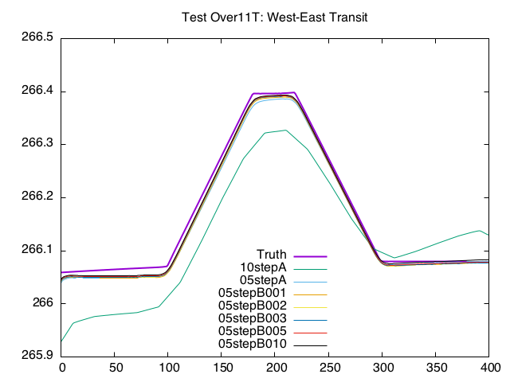
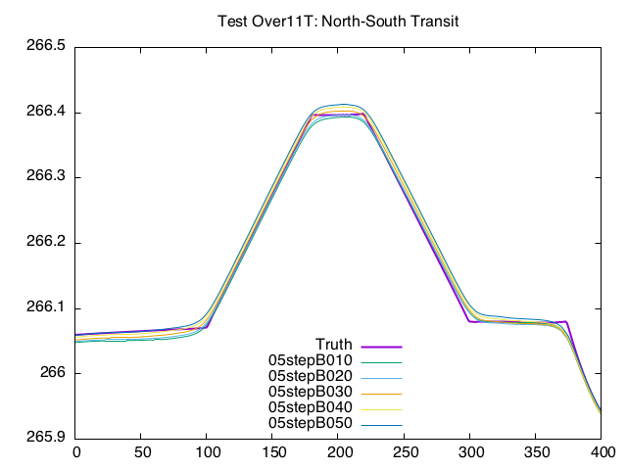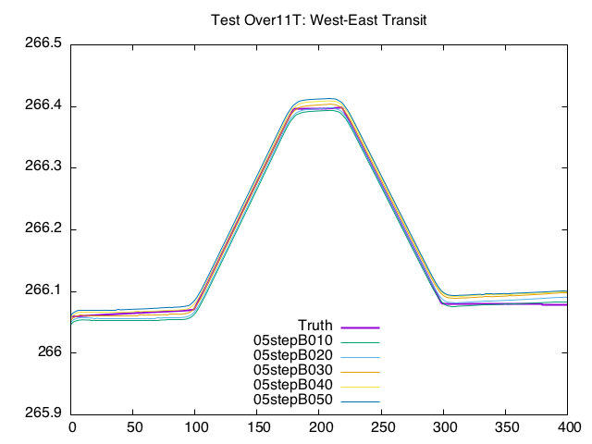
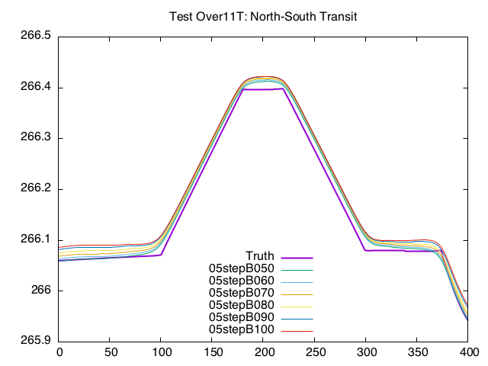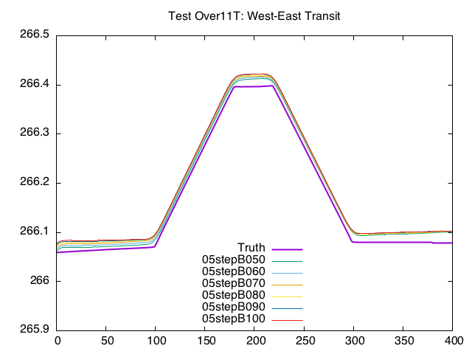
CompMapVecRMS HeatMaps:
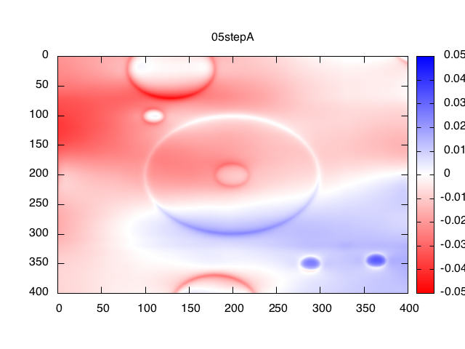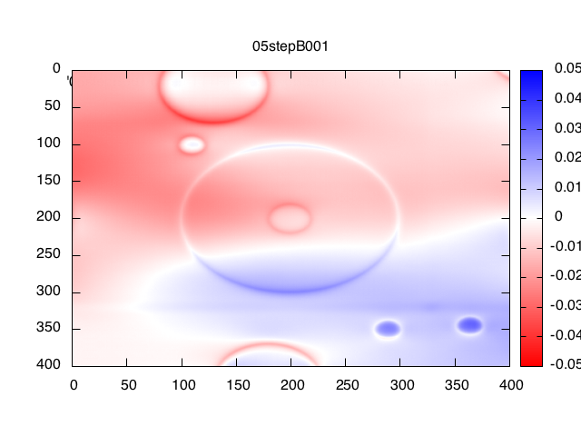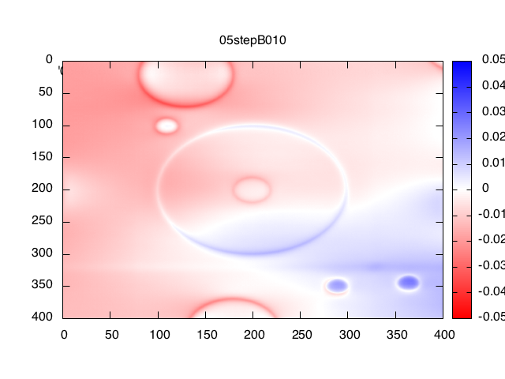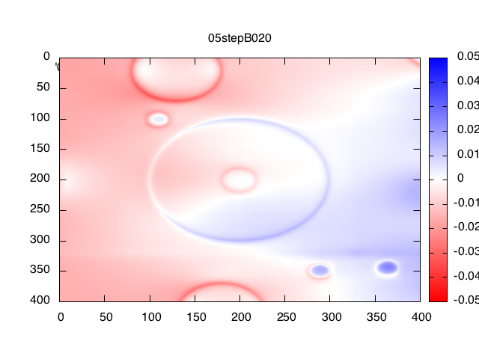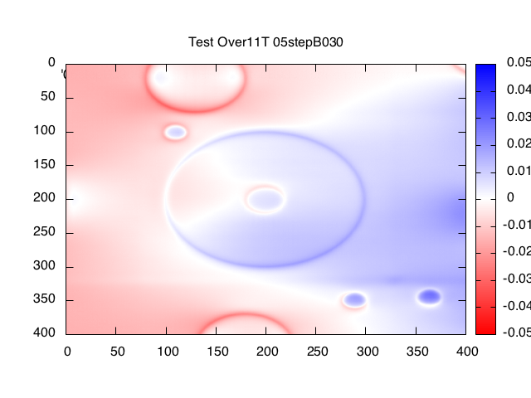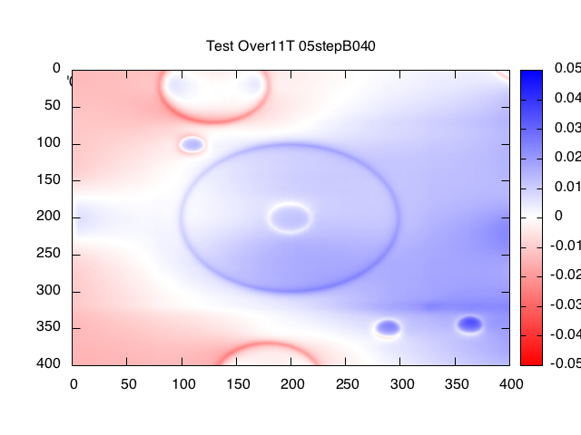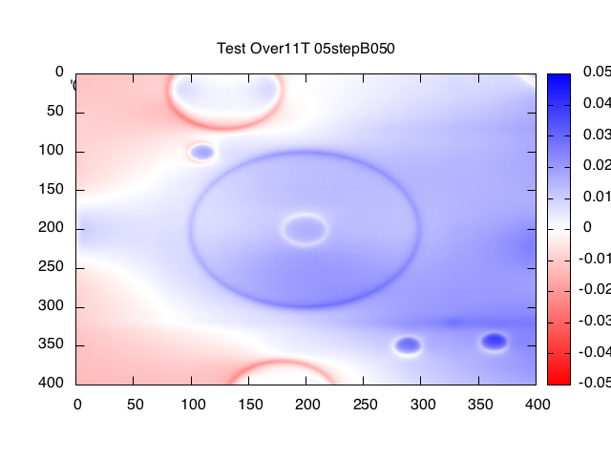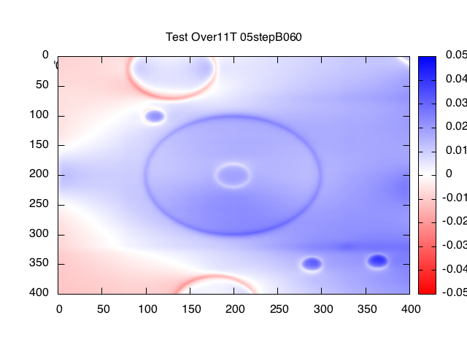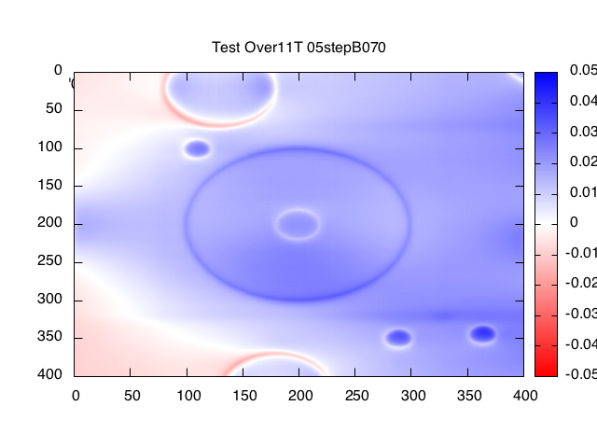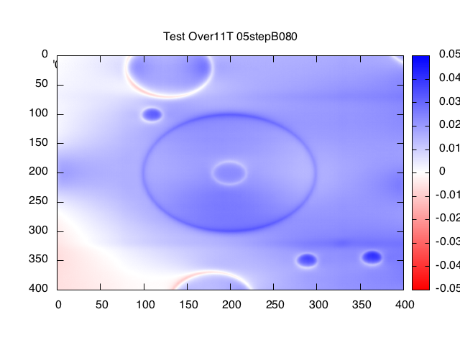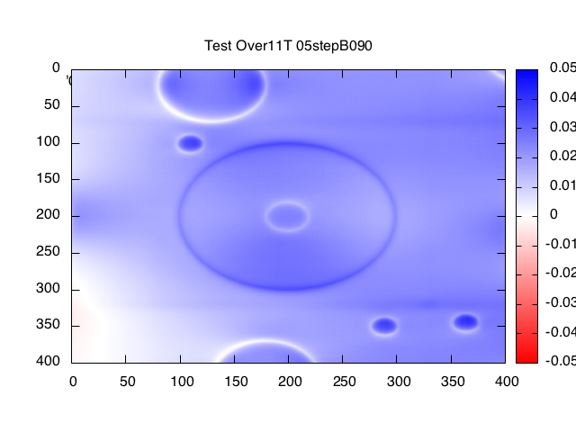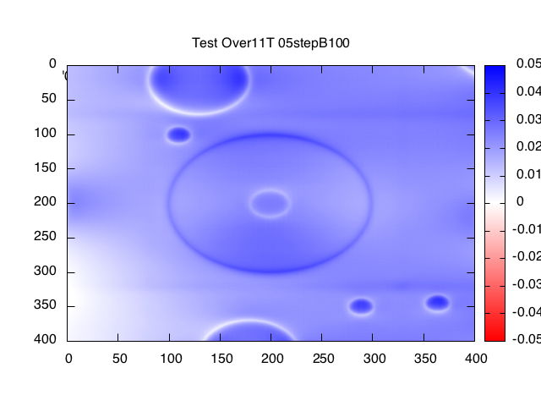
Landmark Display after 1 iteration:
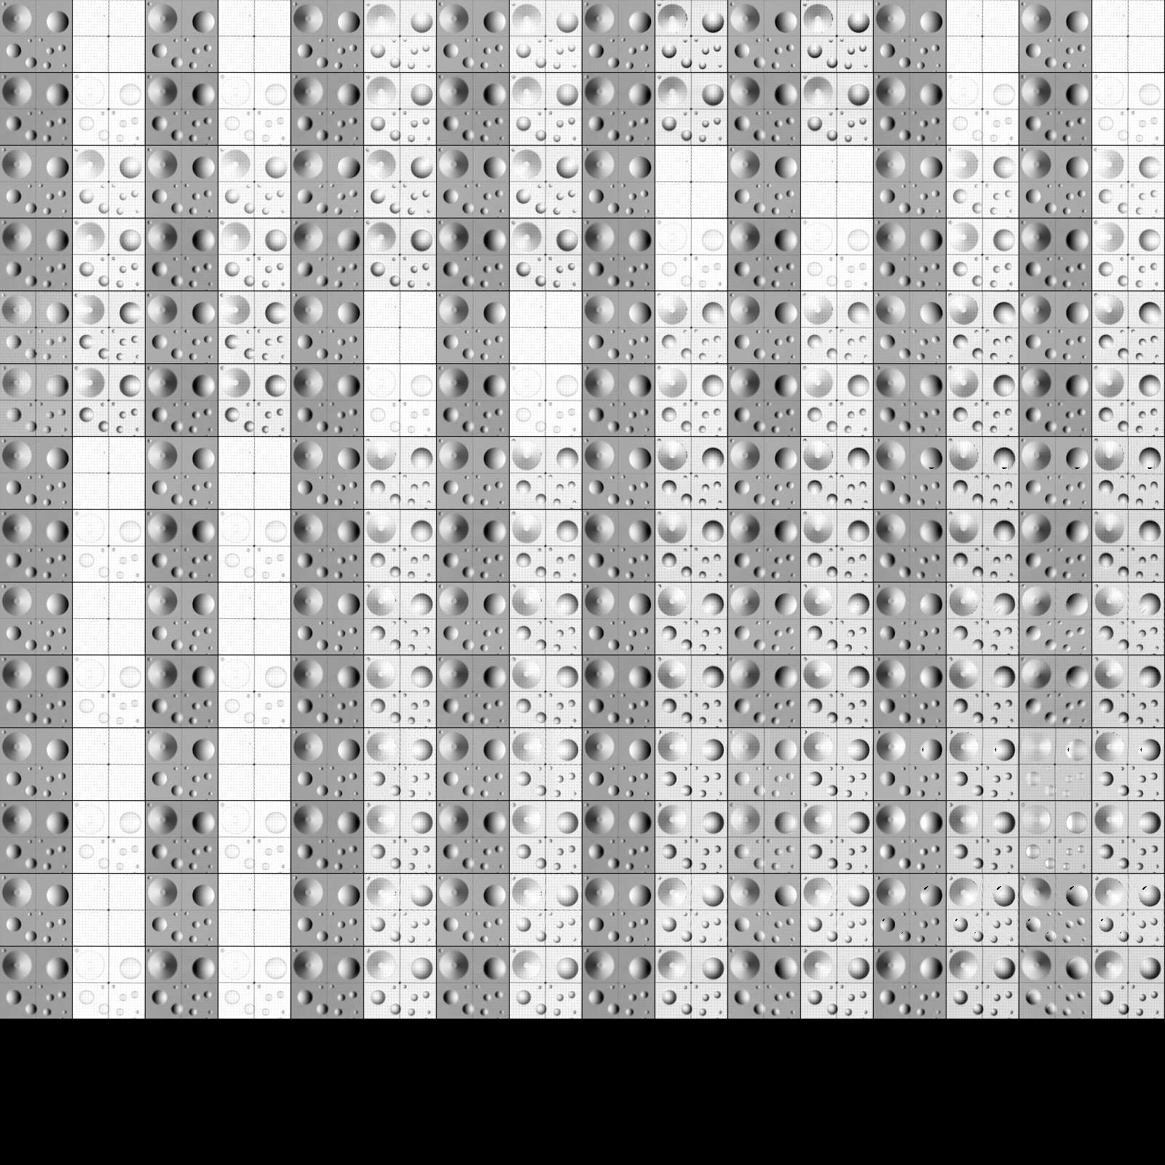
Landmark Display after 10 iterations:
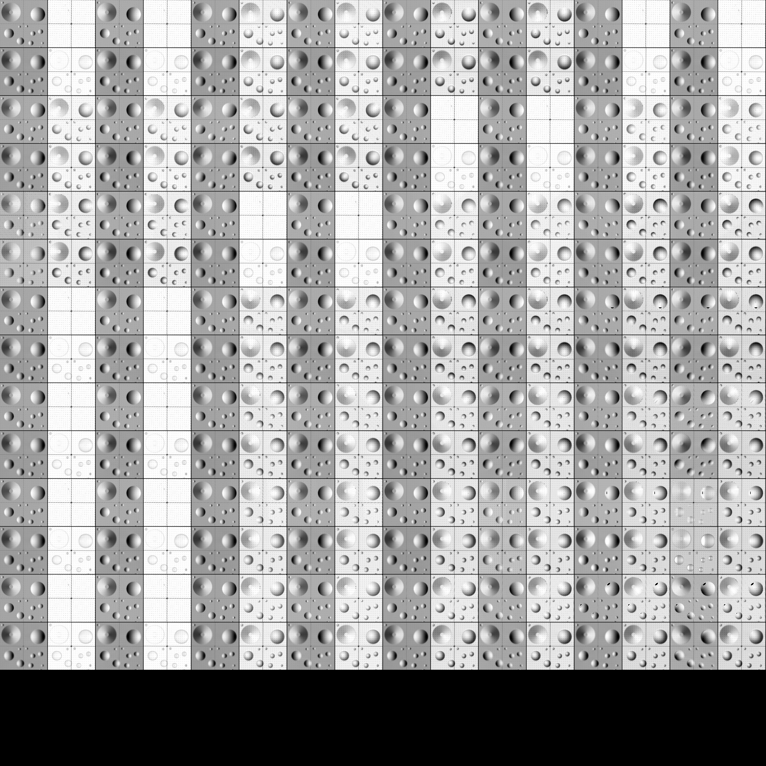
Landmark Display after 20 iterations:


