Test 11F
Truth topography: flat-topped cone with 20deg slope.
Image suite: One 5cm resolution image for each Sun&S/C combination:
- Sun at 45deg, 0, -45deg;
S/C at every 20deg Azimuth, 45deg Zenith.
Model bigmap parameters: GSD = 5cm, Q = 49 (width=4.9m).

Results
Note: Image auto-alignment conducted after iteration 30 and 50.
Iteration | CompareOBJ-RMS(cm) | CompareOBJ-RMS with Opt Trans &Rot (cm) | CompMapVec-RMS(cm) | Notes
1 | 22.39 | 5.24 | 21.22 | manual image-alignment
2 | 19.48 | 5.57 | 18.09
3 | 17.81 | 5.11 | 16.14
4 | 16.68 | 4.74 | 14.52
5 | 15.86 | 4.45 | 13.30
6 | 15.25 | 4.19 | 12.25
7 | 14.82 | 3.97 | 11.29
8 | 14.42 | 3.77 | 10.41
9 | 14.10 | 3.61 | 9.72
10 | 13.84 | 3.45 | 9.16
11 | 13.63 | 3.27 | 8.51
12 | 13.46 | 3.11 | 8.02
13 | 13.28 | 2.96 | 7.56
14 | 13.13 | 2.81 | 7.19
15 | 13.00 | 2.68 | 6.86
16 | 12.90 | 2.54 | 6.63
17 | 12.80 | 2.40 | 6.39
18 | 12.70 | 2.28 | 6.03
19 | 12.58 | 2.15 | 5.64
20 | 12.52 | 2.02 | 5.26
30 | 12.22 | 1.29 | 3.23
31 | 12.09 | 1.23 | 2.97 | images auto-aligned
40 | 12.01 | 0.77 | 1.74
50 | 11.80 | 0.81 | 0.28
51 | 11.78 | 0.82 | 0.39 | images auto-aligned
60 | 11.69 | 0.76 | 0.33
70 | 11.42 | 0.80 | 0.29
80 | 11.42 | 0.75 | 0.48
90 | 11.39 | 0.76 | 0.63
100 | 11.40 | 0.77 | 0.70
120 | 11.49 | 0.82 | 0.85
140 | 11.62 | 0.84 | 1.07
160 | 11.78 | 0.93 | 1.51
180 | 11.77 | 0.93 | 1.61
200 | 11.78 | 0.94 | 1.64
220 | 11.77 | 0.92 | 1.64
240 | 11.78 | 0.95 | 1.66
260 | 11.77 | 0.93 | 1.65
280 | 11.77 | 0.93 | 1.68
300 | 11.78 | 0.92 | 1.68
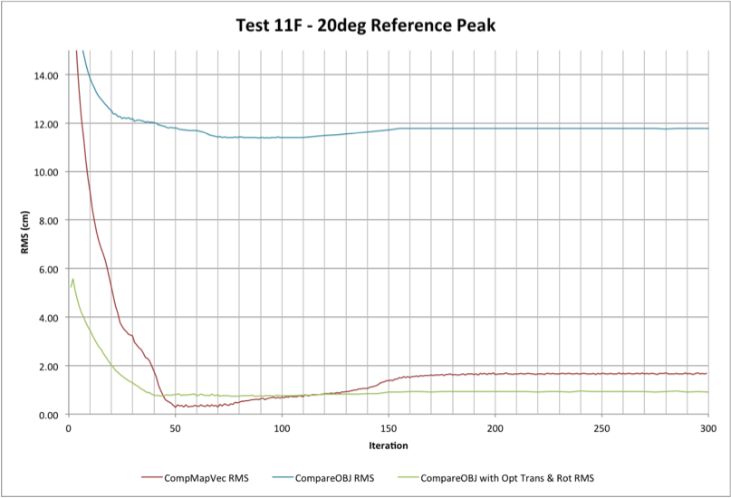
Center Traces:
Note: Image auto-alignment conducted after iteration 30 and 50.
Traces Running North-South:
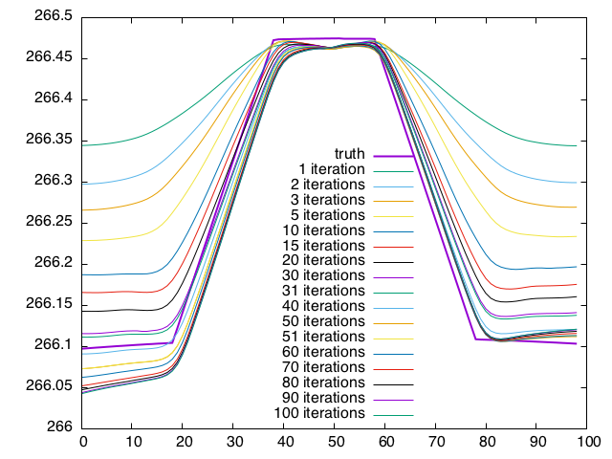
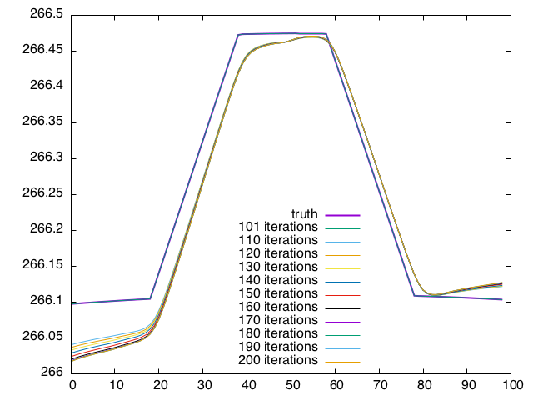
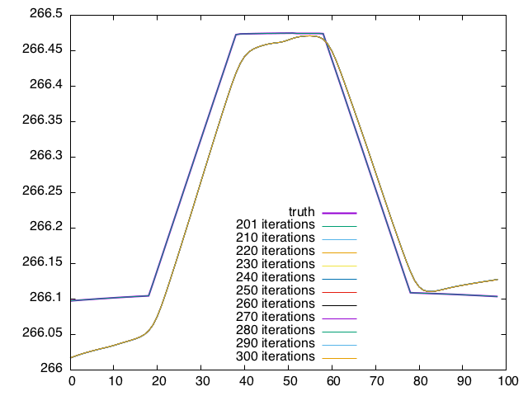
Traces Running West-East:
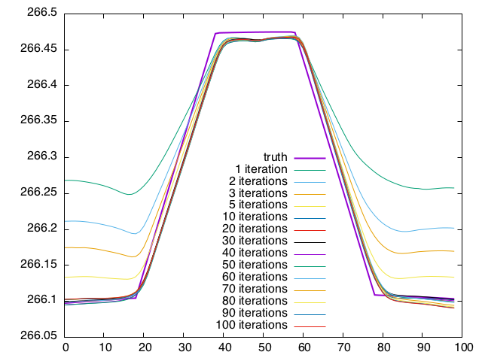
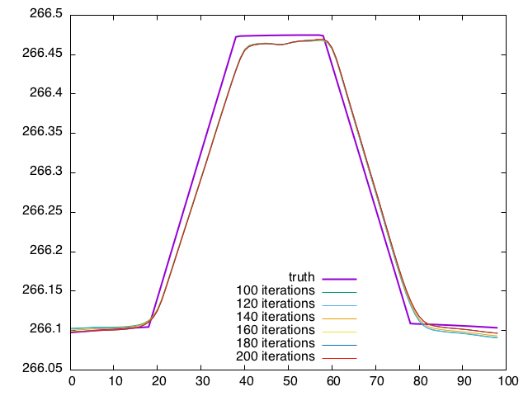
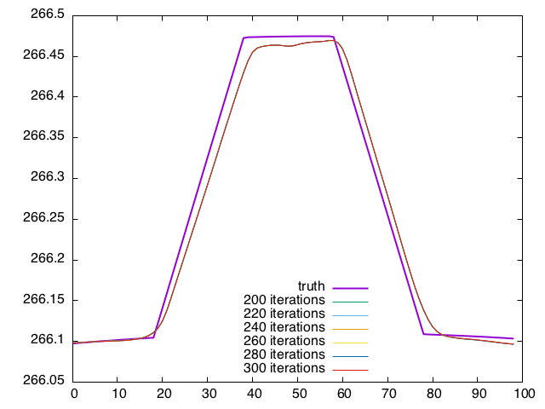
Landmark Display after 1 iteration:
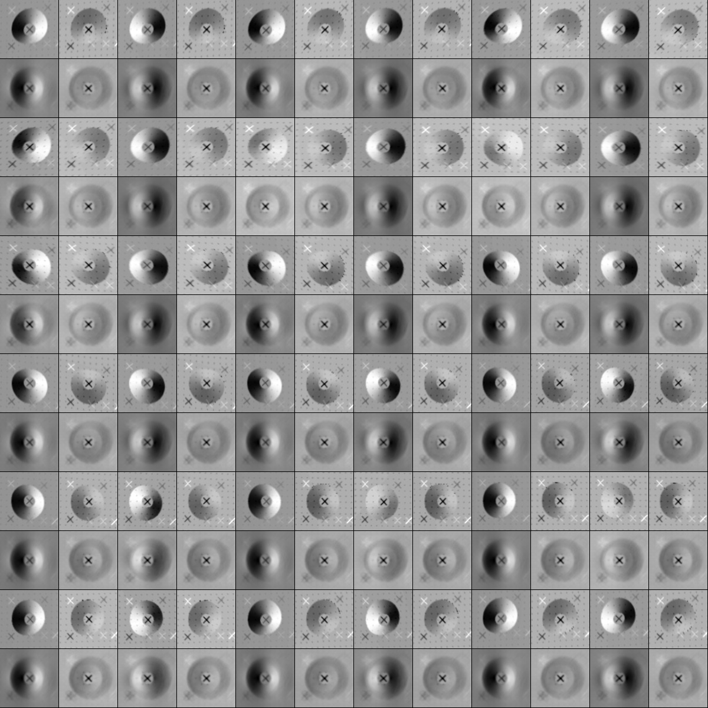
Landmark Display after 10 iterations:
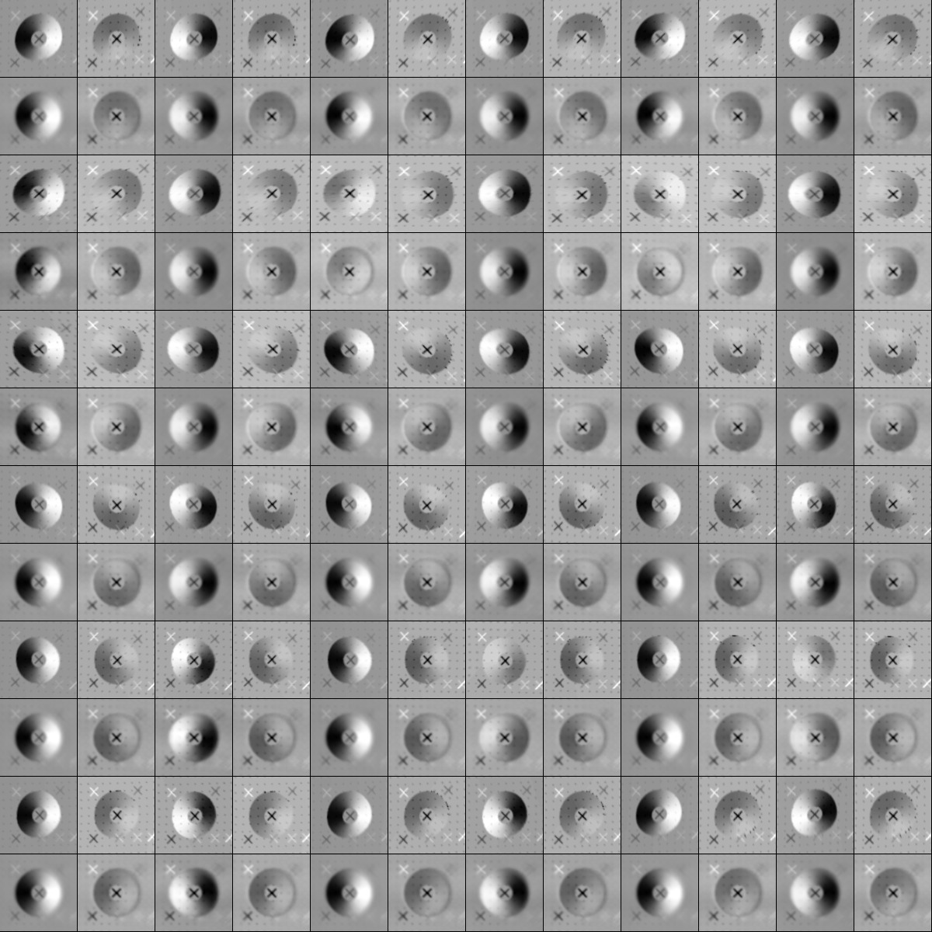
Landmark Display after 50 iterations:
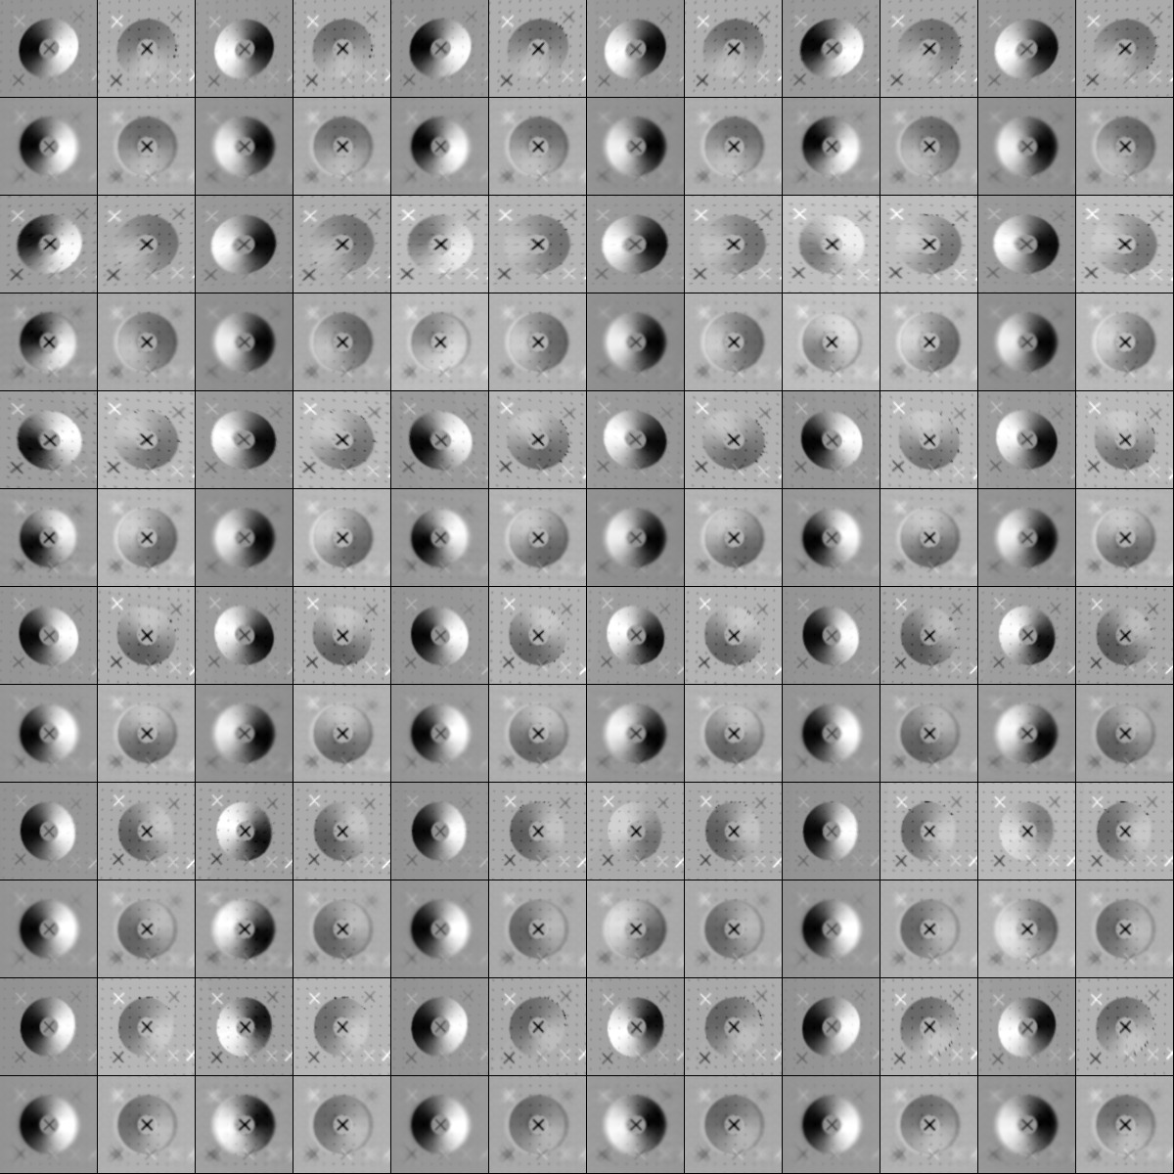
Landmark Display after 100 iterations:
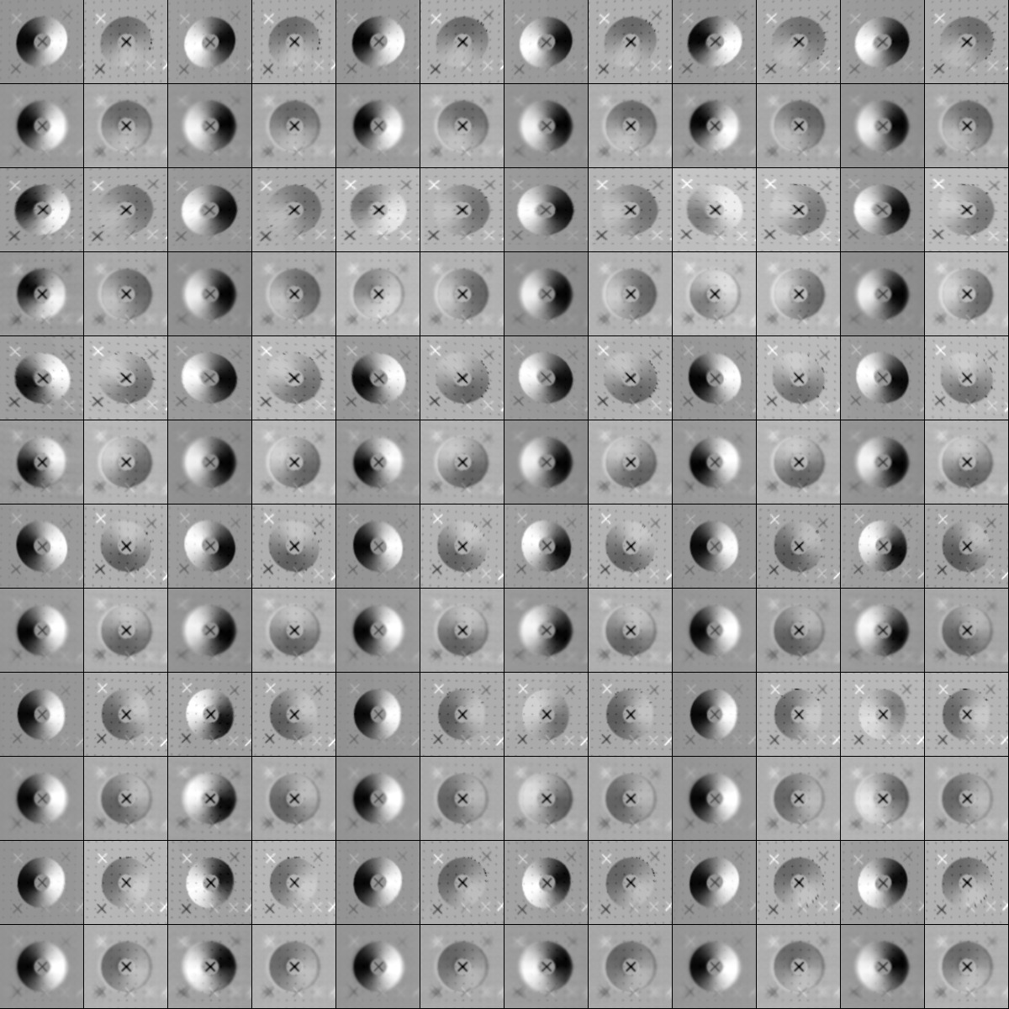
Landmark Display after 200 iterations:
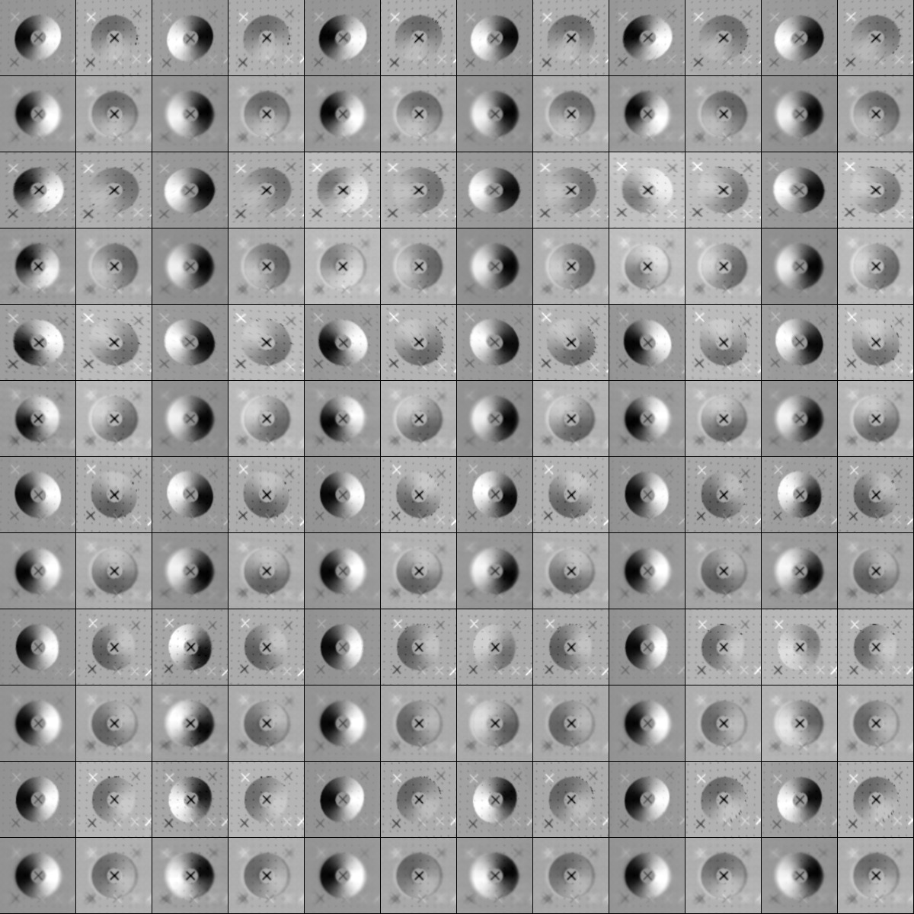
Landmark Display after 300 iterations:
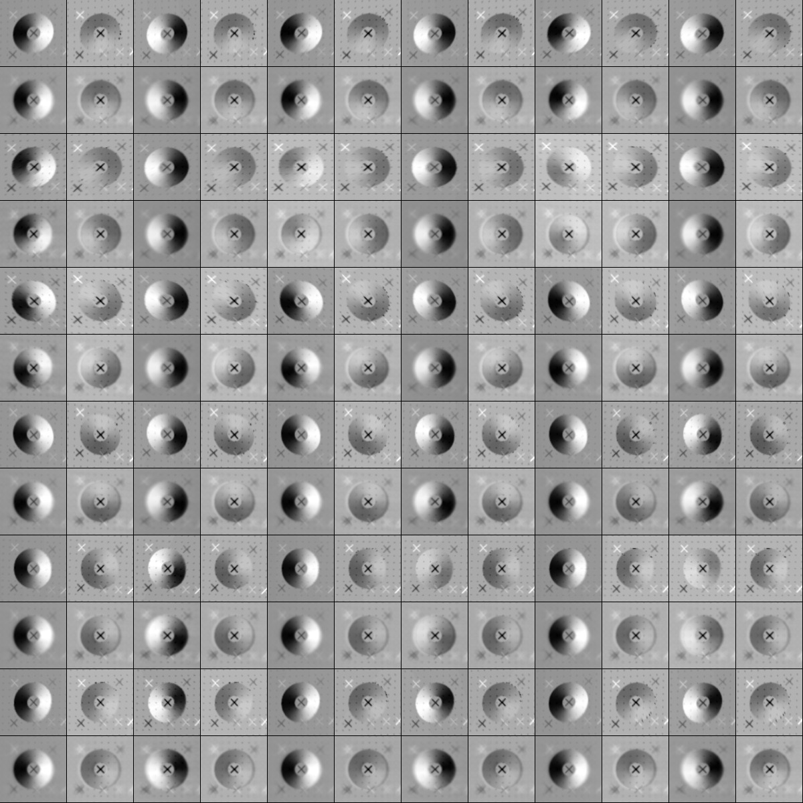
Heat Plots of CopmMapVecRMS


