Test11J:
Building topography with s/c azimuth every 90deg and 5cm images.

Results Summary:
After 10 or so iterations the maplet isn't changing much. The RMS continues to improve, mostly due to vertical displacement, but the representation of the boulder hasn't really changed much. Also note that at step07 I also did a global shift since the center had wandered, which also improved the RMS.

RMS values:
Name | CompareOBJ(cm) | CompMapVec(cm) | Notes
step01 | 22.1 | 20.6 | aligned by hand
step02 | 20.1 | 18.8
step03 | 18.6 | 17.2
step05 | 16.3 | 15.3
step06 | 15.4 | 14.6 | autoalign
step07 | 13.1 | 11.0 | aligned by hand again
step08 | 12.6 | 10.6
step10 | 11.9 | 10.1
step15 | 10.6 | 8.89
step20 | 9.80 | 7.50
step25 | 8.97 | 6.45
step30 | 8.60 | 5.94
step40 | 8.14 | 6.04
step41 | 8.11 | 5.91 | start autoalign
step45 | 6.04 | 2.82
step50 | 5.94 | 2.79
step60 | 5.97 | 3.03
step70 | 5.95 | 2.73 | used x .025

Traces:
step01 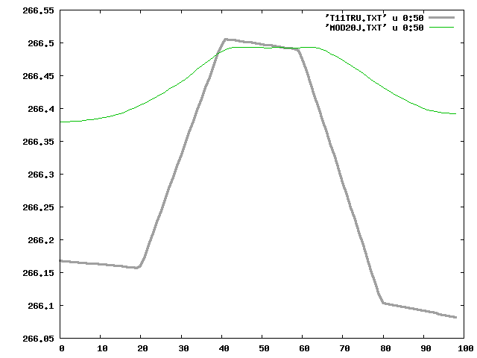 step02 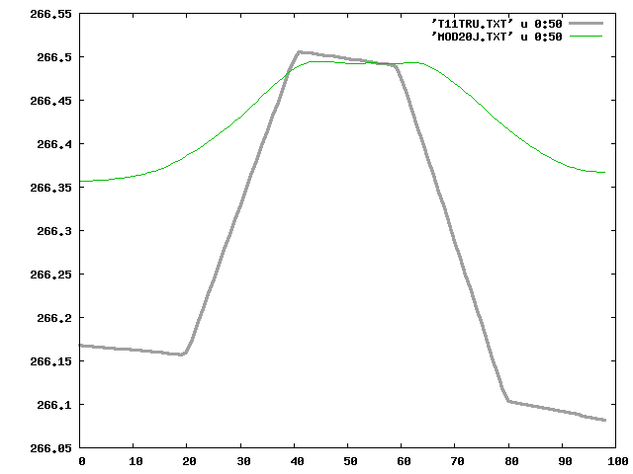 step03 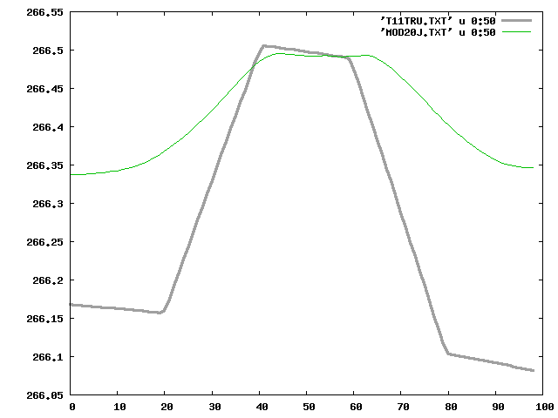 step05 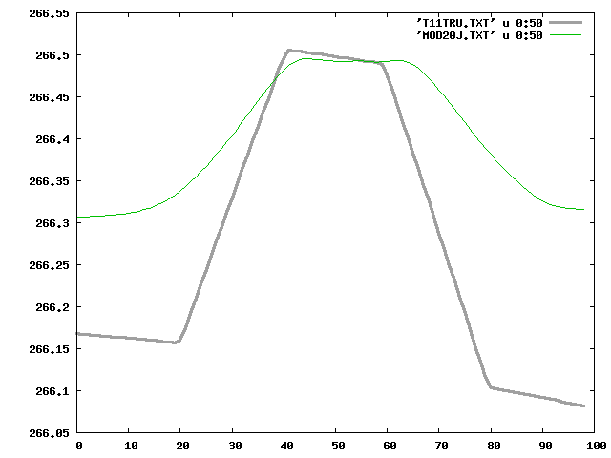 step06 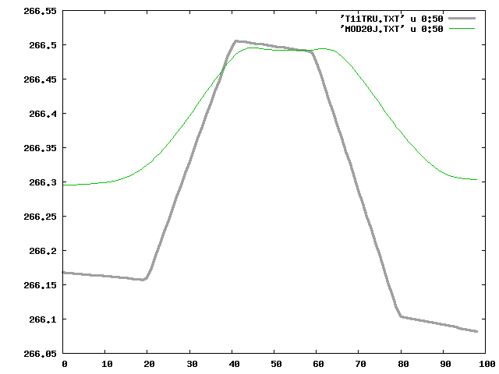 step07 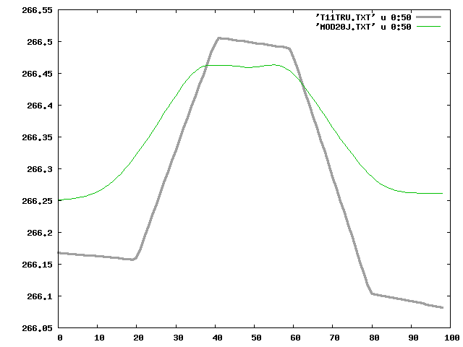 step08 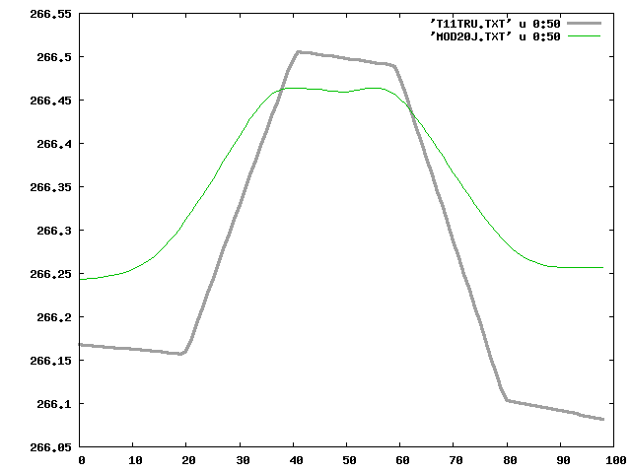 step10 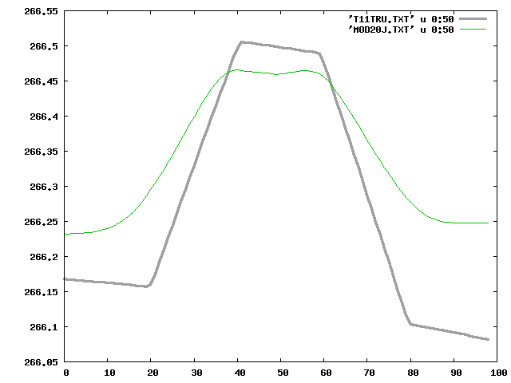 step15 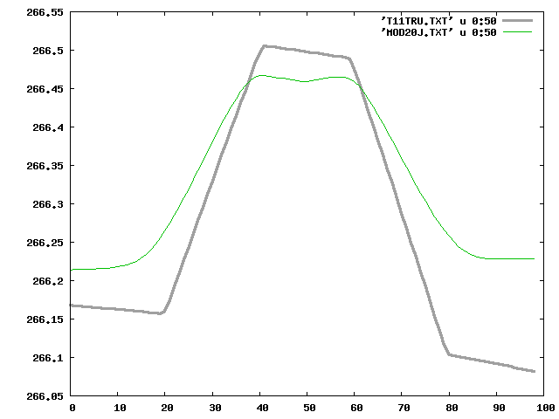 step20 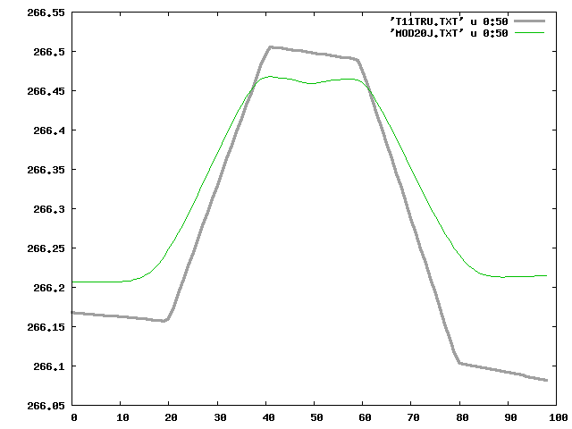 step25 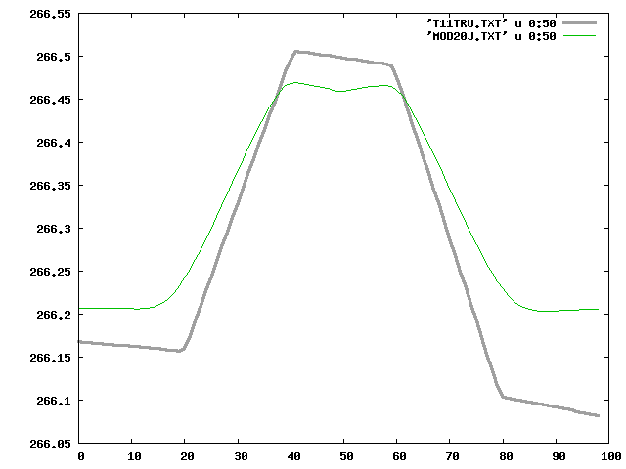 step30 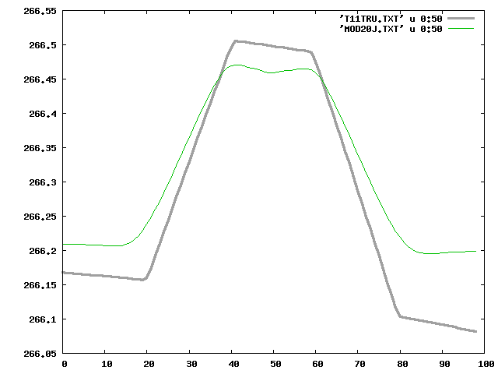 step40 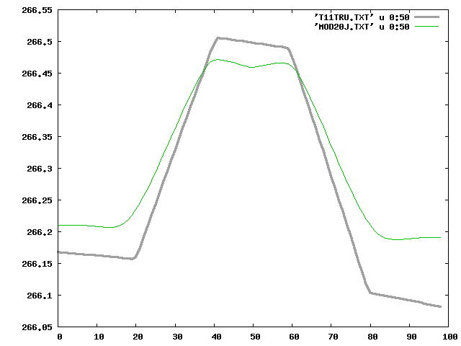 step45 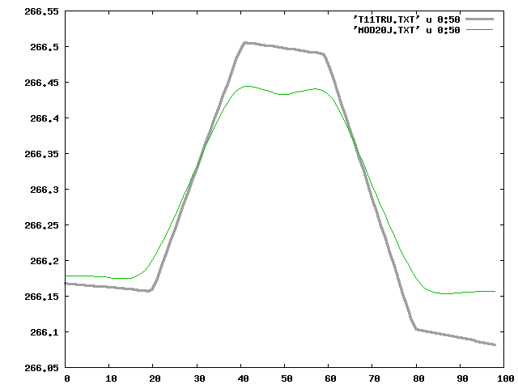 step50 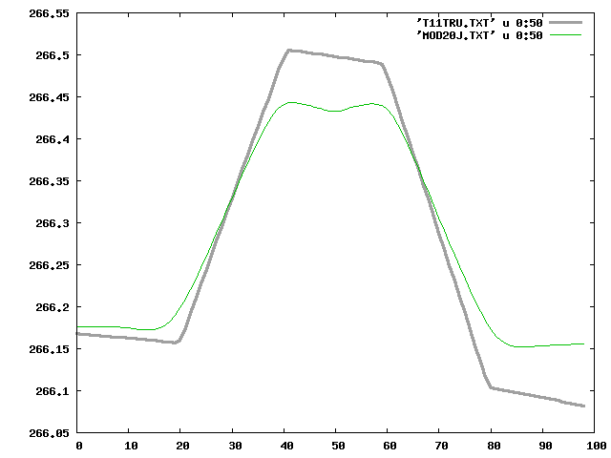 step60 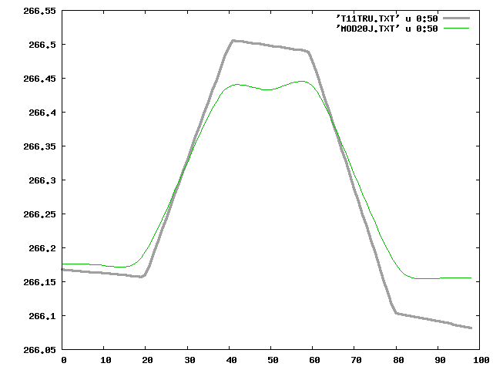 step70 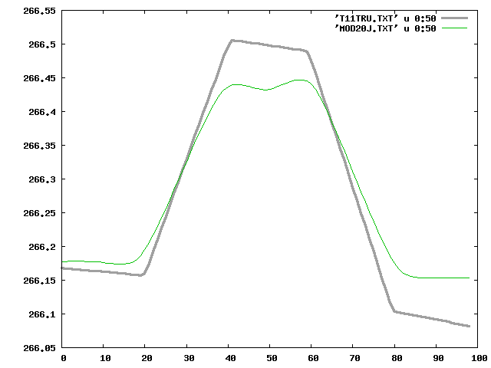

Landmark Display:
step01 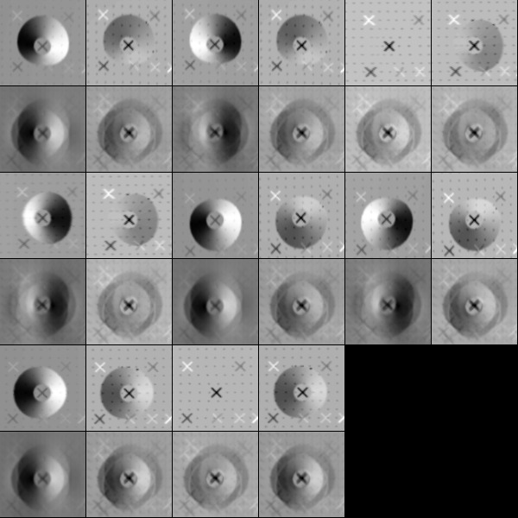 step70 

