Data Set
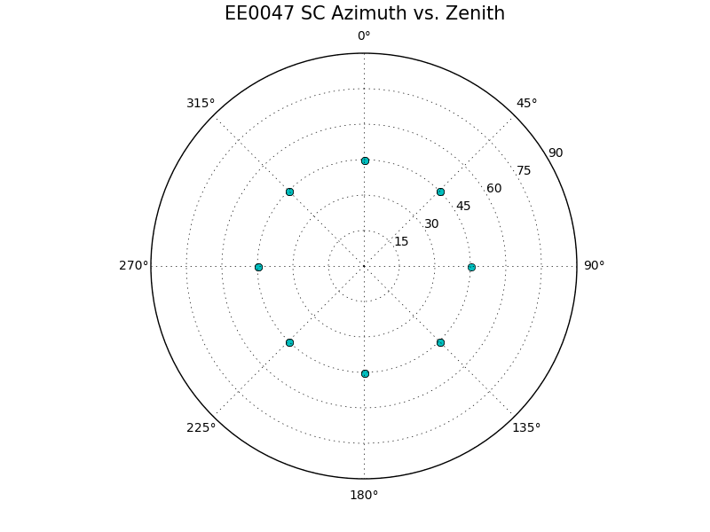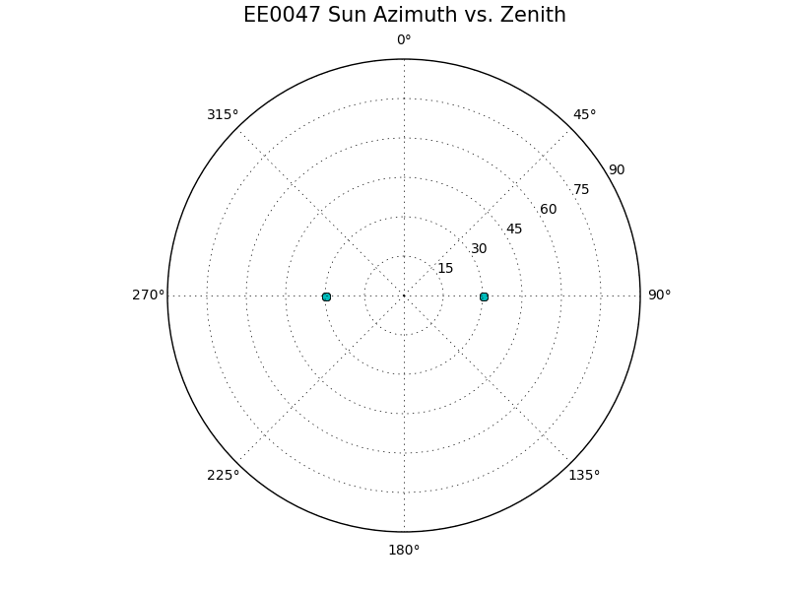

Transits
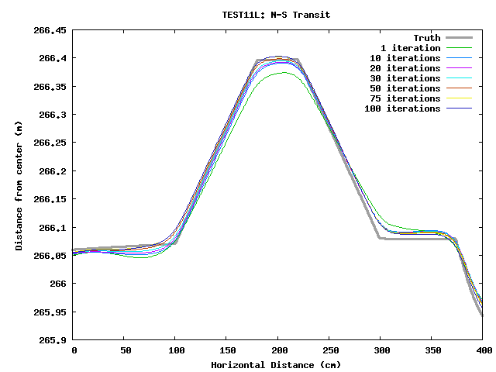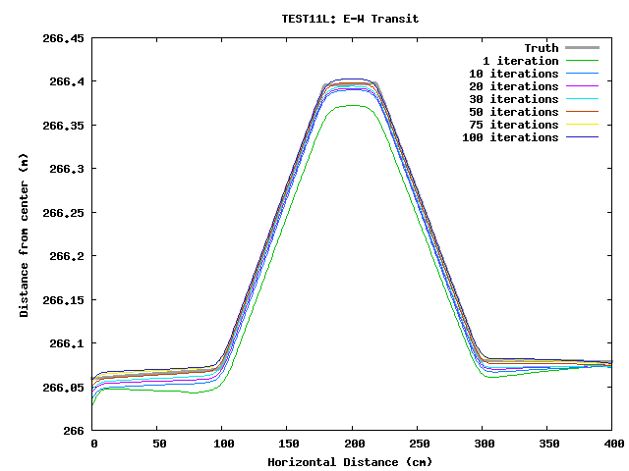
The solution starts off a bit low, but by iteration 10 the solution is changing slowly. Later iterations actually increase the height above the truth.

Heat Maps (x and y is in units of pixels, z is deviation from truth and has units of meters)
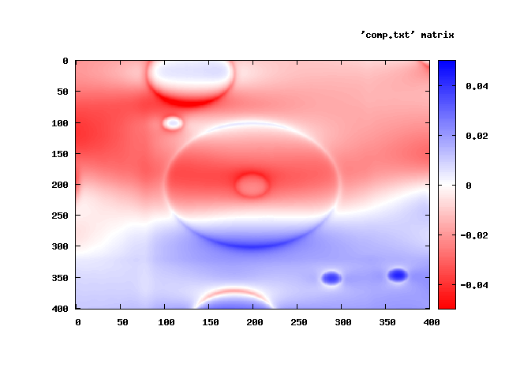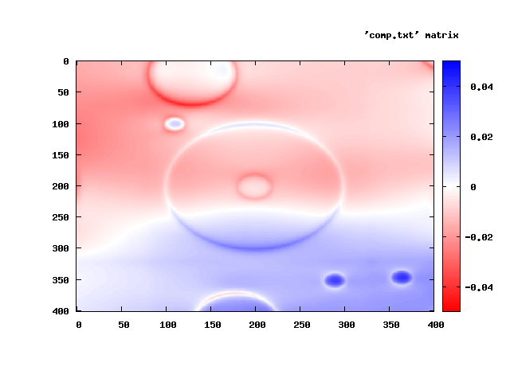
iterations 001 and 010:
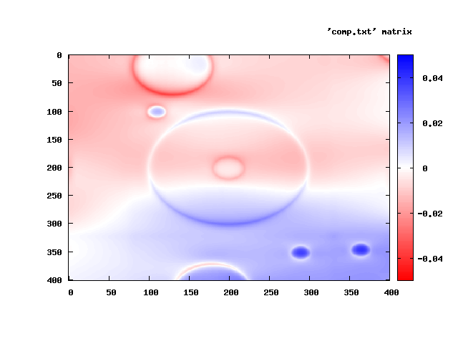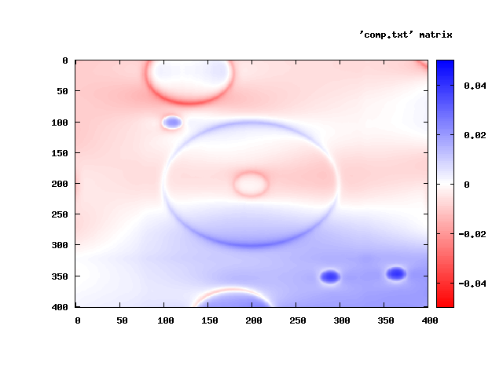
iterations 020 and 030:
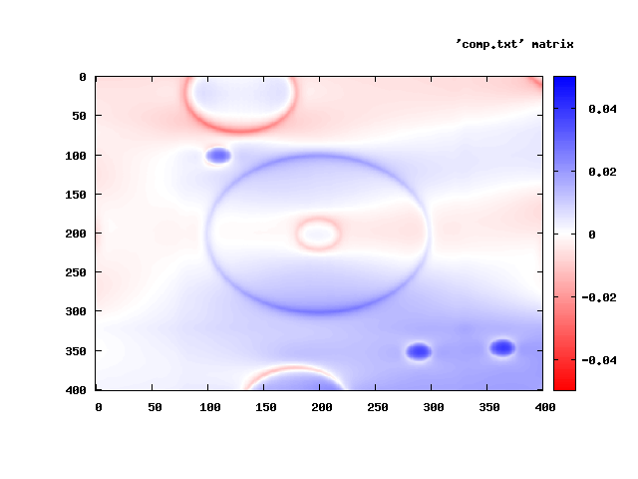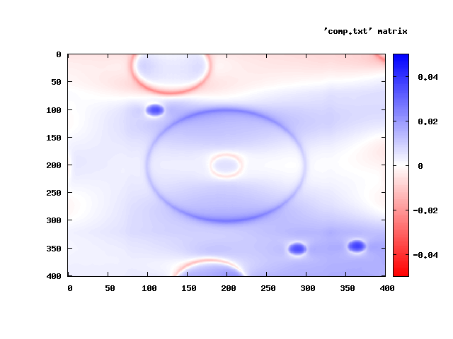
iterations 050 and 075:
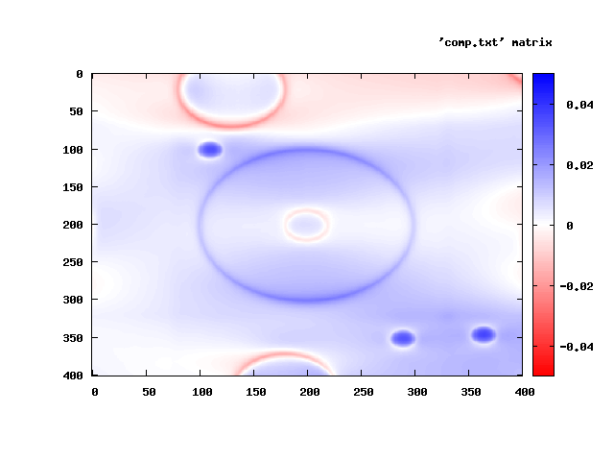
iteration 100: The tilt isn't too bad anymore, but the north is still lower and the south higher than truth.

