Test11N:
Building topography with Sun position at 30, 0, -30, S/C Az every 45, S/C zenith 45

Results Summary:
CompareOBJ with translate is probably meaningless. CompareOBJ without translate is better, but is still quite different from compMapVec (10cm vs 1cm). Once I started auto aligning the top of the boulder dropped down.

RMS Values:
STEP | COMPAREOBJ(cm)(w/ trans) | CompareOBJ (cm) w/o trans | compMapVec(cm) | NOTES
step01 | 1.73 | ND | 32.9 | align by hand
step02 | 2.79 | 29.1 | 30.1
step03 | 3.62 | 27.2 | 27.7
step05 | 4.89 | 24.1 | 24.0
step10 | 5.21 | 19.7 | 18.8
step15 | 4.44 | 17.5 | 15.5 | start autoalign at 16
step20 | 3.89 | 15.2 | 11.2
step30 | 3.03 | 14.3 | 8.88
step40 | 2.21 | 13.9 | 7.58
step50 | 1.72 | 13.3 | 6.17
step100 | 0.96 | 13.4 | 3.66
step150 | 1.33 | 12.8 | 0.32 | CompMapVec dropped 10x
step200 | 1.74 | 12.4 | 1.46 | CompMapVec increased

Traces:
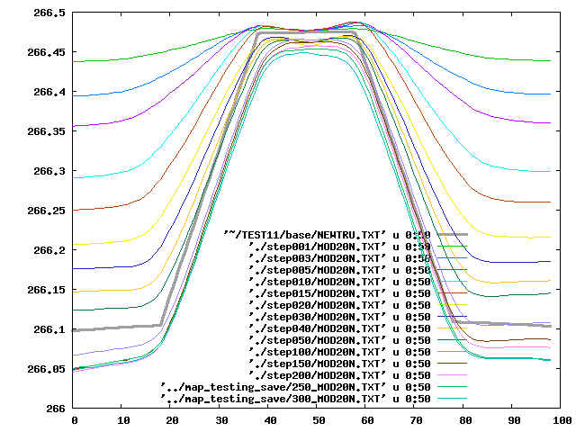

Landmark Display:
step01 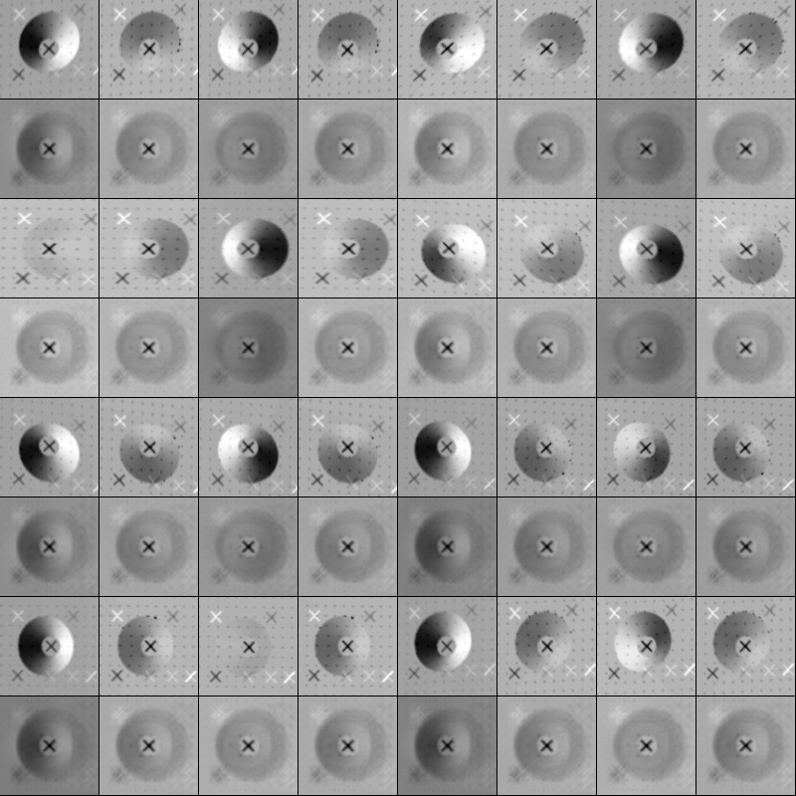
step200 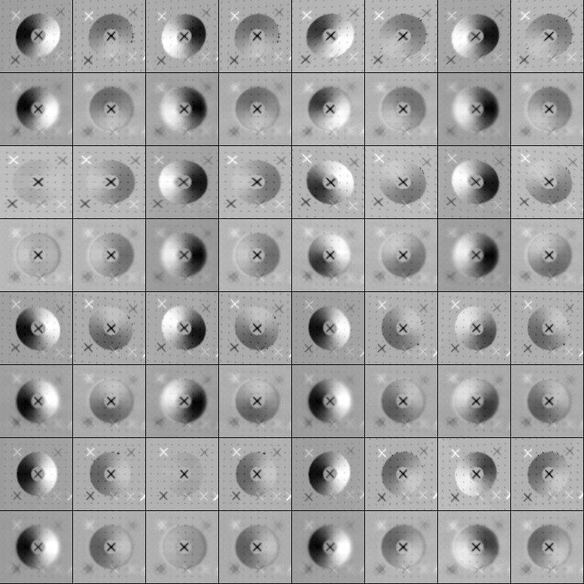
step300 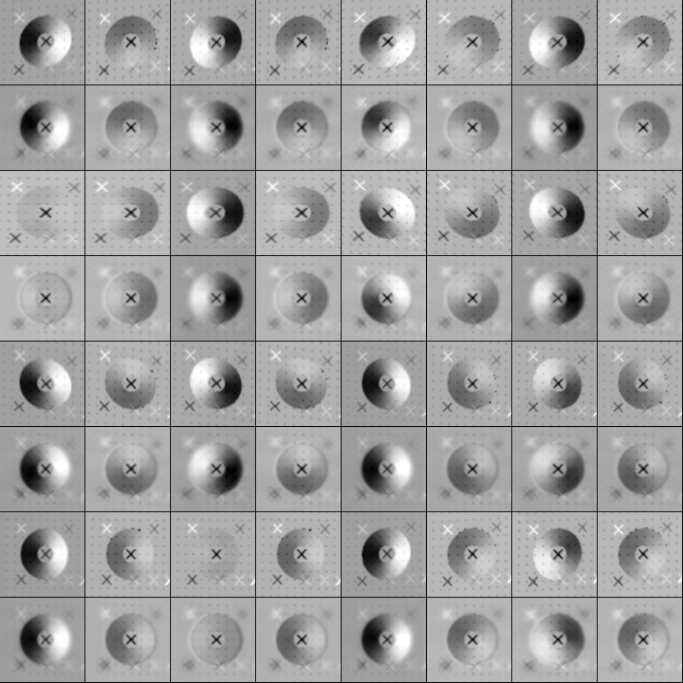

Run the model even further:
Run the model out many iterations further and track the RMS for CompareOBJ with and without translate.
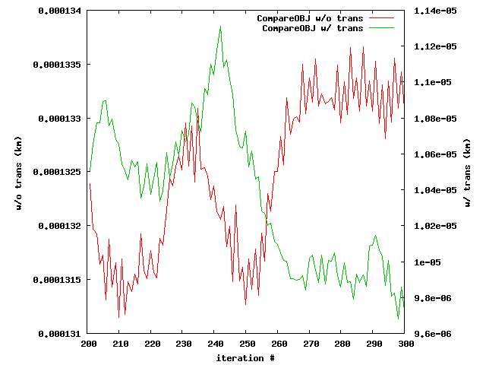
step300 

