Test 11U Results
Truth topography: flat-topped cone with 20deg slope. Model bigmap parameters: GSD = 5cm, Q = 49 (width=4.9m).
Note: Image auto-alignment conducted after iteration 30 and 50.
Iteration | CompareOBJ-RMS(cm) | CompareOBJ-RMS with Opt Trans &Rot (cm) | CompMapVec-RMS(cm) | Notes
1 | 23.51 | 5.01 | 21.73 | manual image-alignment
2 | 18.90 | 5.17 | 15.55
3 | 16.16 | 4.43 | 11.42
4 | 14.31 | 3.86 | 8.21
5 | 13.00 | 3.41 | 5.76
6 | 11.91 | 3.02 | 3.61
7 | 11.02 | 2.67 | 1.83
8 | 10.28 | 2.39 | 0.29
9 | 9.62 | 2.14 | 1.09
10 | 9.03 | 1.91 | 2.24
11 | 8.51 | 1.70 | 3.20
12 | 8.04 | 1.51 | 4.08
13 | 7.65 | 1.35 | 4.90
14 | 7.30 | 1.21 | 5.66
15 | 7.00 | 1.07 | 6.32
16 | 6.73 | 0.96 | 6.87
17 | 6.50 | 0.85 | 7.38
18 | 6.30 | 0.76 | 7.88
19 | 6.14 | 0.72 | 8.26
20 | 6.02 | 0.64 | 8.62
30 | 5.86 | 0.64 | 10.65
31 | 5.83 | 0.66 | 10.27 | images auto-aligned
40 | 6.13 | 0.80 | 10.58
50 | 5.32 | 0.93 | 10.75
51 | 6.31 | 0.93 | 10.33 | images auto-aligned
60 | 6.42 | 0.96 | 10.66
70 | 6.47 | 0.99 | 10.92
80 | 6.55 | 1.01 | 10.99
90 | 6.62 | 1.03 | 11.13
100 | 6.72 | 1.02 | 11.19
Center Traces:
Note: Image auto-alignment conducted after iteration 30 and 50.
Traces Running North-South:
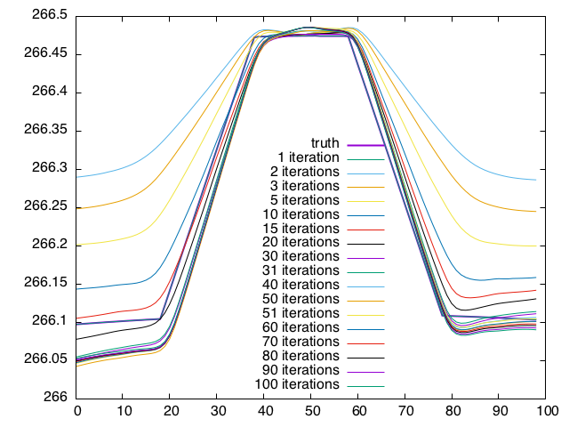
Traces Running West-East:
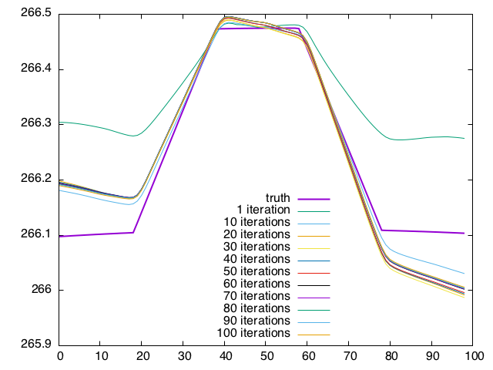
Landmark Display after 1 iteration:
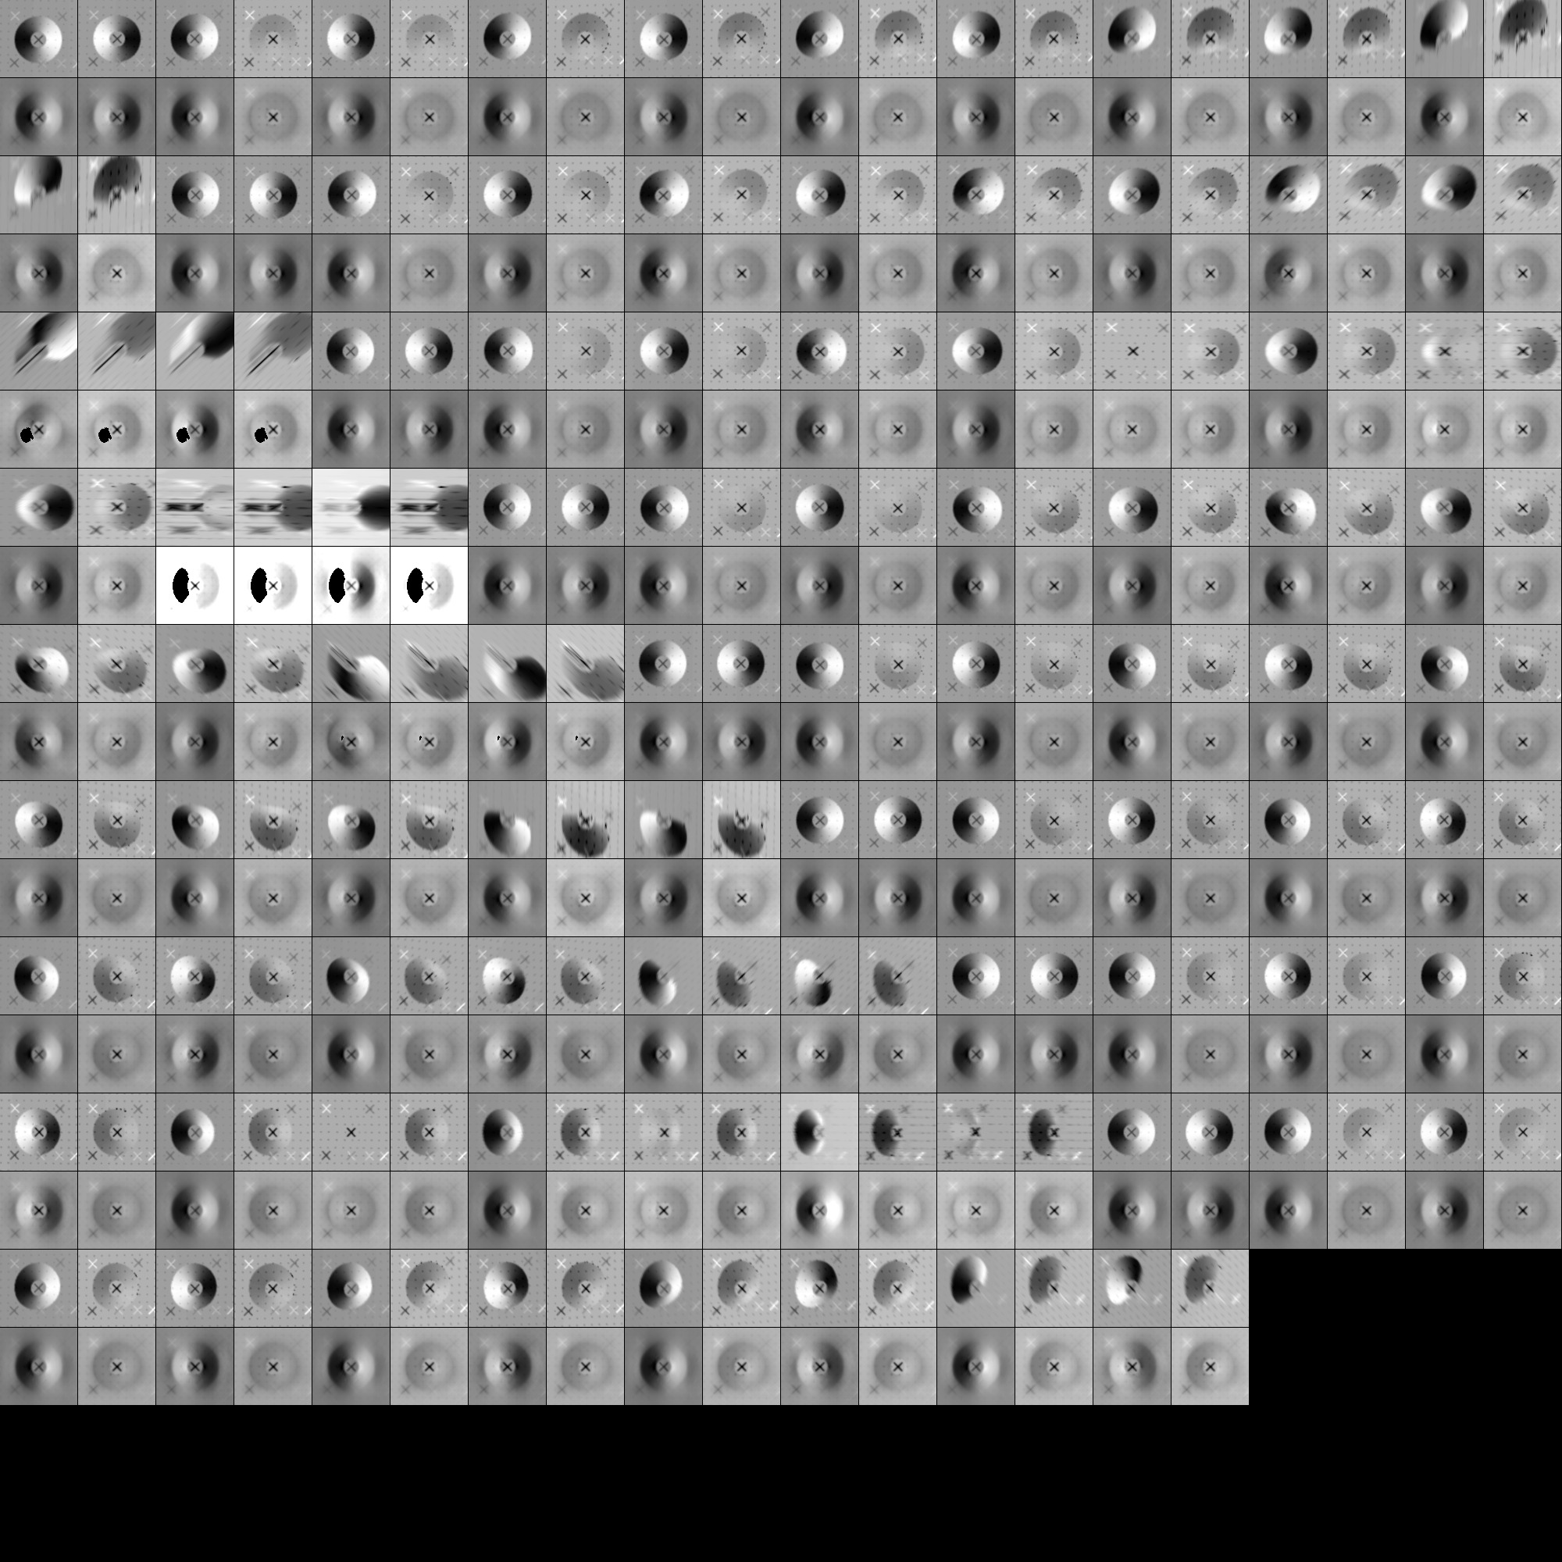
Landmark Display after 10 iterations:
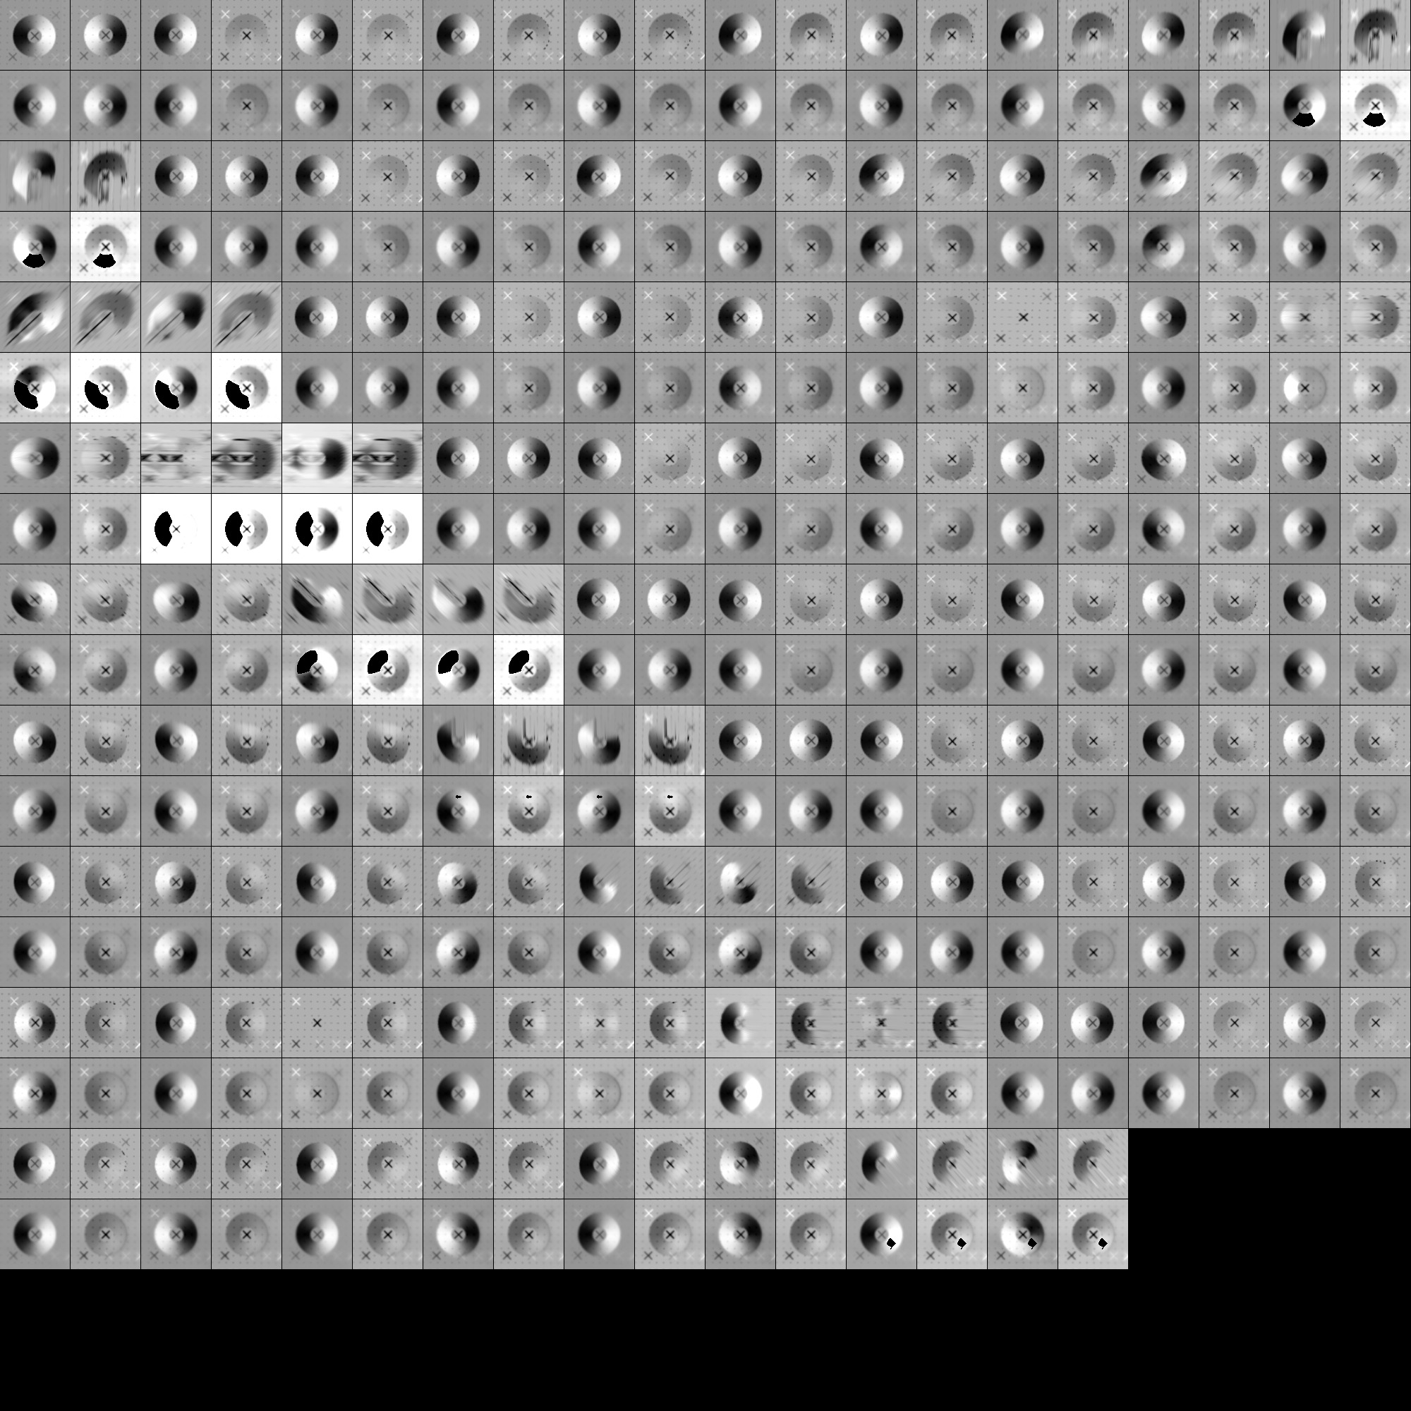
Landmark Display after 50 iterations:
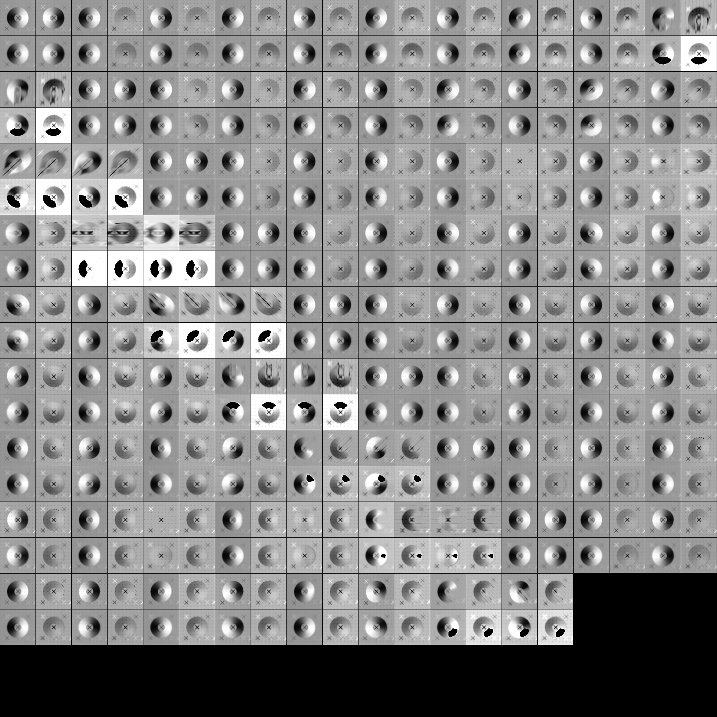
Landmark Display after 100 iterations:
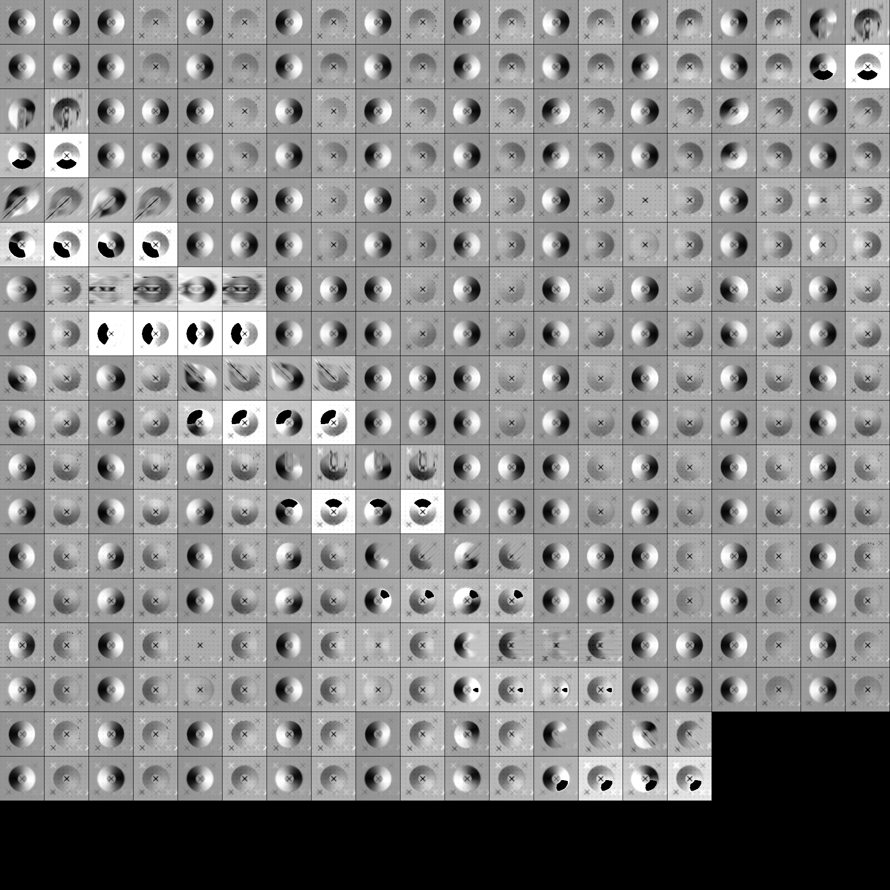
CompMapVecRMS HeatMaps:


