Test F3C - Quality of Observing Condition
Test Procedures
Test Results
Goal: SPC is highly dependent on the stereo angle and illumination conditions of the images. However, there has not been a systematic study to show how much those parameters affect the accuracy of the solution. We will test the accuracy by adding a few images with better stereo and photoclinometry angles.
This has been supported by Test 09 OrbitBUltra, Test 10 UltraFeatureF2 and T11 ReferencePeaks, tests conducted as part of the Calibration Test Phase.

Test Set Up
Data: Specific Detailed survey images with perturbed SUMFILES
Start: 35cm Detailed Survey Shape model
Build:
- TAG Site #1
- Use the "quality diagrams" to see where to add images
- Supports Safety map, FDS and NFT
Sub-Test F3C: Include non-physical solar angles to show the improvement of photoclinometry
Evaluate:
- Accuracy
- Relative Accuracy

Sub-Test F3C-1 - Matched Pairs
Four images with observing conditions matched with the Sun position. Meets MRD-576.
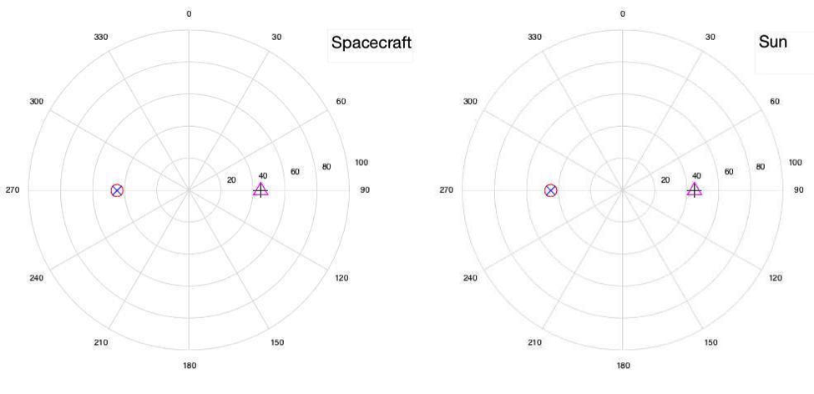

Sub-Test F3C-2 - Cross Pairs
Four images with observing conditions different for each pair of images. Meets MRD-576.
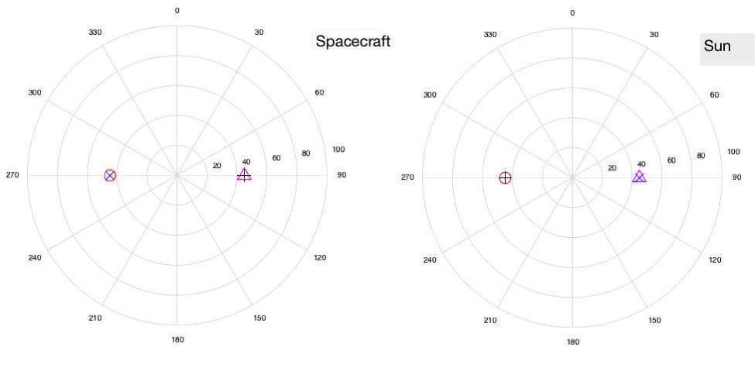

Sub-Test F3C-3 – Matched Pairs
Three images, all on the same side and with only 10° difference in position. Meets MRD-576.
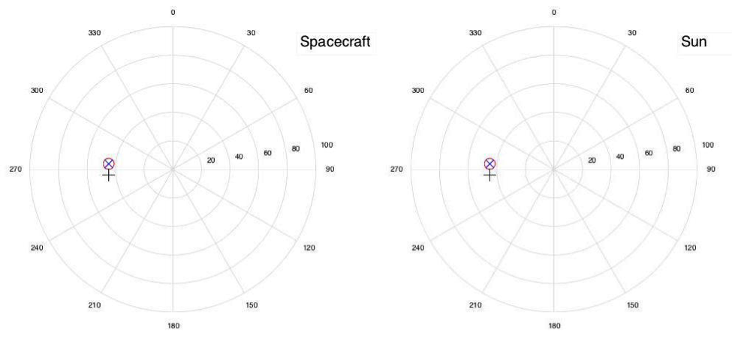

Sub-Test F3C-4 – Crossed Pairs
Three images, on opposite sides and with only 10° difference in position. Meets MRD-576.
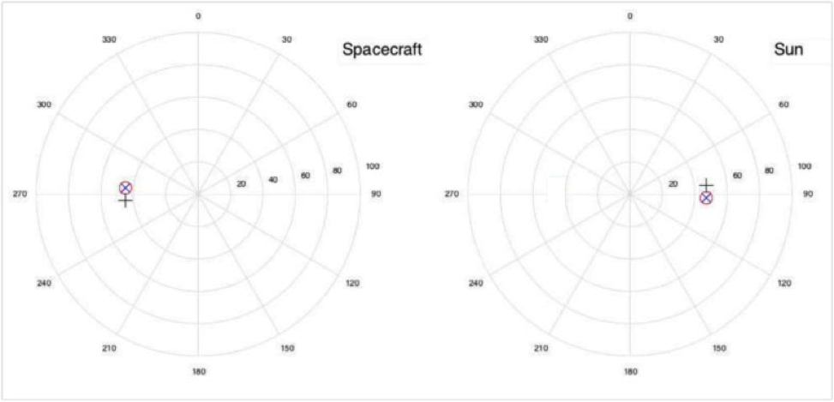

Sub-Test F3C-5
Every 45° with minimum Sun angle change. Meets MRD-576
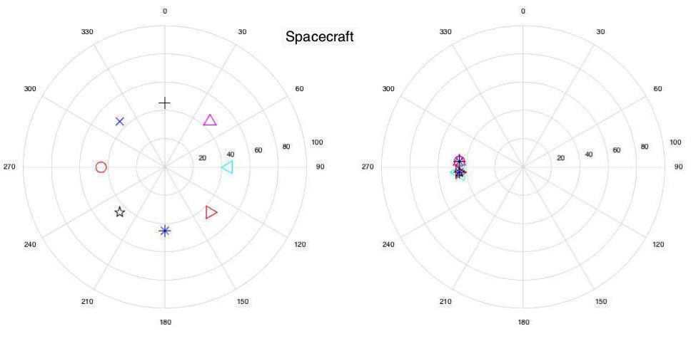

Sub-Test F3C-6
Every 45° with opposite sides for Sun position. Meets MRD-576


