Test 10: UltraFeatureF2
Purpose of test: To obtain highest possible topographic accuracy and resolution for features such as 2m wide boulders and craters, given perfect camera position and pointing and optimal SPC image suite.

Additional Technique Testing - DTM Evaluation Based on Highest Resolution Maplets Only
In the standard SPC procedure, lower resolution maplets from earlier processing steps are included in evaluation bigmaps. Information from the highest resolution maplets is therefore conditioned with low resolution data. Theoretically, the accuracy of the DTM would increase if the topography was generated using only the highest resolution maplets.
A subtest was conducted on Lockheed Feature 1 to investigate the effect of only included the highest resolution maplets in the evaluation bigmap.

Data
- Data was generated by Imager_mg using shape3.8 on ormacsrv1.
- PT10A - Centered at the middle of TAG site one.
  - Image resolution:
    - 50cm, 20cm, 10cm, 5cm, 1cm, 0.25cm.
  - Emission:
    - Every 20° azimuth, 45° zenith angle.
  - Incidence:
    - 0, 90°, 180°, 270° azimuth, 45° zenith angle.
    - 135° azimuth, 30° zenith angle.
Spacecraft:
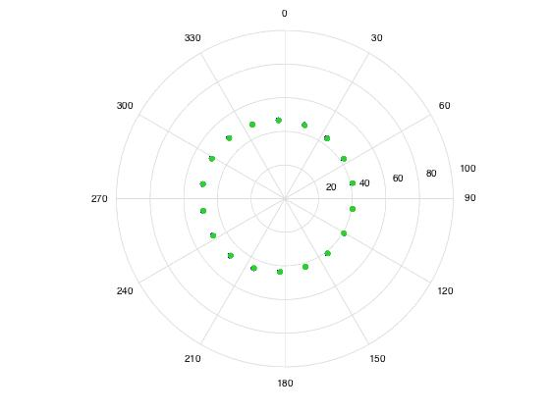
Sun:
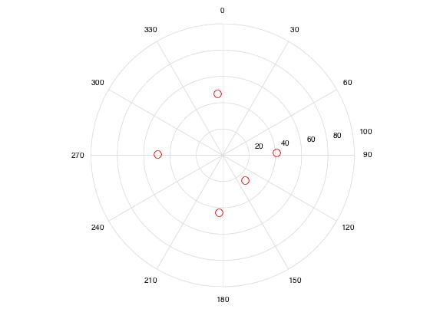
- PT10B, PT10C, PT10D, PT10E, PT10F, matches Lockheed Features 1-5 respectively.
  - Lockheed features were the suite from October 2015, located in TAG site 1.
Five features have been identified in TAG site 1. For each feature the following bigmaps will be tiled and evaluated:
Test Step | Ground Sample Distance (cm) | Maplet Overlap Factor | Approx. Maplet Overlap | Q Size | Width
2cm-Tiling | 2cm | 1/1.3 | 60% | 85 | 2.5m
1cm-Tiling | 1cm | 1/1.3 | 60% | 160 | 2.5m
0.5cm-Tiling | 0.5cm | 1/1.3 | 60% | 315 | 2.5m
Evaluation | 0.5cm | N/A | N/A | 200 | 2m
Lockheed Features -- Oct 2015
- MMAPL1 - standard procedure -9.203 262.089 - Diane
- MMAPL1 - alternate procedure -9.203 262.089 - Diane
- MMAPL2 -6.500 263.519 - Kris
- MMAPL3 -7.683 261.658
- MMAPL4 -8.054 263.091 - Eric
- MMAPL5 -8.858 263.551 - John

Evaluation
Truth Maps:
- TEV-L1 (1-5).
Q=320, Res=0.5cm.
In the truth directory as "obj" files.
Slightly bigger than the bigmap so we can do CompareOBJ. Reference T15-1K.
- TLOCK1 (1-5).
Q=300, Res=0.5cm.
In the truth directory as MAP files.
Use for flatMapVec and compMapVec.
Reference T15-1K.

