coverage
Category D | Version 3.0
Generates global coverage of what has been tiled and processed (as per landmark files)

Input - files
- view_maps.in (you get this from using update_infiles.e)

Input - stdin
- What type of maps to use (all, only with landmarks and/or limbs). Typically 2
- Resolution (start and ending resolution).
- If you are working with limbs, do you want to see that data also?
Example
~/bin/coverage.e 0. All maps 1. Maps with lmks or limbs 2. Maps with lmks 2 0,.1 n

Output
- coverage_g.pgm - a global map showing what has been tiled to the specified resolution
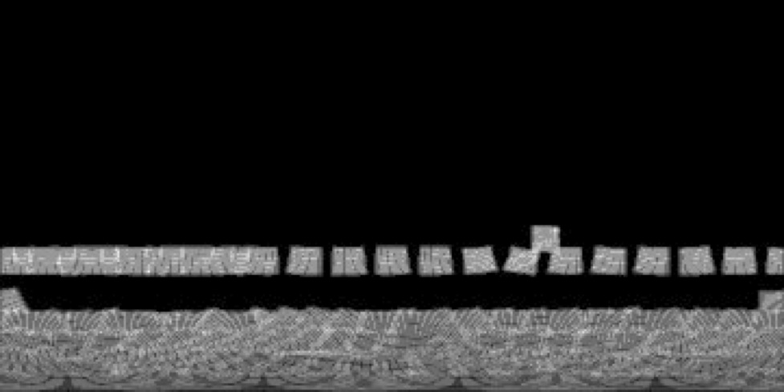

CategoryPrograms

