1.Test:
- SPC 1.1 - process_img

2.System or CSCI requirements:
- This test will process MapCam images and created the image data needed within SPC format (unsigned int) for processing. This tests the ability of SPC to ingest the images that will be used to create the shape model.

3.Prerequisite conditions:
- Test environment Bennu-init

4.Test Input
- Eight test images formatted with the FITS headers that the SPOC will put on during pipleine processing. The files are actual files from MapCam, showing the file format and headers are working. It is not simulated Bennu data.

2013-11-07T23:52:39_MCAM_L0b_V001.fits 2013-11-07T23:52:39_MCAM_L2_V001.fits 2013-11-07T23:52:44_MCAM_L0b_V001.fits 2013-11-07T23:52:44_MCAM_L2_V001.fits 2013-11-07T23:52:46_MCAM_L0b_V001.fits 2013-11-07T23:52:46_MCAM_L2_V001.fits 2013-11-07T23:52:49_MCAM_L0b_V001.fits 2013-11-07T23:52:49_MCAM_L2_V001.fits

5. Instructions for conducting procedure:

cd /SPOC_Test echo 1 | bin/revert.sh bin/testScript.sh 1.1

6.Expected test results
- All eight files will process and produce four <filename.DAT> files in the IMAGES directory. The input files have redundant data with different processing levels, so the highest quality output file will be saved.

7.Criteria for evaluating results
- No errors.
- Output directly matches previous run done on the development computer.
We do a binary diff that inspects every bit to ensure an exact match.
- TEMPFILE.pgm is created as the image during the processing.
This file is converted into a jpeg file for visual inspection (see attached example).
The stretch on the file has been left alone, so most of the image is substantially dark.
- Generation of an input file needed for make_sumfiles
make_sumfiles.in
M437140426F4 2013 NOV 07 23:52:39.050 1 1 1 2013-11-07T23:52:39_MCAM M437140431F4 2013 NOV 07 23:52:44.050 1 1 1 2013-11-07T23:52:44_MCAM M437140433F4 2013 NOV 07 23:52:46.050 1 1 1 2013-11-07T23:52:46_MCAM M437140436F4 2013 NOV 07 23:52:49.050 1 1 1 2013-11-07T23:52:49_MCAM

c.Requirements traceability
- SDP-SPC-40.01

d.Identification of test configuration
- Input:
SVN commit 5836
Software:
2.1A7
Supporting files: image 39.jpg.
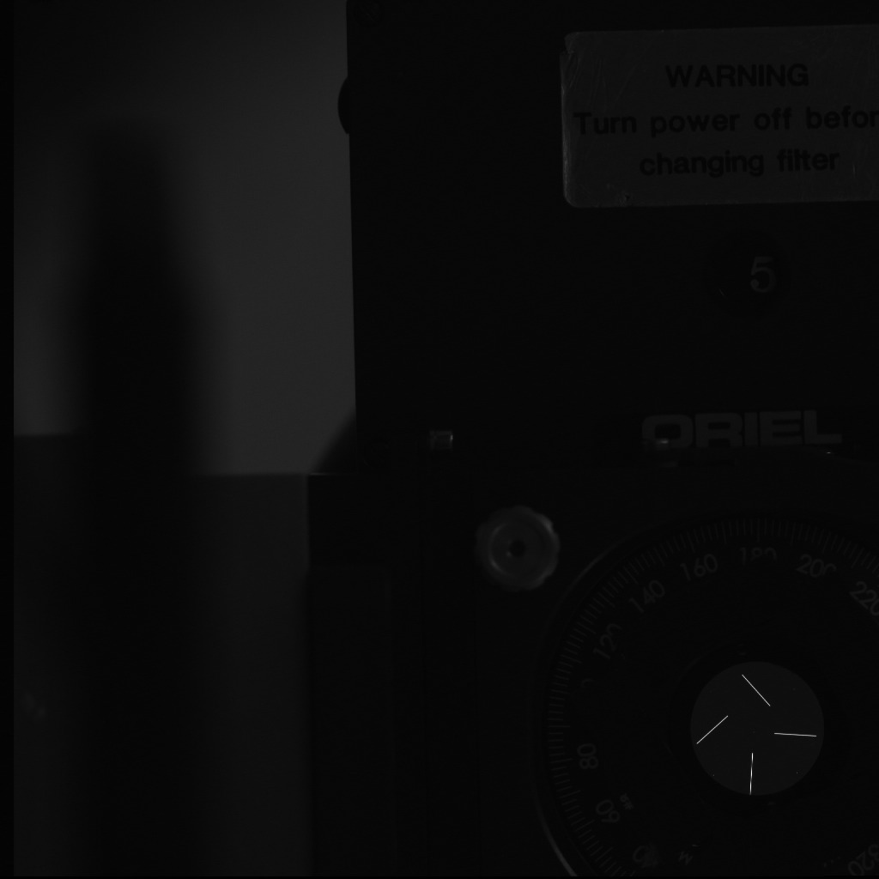

Test_Files
Put images in the ~/DAWN/NEW_IMAGES
Build a list of images to process, newpix.txt. This is used by process_img to read the images and build make_sumfiles.in.

cd ~/DAWN/NEW_IMAGES/bin/ls > newpix.txtmv newpix.txt ../../working

~/bin/e.process_img
Output is make_sumfiles.in

FC21A0014660 377642527:229 2 1 1 FC21A0014661 377642632:224 2 1 1 FC21A0016635 379008054:128 2 1 1 FC21A0016636 379008129:164 2 1 1 FC21A0022692 385355673:123 2 1 1 FC21A0023442 385989956:048 2 1 1 FC21A0023449 385990630:164 2 1 1 FC21A0026846 388895027:120 2 1 1 FC21A0026847 388895117:120 2 1 1

