Test_Files

Overview
3.4 SpheremapB reads in the current shape model and uses it to calculate gravity and albedo data (2D grids and images) for a specific bigmap region.

Input

/usr/local/bin/spheremapB10.429 191 0.050500 500 265 70samplec10a0 0 0 n60n

Output
Output should be exact (diff)
This created a suite of data files for a bigmap (REFMAP). It created a raw (simple binary file) of a 2D matrix for the scaled albedo (sample_ALB) and the topography (DTM). It also created images (pgm format) of the albedo, topography and color scaled topography.

/Users/epalm#/osiris/working$ ~/bin/spheremapsB.e input ltd (deg), elon (deg), scale (km/px), half-sizes (px/ln), ref radius (km), tolerance (km)10.429 169.196 0.005500 50026550 input map namesample a. orthographic b. stereographic c. equirectangularc Enter reference latitude0 a. 8 bit DTM b. 16 bit DTMa Enter i,j,h map shift (m) (eg map-lola)0 0 0 10.109395337649858 20.857825073993354 Fix hmin, hmax? (y/n)n Set max slope (deg)60 Lat/Lon markings? (y/n)n
- Albedo
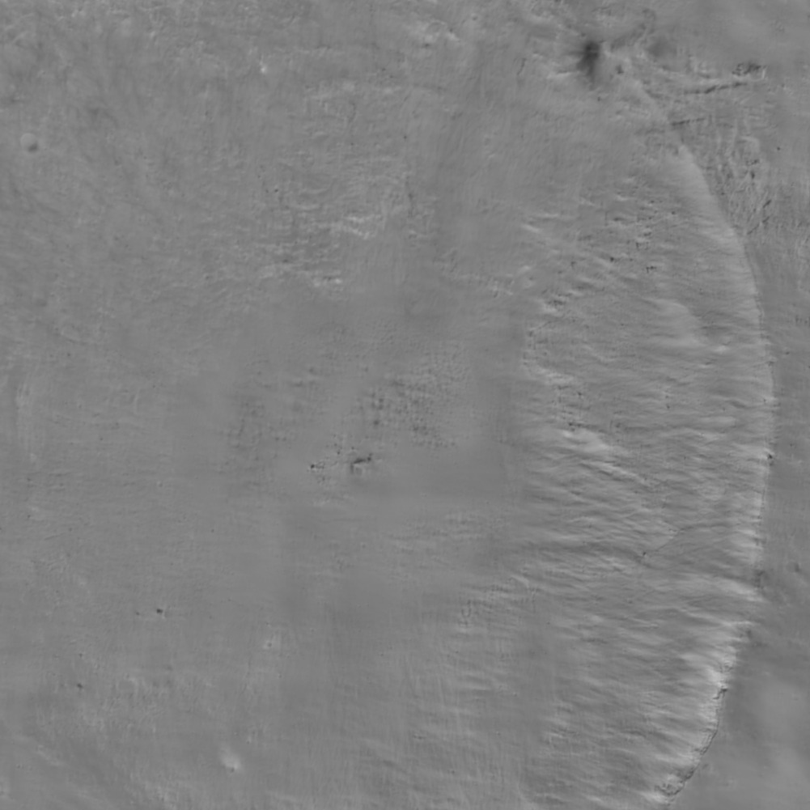
- Color DTM
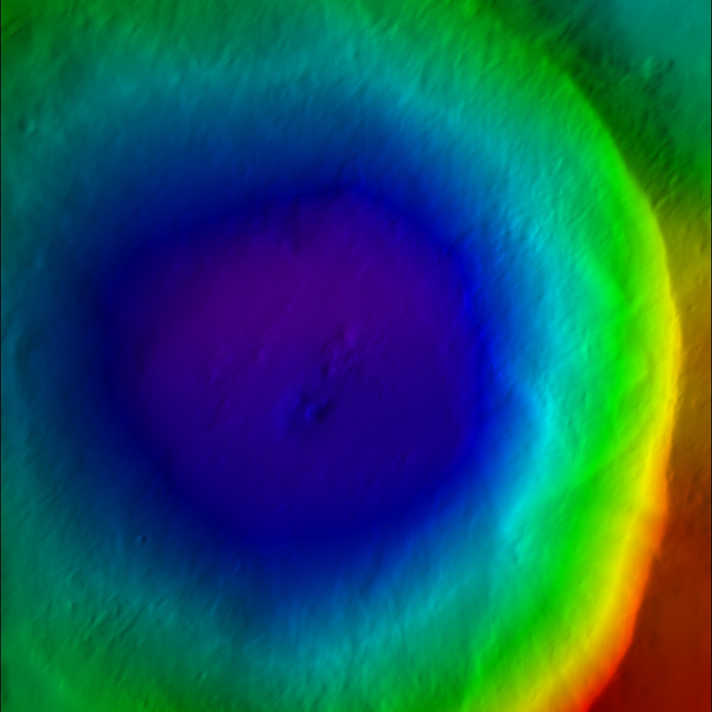
- Greyscale DTM


