image_map_mono
Category ? | Version ?

Description
What this program does

Input Files
- Bigmap - filename given as stdin
- PICTFILES -

Input stdin
- /!\ No prompt is given for the name of the bigmap
- A 6 character filename of a bigmap (which needs to be in ./MAPFILES).
The program will append the required suffix "MAP" itself.
- The program asks for slant angle.
0 is straight down.
I assume it goes from 0 to 90 degrees.
123456 Enter slant angle (degrees) 30 Input PICNM FC21A0011878
  - /!\ This input looks like the name of an image that has a SUMFILE with it. I am guessing that it this image contains the sun position and view angle for the map specified.

Output Files
- An output image, view.pgm
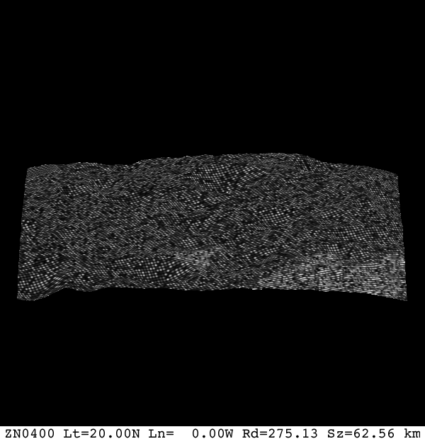

CategoryPrograms

