image_map_rgb
Category D | Version 3.0

Description
ímage_map_rgb generates an image of the bigmap. It renders a 3D image using the red and blue colors to establish depth of view.

Input Files
- Bigmap - filename given as stdin
- PICTFILES -

Input stdin
- A 6 character filename of a bigmap (which needs to be in ./MAPFILES).
The program will append the required suffix "MAP" itself.
- The program asks for slant angle.
0 is straight down.
I assume it from 0 to 90 degrees.

123456 Enter slant angle (degrees) 30 Input PICNM
- /!\ This looks like the name of an image that has a SUMFILE with it. I am guessing that it this image contains the sun position and view angle for the map specified.

Flatten? (y/n)
- /!\ Not sure what this does

Magnification
- /!\ Note sure what the values are. I've tried 1

Output Files
- An output image, view.ppm
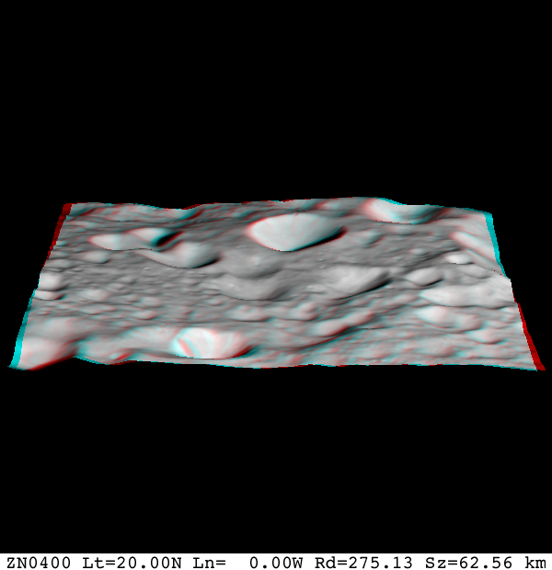

CategoryPrograms

