lithos
Category B | Version 3.0

Description
This program aligns maplets to the current shape model and provides slight changes to the shape (stored in MAPFILES).
lithos is the key for SPC. It works on a single landmark, which defines the associated maplet. This landmark must be created (i.e., fully defined) and all the images it includes must be shifted so that everything is aligned. Once those steps are done, you can calculate the topography, which includes identifying other maps that overlap, creating a template, and then solving the whole system.
The outputs from make_scriptT and make_scriptP are used as input to lithos and lithosP for batch processing. The make_script program will create an entry for each landmark in the script.b. You will then process it as input, like this: 'lithos < LAND01.INN > LAND01.OOT'
Throughout LITHOS , you can simply hit 'Enter' for the default selection, which is usually indicted by brackets.
- For instance, in the case of "Do you wish to continue? y[n]" hitting 'Enter' key will default to the 'n' selection.
- When editing a seed file, a blank line will act as if the 'Enter' key was pressed at the command prompt.

Required Files
- DATA/ - data specific to each mission
- IMAGEFILES/ - a directory containing the image .DAT files
- SUMFILES/ - a directory containing the image .SUM files (updated solution image, S/C and camera information; lmrks and limbs)
- MAPFILES/ - a directory containing the full suite of maplets
- LMKFILES/ - a directory containing the full suite of landmarks
- BIGFILES/ - a directory containing all the bigmaps
- NOMINALS/ - a directory containing the full suite of nominals
- SHAPEFILES/ - a directory containing the shapemodel
- LMRKLIST.TXT - a list of the landmarks contained in the solution
- PICTLIST.TXT - a list of the pictures contained in the solution
  - Will be used if PICTLISTX.TXT and PICTLISTRX.TXT do not exist.
- BIGLIST.TXT - a list of all the bigmaps that have been created
- INIT_LITHOS.TXT - file containing default values to be read in by SPC toolkit

Output Files
- tmpl.pgm - Temporary pgm amp file convert by RAW2PGM
- seeds.pgm - Temporary pgm amp file convert by RAW2PGM
- LMRK_DISPLAY0.pgm - Temporary pgm amp file convert by RAW2PGM (See below.)
- LMRK_DISPLAY1.pgm - Temporary pgm amp file convert by RAW2PGM (See below.)

Optional Files
- LMRKLISTO.TXT - If present, LMRKLISTO.TXT is used to calculate overlaps instead of LMRKLIST.TXT. This action enables lithos and lithosP to run faster by searching for overlaps among a limited set of landmarks.
- LMRKLISTX.TXT - Extended landmark list containing .LMK file information that speeds up processing by eliminating the need to open individual .LMK files multiple times.
- PICTLISTR.TXT - User-generated restricted list of pictures for processing.
- PICTLISTX.TXT - Picture information similar in concept to LMRKLISTX.TXT. This file will be used if PICTLISTRX.TXT does not exist.
- PICTLISTRX.TXT - User-generated restricted extended picture list, i.e. a sub-set from PICTLISTX.TXT.

Using lithos
lithos is an interactive program that runs from a Main Menu. To access the Main Menu from anywhere within lithos , type '?' at the user prompt.
For information about each of the Main Menu options, click on its link in the Main Menu sample below:

- ...MAIN MENU...
- Q. Quit LITHOS
- LANDMARK/MAPLET CONSTRUCTION
- 0. Find template
- 1. Align landmarks
- 2. Find heights
- O. Attach map to maps or limbs
- LANDMARK/MAPLET I/O AND CREATION
- I. Input landmark
- U. Update landmark files
- C. Create new landmark
- R. Replicate or Rename landmark
- S. Change scale, qsz or orientation
- G. Turn on rename
- ADJUST INPUT DATA AND NOMINALS
- N. Find normal
- V. Find V, Z or PTG
- A. Reset albedo or slopes
- M. Get heights from shape model
- B. Get heights from surrounding map
- X. Turn on extract filter
- DELETE, ELIMINATE OR IGNORE FILES
- D. Delete or Disconnect landmark
- E. Eliminate pictures from landmark
- P. Picture status
- L. Turn off picture restriction
- INFORMATION AND DISPLAY
- F. Find maplets containing surface point
- Z. Use zoom display
- H. Hide screen output

When you're using LITHOS, you can see the most recent updates in the two files that are displayed every time the Main Menu is loaded. This sample shows how those appear:

Current landmark = EE0001SCALE = 0.000100 QSZ = 49 Lat/Lon/Rad = -6.800 264.090 0.266 Region = EE gc LMRK_DISPLAY0.pgm gc LMRK_DISPLAY1.pgm check displayMain Menu: Q 0123O IUCRSG NVAMBX DEPL FZH?
Below is a sample of LMRK_DISPLAY0.pgm. It displays the raw images (i.e., without brightness scaling). This image is the data used by lithos for the correlation evaluation.

Figure 00: Rarely Used Output from LMRK_DISPLAY0
Below is a sample of LMRK_DISPLAY1.pgm. It displays images with the brightness stretched to bring out features and make the images more "readable". This image is used by human operators extensively while while operating lithos .
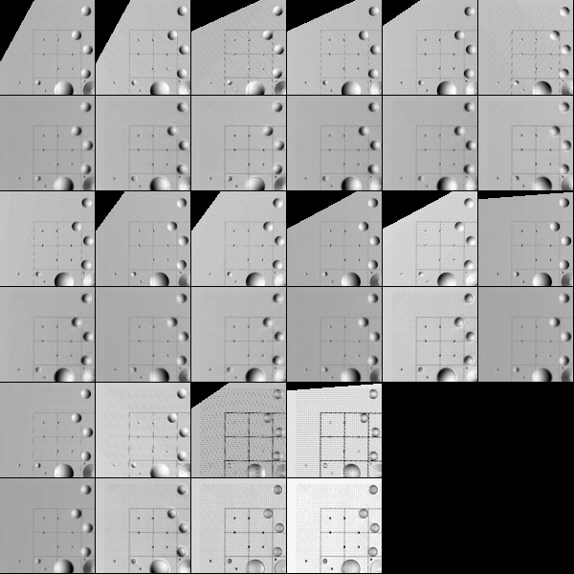
Figure 00: Rarely Used Output from LMRK_DISPLAY1

(compiled by JRW)
CategoryPrograms
Link to original one page version (renamed 1/13/16): Old_lithos_text

