Test_Files
= Overview =
Build a template
Output is matching the script
= Input =

# Select the landmarkiTEST01nn# Set correlation101n0n# Lose the shape model - degradeM# Output image #1# Build a template with a single image, high correlation0c.9500300# Output image #2# Build a template all HAMO080300# Output image #2# Use All0a0040# Saveu0q
= Output =
Images
- Image #1 - heights from shape model
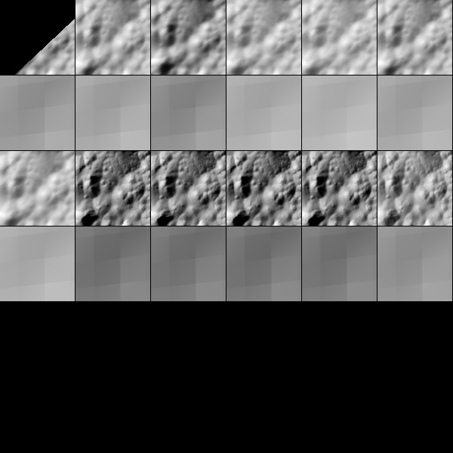
- Image #2 - run with HAMO
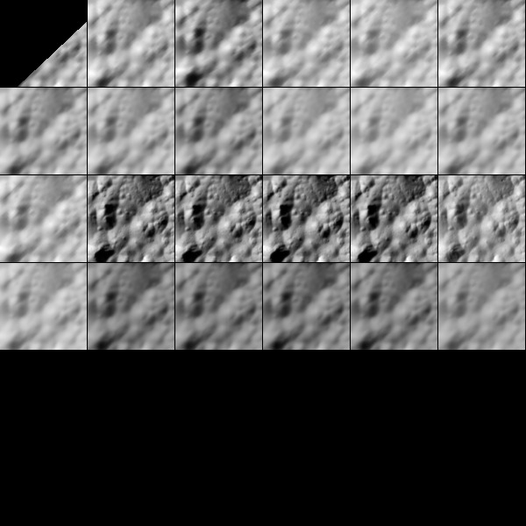
- Image #3 - run with 1 LAMO images
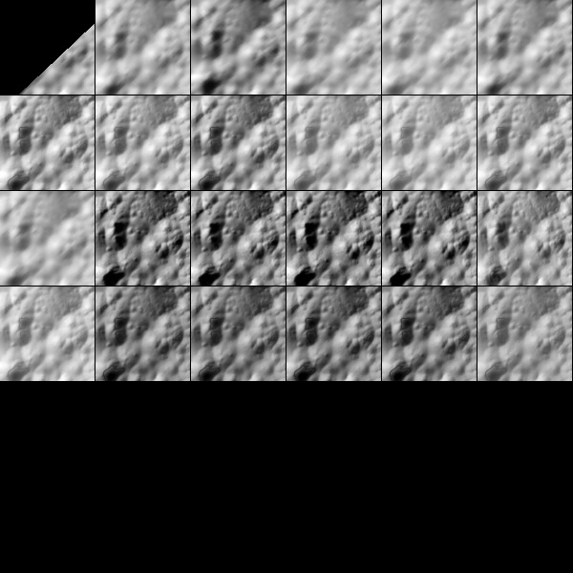
- Image #4 - run with all




