make_sumfiles.txt
Category ? | Version 3.0

Description
This configuration file contains basic camera distortion data and a list of available SPICE kernels. It is used by make_sumfiles as a configuration file when generating SUMFILES and NOMINALS. At this time, make_sumfiles.txt is created by hand.

Creating make_sumfiles.txt
Here is a sample make_sumfiles.txt file. Annotations on the right indicate what the data elements are.

4 NCAM'ORX_OCAMS_MAPCAM'1024 1024 NPXB, NLNB125.0 512.5 512.5 MMFLB, PX0B, LN0B117.647, 0, 0, 0, 117.647, 0 KMATB -1, -2, 3 PROJECT CAMERA AXES5, 16383 T1,T2'ORX_OCAMS_SAMCAM'1024 1024 NPXC, NLNC24.0 512.5 512.5 MMFLC, PX0C, LN0C117.647, 0, 0, 0, 117.647, 0 KMATC 1, 2, 3 PROJECT CAMERA AXES5, 16383 T1,T2'ORX_OCAMS_POLYCAM'1024 1024 NPXA, NLNA611.0 512.5 512.5 MMFLA, PX0A, LN0A117.647, 0, 0, 0, 117.647, 0 KMATA -1, -2, 3 PROJECT CAMERA AXES5, 16383 T1,T2'ORX_NAVCAM'2592 1944 NPXC, NLNC7.6 1296.5 972.5 MMFLC, PX0C, LN0C454.54, 0, 0, 0, 454.54, 0 KMATC 1, 2, 3 PROJECT CAMERA AXES5, 4096 T1,T21 NSC-64 ORX1.d0 1.d0 1.d0 sigV01.d-3 1.d-3 1.d-3 sigPT2101955 BENNU'IAU_BENNU' BFRAME'NONE' ABCORR'../ORex/DATA/' PREFIXKERNELSsb-101955-76.bspbennu_v10.tpcde421.bspnaif0011.tlsorex_ocams_v02.tiorx_aux_v01.tiorx_v03.tfpck00010.tpcApproachPrelim_Perturbed.bspDetailedSurvey_Perturbed.bspOrbitalB_Perturbed.bspORX_SCLKSCET.00000.example.tscF3A_AllObs_20181109T000000_20181118T000000_Perturbed.bcF3A_BD_AllObs_20190113T000000_20190122T120000_p.bcF3A_ES_Obs1_20190127T094200_20190127T161200_p.bcF3A_ES_Obs2_20190203T094300_20190203T161300_p.bcF3A_ES_Obs3_20190210T100500_20190210T163500_p.bc...END_KRNLS

Description of codes
NCAM | Number of cameras in the file
NPXV, NLNB or NPXC, NLNC, or NPXA, NLNA | Number of pixels and lines for the camera image
MMFLB, PX0B, LN0B | focal length and center pixel/line of the camera
PROJECT CAMERA AXIS | The axis of the camera mounted onto the spacecraft. This is the same thing that is described in all the frame kernels
T1, T2 | The min and maximum value of "accepted" values for the image's DN. Below and above this threshold, it denotes no data
ORX | NAIF base code for the spacecraft
sigV0 | The default value for the spacecraft object uncertainty, in km. Can be overwritten by DYNAMICS
sigPT | The default value for the camera pointing uncertainty, in Rad. Can be overwritten by DYNAMICS
BENNU | Asteroid number for the object. Used for SPICE Calls
BFRAME | Object that defines the body fixed frame to be used in SPC
ABCORR | Correction needed for adjustment for light speed (Aberration correction indicates the aberration corrections to be applied to the state of the target body to account for one-way light time and stellar aberration.)
KERNELS | Here one lists all of the kernels that are needed to properly project spacecraft camera pointing onto the body-fixed surface
The make_sumfiles.txt file consists of three sections:

Camera Data Definitions
Enter the number of cameras that the file maintains (NCAM). List the following for each camera:
- Camera Name
- Pixels (sample and rows)
- Focal length, center pixel (x/y)
- K Matrix - distortion matrix
- Min and max expected DN for this data type
Enter sigV0 - The uncertainty of the spacecraft position [km] Enter sigPt - The uncertainty of the camera pointing [Rad]
The PROJECT CAMERA AXIS relates to how the camera is mounted to the spacecraft (it's orientation). I *think* this could be handled by frame kernels, but it isn't done that way right now. Thus, we have to put in a camera orientation matrix. From my testing, it appears that there are 4 orientations that valid.
- 1
2
3
- -1 -2
3
- -2
1
3
- 2 -1
3

Target Information
Enter the follow three rows:
- the names of the ID of the target body
- body fixed frame in the kernels
- aberration correction desired

Kernel List
If the SPICE kernels are not in your working directory, give the path to the kernels (PREFIX).
Start the SPICE kernels list with these two rows:
- KERNELS #
List each kernel on a separate row.
- /!\ When in doubt, list all the available kernels.
Here is a list of kernels that are known to make make_sumfiles work:
- SPK kernels (.bsp) - for spacecraft and target object - ephemeris
- CK kernels (.bc) - orientation/attitude of spacecraft and other structures (like camera)
- SCLK kernels (.tsc) - spacecraft clock coefficients
- IK kernels (.ti) - instrument geometry for camera taking pictures
- LSK kernels (.tls) - leap seconds
- FK kernels (.tf) - reference frame specifications
- PCK kernels (.tpc) - text form of planetary/asteroidal constants
End the kernels list with this row:
- END_KRNLS
When processing make_sumfiles
- If you get the "NOFRAMECONNECT" error (display says, "At epoch...") - You likely need a CK Kernel (<filename>.bc). Additional questions can be answered by referencing NAIF's SPICE website. http://naif.jpl.nasa.gov
- If you get the "SPKINSUFFDATA" error (display says, "Insufficient...") - You likely need a SPK Kernel (<filename>.bsp).

Additional Reference
Here is the same make_sumfiles.txt but with additional comments:
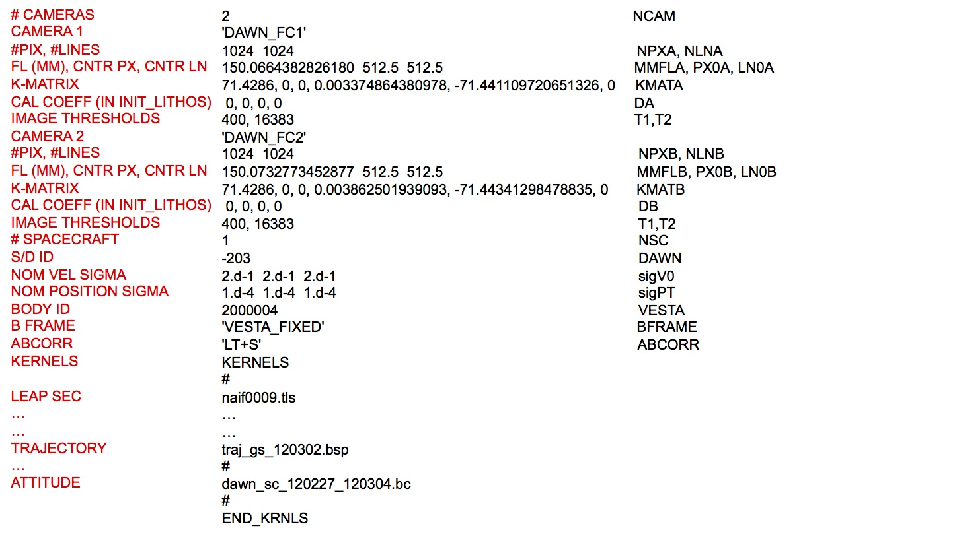
Figure 00: Illustration of make_sumfiles.txt File with Explanations

(Compiled by KD)
CategoryFiles CategoryInputFiles

