newover11I:
Building topography with s/c azimuth every 90deg and 5cm images.

Results Summary:

RMS Values:
STEP | CompareOBJ (cm) w/o trans | compMapVec(cm) | NOTES
step001 | ND | ND | tiling at 10cm
step002 | 1.62 | .705 | tiling at 5cm (BIGMAP instead of bigmapref)
step003 | 1.52 | .824 | (BIGMAP instead of bigmapref)
step004 | 1.44 | .891 | (BIGMAP instead of bigmapref)
step005 | 1.41 | 1.77 | iteration 3
step007 | 1.33 | 1.90 | iteration 5
step012 | 1.22 | 2.03 | iteration 10
step013 | 1.21 | 2.01
step023 | 1.06 | 2.06
step033 | 0.97 | 1.97 | iteration 31
step043 | 1.11 | 2.04 | iteration 36 (step38) had a hangup. Not all maplets were iterated
step053 | 1.23 | 1.95
step063 | 1.28 | 2.01
step073 | 1.31 | 1.90
step083 | 1.31 | 1.86
step093 | 1.32 | 1.76
step103 | 1.28 | 1.76 | iteration 100

Trace:
JRW Results 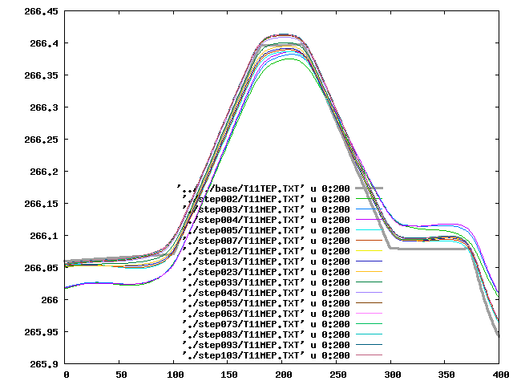

Heat maps: Notice how N part gets better while SE part gets worse.
Iteration 41 (same FOV as REGION) 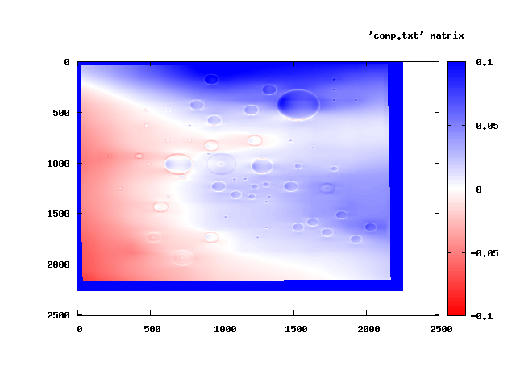
Iteration 100 (same FOV as REGION) 

