panaroma
Category ? | Version ?
(!) This code was developed for the Mercator Project (LASER Program). The code uses Gaskell's basic infrastructure and data files.

Description
Panaroma will take a big map and generate a 360-degree view of the surface.

Input Files
- none

Input stdin
- Bigmap - 6 character name of a bigmap
- Location - x, y, z of where to make the image.
x and y are based on pixels within the bigmap (rather than lat/lon or meters).
Z is meters above the surface.
Here's an example input:
- 123456 390, 1990, 10

Output Files
- PANORAMA.pgm - The image file (in pgm format).
Currently, I've been using a version that has lines at N, E, S and W. ~epalmer
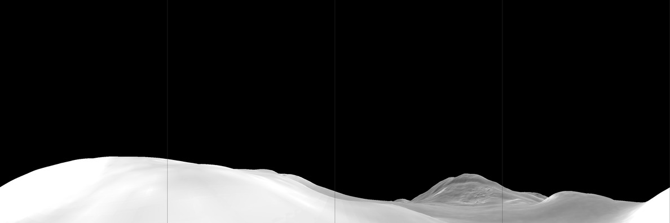

CategoryPrograms CategoryMercator

