showmap
Category D | Version 3.0

Description
showmap takes a bigmap and generates an image of that specific map. The view is from directly above with a limited shaded relief. There are no controls to adjust the Sun angle.

Input Files
- Bigmap - Filename given via stdin. The file must be in the MAPFILES subdirectory.

Input stdin
- The 6 character name of a bigmap.
The suffix ".MAP" will be added by the program.

123456

Output Files
- Generates an image (pgm) format from the bigmap. The output name is the same as the filename, except it has a different extension.
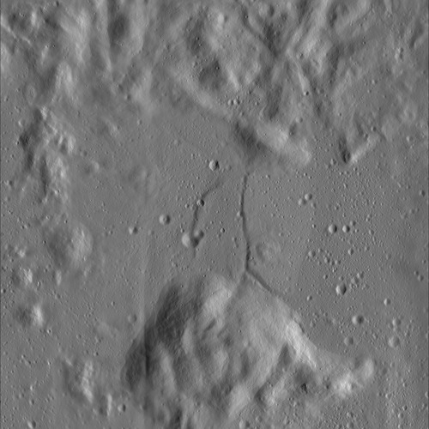

CategoryPrograms

