How SPC Works
SPC is a suite of software routines that uses both stereo imaging and photoclinometry to derive topography, referred to as "the shape model". The routines are able to generate topography with accuracy near the resolution of the source images. If the images have significant overlap, then it can produce a stereo derived topographic model. If the images have significantly different illumination conditions, then it can produce a photoclinometry-based model. However, with most planetary missions, there are many more images that do not qualify as stereo pairs, so a combination of the two methods provide topographic solutions based on a much wider base of images.
At its root, SPC is geometric stereo, meaning that it starts with geometry to calculate the height of individual control points on the surface using two or more images taken from different directions. The advantage of SPC is that it integrates both the albedo and shape of the surface in an iterative process to increase precision and resolution. If there is no change in illumination conditions, SPC is reduced to multi-image photogrammetry. If there is an insignificant stereo angle, SPC works as 2D photoclinometry with multiple images. For additional background, see Gaskell et al., 2008.

Data and Environment Requirements for the SPC Process

Observation and Data for Optimal SPC Results
Traditional stereo requires:
- Images that are taken with similar lighting conditions
- Stereo angle between 10 and 40°
- Images have nearly identical image resolution
Stereophotoclinometry works best with:
- A minimum of three images (typically >30, this study 4)
- Two stereo images
- Emission angles 45° (acceptable 35-48°, limit 5-60°)
- Stereo angle 90° (acceptable 70-110°, limit 10-120°)
- Incidence angle 0° (acceptable 0-20°, limit 0-60°)
- Three photoclinometry images
- Emission 0° (acceptable 0-20°, limit 0-60°)
- Incidence angles 45° (acceptable 30-50°, limit 0-60°)
- Variation in illumination geometry of 90° (acceptable 40-90°, limit 10-120°). This refers to having different positions of the Sun with respect to the observed target.
In general, geometric stereo is more accurate for long scale topography, while photoclinometry is better for short scale (Kirk 2003). SPC uses both of these components to mitigate the errors that are caused by each of them. Stereo creates a position in 3D space using 3-5 pixels from an image. SPC typically sets control points (called "landmarks") with a spacing of 30 pixels. Thus, the landmarks (or point clouds) have a spacing that is a factor of 10 lower than traditional geometric results.
SPC will use photoclinometry to calculate and fill in the heights of the points between the landmarks. The horizontal ground sample distance (referred to as "resolution") is typically on the order of the resolution of the images, and we have successfully generated topography at double the image resolution. The calculations of the points between landmarks are solved in 99x99 grids (or "maplets"), so most heights are solved by multiple maplets. The iterative solution is continued until the solutions for points common to multiple maplets agree, resulting in the accuracy of all of the topographic heights being controlled by stereo but generated by photoclinometry at a higher ground sample distance.

Computing Environment and Tools for SPC Process
The programs described in this document are written in FORTRAN and compose a toolkit that have been traditionally compiled and run within a UNIX or LINUX operating system. Most of these machines have been Apple computers . Specific computers and tools used in the SPC process are listed below.
Table 00: Required Resources and Ancillary Tools
Machines/Workstations | OS / Core SW Versions | Notes
ormacsrv1.lpl.arizona.edu |  | A 12-core Macintosh X-Server, to execute the SPC programs
cloud.psi.edu: |  | A 12-core Macintosh Pro Workstation, to execute the SPC programs
cloud9.psi.edu |  | A 12-core Macintosh Pro Workstation, to execute the SPC programs
ormacsrv1 | Mac OSX 10.9.5 | Access to ormacsrv1 via internet, to allow testers to run programs from their local facility
ormacsrv1/tape |  | Backup storage for test results, scripts, etc
Software Tools | Version | Notes
SPC Tools | 3.0A2 | As a set the complete tool kit is identified as release 3.0A2 but modules can have different revisions and are identified here.
Baseline | 2.1A7
REGRES | 3.0A0
GEOMETRY | 3.0A0
PROCESS_FITS | 3.0A2
Bash shell
awk
perl
rsync
xv
ImageMagick
vi
Graphics Converter
webserver
spc_align toolkit

SPC Process
SPC uses a three-step iterative process to derive a shape model:
- register images
- warp the model
- update camera position/pointing
We start with an initial shape model that is very low resolution but that provides a starting point for SPC. This shape can come from limb measurements, a radar shape model, spherical harmonics or, if need be, can be derived via a mathematical representation of a tri-axial shape. In this case, it is set to a flat surface.
The following discussions explain each of these three steps in more detail.

Step 1. Register
The first step is to register the images to a reference frame. To do this, we use a large number of landmarks. For each landmark, we generate a small 99x99 pixel maplet. Each image that falls within one maplet is orthorectified and projected onto the shape model. Here is a sample:
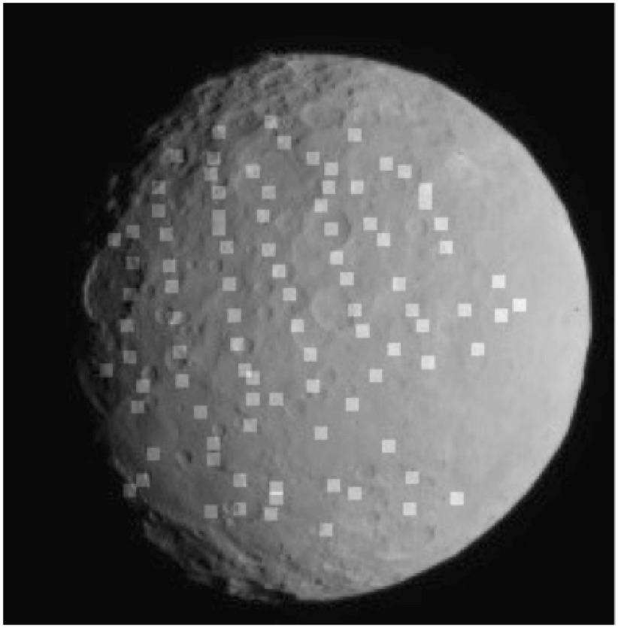
Figure 00: Initial Shape with Maplet Overlay
Associated with each of these maplet views is the shape model with albedo, which is illuminated at the same solar geometry, as shown in the following sample:
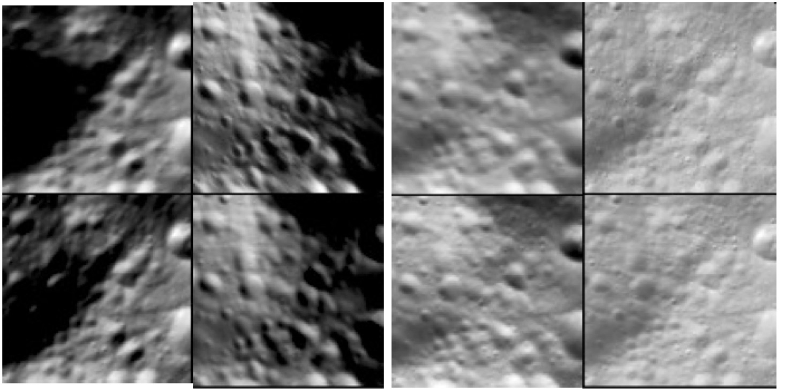
Figure 00: Maplet with Variation in Solar Illumination
In these four images, there is significant variation in illumination conditions, resulting in a significantly different looking terrain. The bottom row are images based on the shape model, only illuminated with the space conditions as the corresponding image. By projecting all the images to the same orientation and scale, and illuminating the model accordingly, we can more precisely register images over a significantly wider range of emission angles, thus reducing topographic error. These maplets are 500 meters across.
We use both manual and automated tools to co-register the images within each maplet such that the center point of each maplet is in the same location as on all the rest. Because the images are orthorectified, we can have the same view of each of them, increasing our ability to match identical features, even if the original viewing geometry makes them hard to identify. There are minor improvements in the co-registration of images as the shape model improves because this reduces projection error and, correspondently, any mis-registration.

Step 2. Warp the Model
Once the landmarks are registered, we use that information to update the shape model. While the height of the center of the landmark is initially derived from geometric stereo, we use photoclinometry to solve for the heights of every pixel of the landmark. Simple photoclinometry is 1D and requires the albedo to be a constant so that the only variation in pixel intensity is the topography. For SPC, we have a full 3D model that includes albedo. As described previously, for each image within a maplet, we illuminate the shape model to correspond to it. Because we are fully controlling for topography and albedo, any variations in each image's pixel DN from its representative shape model DN is an error in the model. The deviations are turned into corrections for both albedo and topography. A configuration file within SPC provides weighting that is applied to the corrections for albedo and topography. For example, when working with a low relief surface with high contrast, the user puts more weight on changing the albedo rather than the topography, and vice versa. The weighting only affects how fast the model converges to a solution; it does not affect the solution itself. For example, if SPC has made an overcorrection to albedo, then when the terrain is processed again, the albedo will be corrected.

Step 3. Update Camera Position/Pointing
The next major step of SPC is to take the updated heights of the surface and use those to improve the actual position and pointing of the spacecraft. Within an image, each of these landmarks (in this context, they are working like a control point) provides the exact sample/line position of the landmark. This data, along with the angular field of view of each pixel, allows SPC to determine the position and pointing of the spacecraft. Note that a narrow field of view makes it difficult to break the degeneracy where a displacement can be either position or pointing. This is handled by weighting each of these terms based upon the calculated errors in positions and pointing. Typically, these estimates are provided by the navigation team. This correction of camera position/pointing and the assumptions made by those generating the topography account for the major differences between SPC and traditional stereogrammetry.

Additional Processing
As the shape model is processed, the steps of register/morph/update are iterated until the residuals of the solution approach a minimum. We use a variety of tools to evaluate mis-registration problems, image artifacts, or regions with insufficient image coverage (the worst of which occurs with a lack of stereo). The main tool is a program called RESIDUALS that reports deviations in distance (meters) or pixels. It calculates the position on the shape model of each landmark/image combination. For each landmark, it takes the deviation of position of each of its images to calculate the RMS error. The RMS error shows how close all of the image data is aligned to represent the surface of the object. It is a fully geometric solution based upon the registration of the landmarks (or control points) and the position of the spacecraft.

Output Products
The main output product for SPC is a shape model, a 3D set of position vectors that define the heights. This can be converted into a vector/plate model. The output from SPC for a bounded surface is called a BIGMAP. This product has a regular ground sample distance (resolution) and, for each point, it takes the average value of all the maplets that contain each point. The BIGMAP also contains a scaled albedo (or scaled average surface reflectance) for each point.

