Stage 1 - Initial Load
The first stage of building the shape model is to bring in the first set of images and generate landmarks from them. The following figure illustrates the general process of this stage.
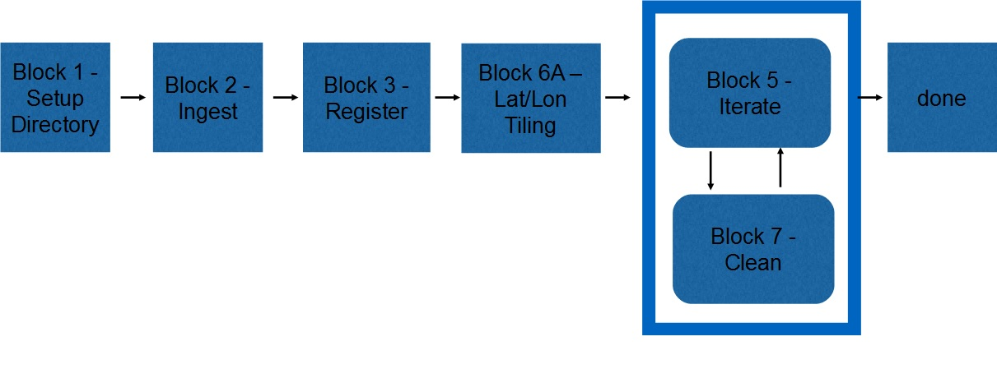
Figure 00: Block Diagram for Startup
First, the images are imported into the SPC system and converted into the SPC internal format. Then the alignment of the images is improved. Next, a set of initial landmarks is generated with a GSD of 120cm at a spacing of 20 degrees. Batch processing then generates the topography and improves the landmark registration.
The following table details the blocks, the procedures and the programs used to accomplish this stage:
Table 00: Procedures for Initial Start
Block | Procedure Name | Executables
Block 1 | Setup Directory
Block 2 | Ingest | process_fits, make_sumfiles
Block 3 | Register | register, make_scriptR
Block 6A | Lat/Lon Tiling | make_scriptT, find_nofit
Block 5 | Iterate | make_scriptP
Block 7 | Clean | residuals, find_nofitP, map_coverage

