Stage 2 - Adding Images
Most of the blocks in Stage 2 are similar to those in Stage 1. For those blocks, the commands will be the same. The major difference in Stage 2 is the use of autoregister. The following diagram shows the general process for Stage 2.
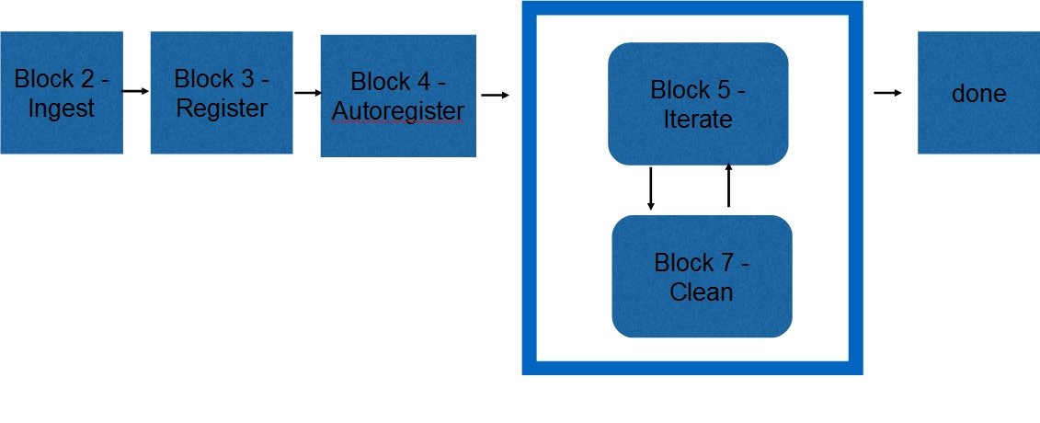
Figure 00: Block Diagram for Adding Images
Autoregister loads existing landmarks into a new image. When you give it an image, it locates all landmarks that fall within its boundaries. Then you can use auto-align (just as in LITHOS). You can also do auto-eliminate and set the star flag for building a template. This generates LMRK_DISPLAY1.pgm which shows pairs of landmarks for the image.
The following table shows the blocks, the procedures and the programs used to complete Stage 2:
Table 00: Procedures for Adding Images
Block | Procedure Name | Executable
Block 2 | Ingest | process_fits, make_sumfiles
Block 3 | Register | register, make_scriptR
Block 4 | Autoregister | autoregister
Block 5 | Iterate | lithos, lithosP, make_scriptP
Block 7 | Clean | residuals, densify
Once you have built the initial shape in Stage 1, it will replace the Nolan radar shape model stored in the SHAPEMODELS directory. This allows a more effective image projection and registration when ingesting new images.

